Mr. Dreyer’s World History Study Guide
1945 – Present

Cold War – World history from 1945 to 199,1 was dominated by the Cold War. The Cold War was a conflict between the Soviet Union and the United States for control of the world. The Soviet Union wanted to spread communism to Europe and other parts of the world and the United States wanted to prevent the spread of communism. The Soviet Union and the United States both had nuclear weapons so they avoided fighting each other directly because they knew no one could win a nuclear war. This doctrine was called MAD or mutually assured destruction. Instead, the two countries fought proxy wars. This means the Soviet Union sold weapons and trained communists in other countries such as Korea and Vietnam and we tried to prevent these countries from becoming communist. The Cold War ended in 1991, because the economy of the Soviet Union could not compete with the market economy of the United States.

Important Ideas and Events of the Cold War

Superpower – At the end of WWII the U.S. and the Soviet Union were called superpowers because they were the only countries in the world with huge militaries and economies.

Containment – President Harry Truman adopted the policy of containment to stop the spread of communism. According to this policy the United States would stop the spread of communism by military, economic, or political means.

Iron Curtain – The Iron Curtain was an expression used during the Cold War that referred to the fact that Eastern Europe was communist and the countries of Eastern Europe were satellite nations of the Soviet Union. Basically, Eastern European countries were not free. The governments of these countries took their orders from Moscow.

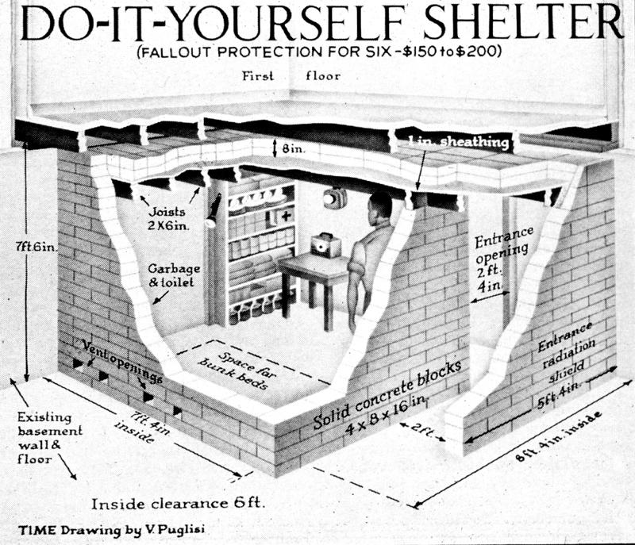
Nuclear Deterrence – This is the idea that if a country has nuclear weapons no other country will want to go to war with it for fear of a nuclear war. The U.S. was the first country to invent nuclear weapons and used them at the end of WWII on Japan. Since WWII several other countries have obtained nuclear weapons such as the Soviet Union (now Russia), U.K., France, China, Pakistan, India, and North Korea. During the Cold War some people built nuclear bomb shelters near their house in case of a nuclear conflict with the Soviet Union.

Timeline of Major Events During the Cold War

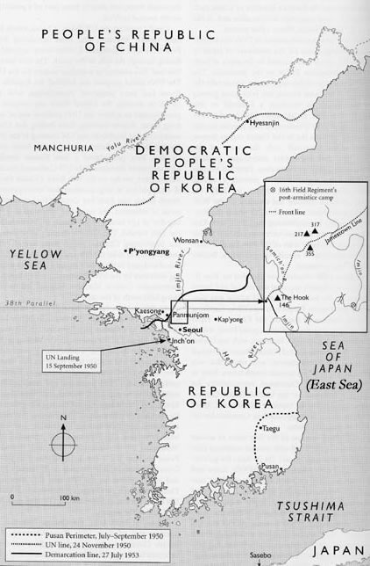
1950 – 1953 Korean Conflict

At the end of WWII Korea was divided at the 38th parallel. North Korea became a communist country and South Korea became a democratic country. Communist North Korea, supported by the Soviet Union, invaded South Korea in 1950. The U.S. responded by sending troops and weapons to help the South Korean Army. After three years of fighting an armistice was signed.

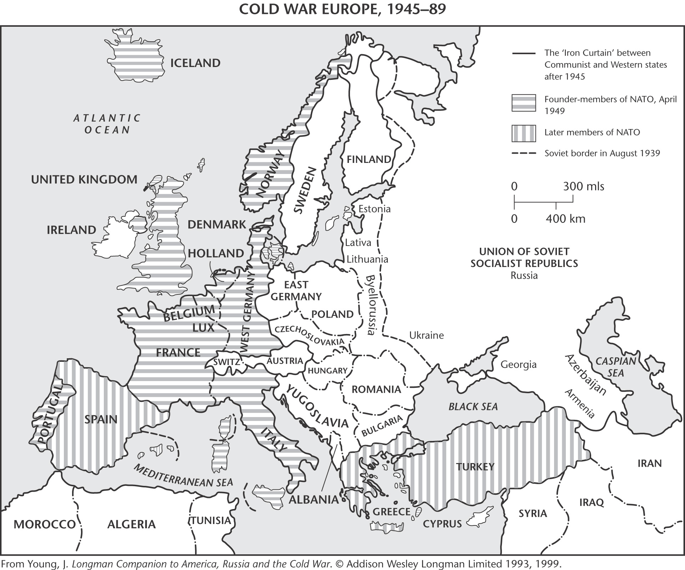
NATO and Warsaw Pact

In order to stop the spread of communism and make Western Europe strong the U.S. formed a political organization called the North Atlantic Treaty Organization (NATO). The organization pledged to defend all member countries from the spread of communism. In response, the Soviet Union formed Warsaw Pact, which was composed of communist Eastern European countries and the Soviet Union. At the end of the Cold War the Warsaw Pact ceased to exist and NATO expanded into Eastern Europe.

1961 Construction of Berlin Wall

At the end of WWII Berlin was divided between the French, British, U.S., and Russians. The Soviet section of Berlin became communist while the French, British, and U.S. sections remained free and democratic even though it was entirely surrounded by communist East Germany. Many East Germans fled to West Berlin because they did not want to be communist. In 1961, the Soviets constructed a wall down the middle of the city to stop East Germans from fleeing. The Berlin Wall became a symbol of the division between communist Eastern Europe and democratic Western Europe.

Figure 1 - Berlin Wall
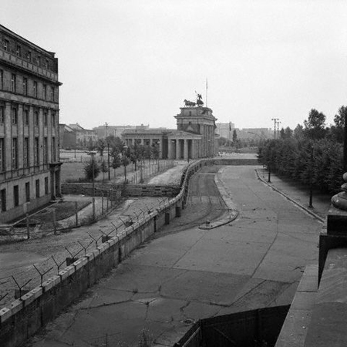

Figure 2 - Map of Divided Berlin
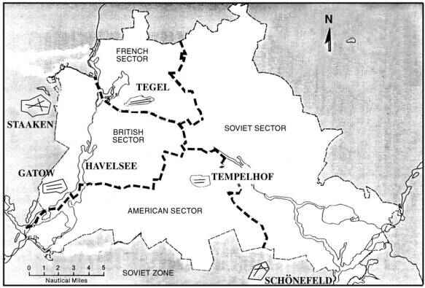

1962 Cuban Missile Crisis

In 1959, Cuba became a communist country under the rule of Fidel Castro. Fidel allied Cuba with the Soviet Union and received weapons and money from the Soviets. In 1962, the Soviet Union began construction of nuclear missile bases in Cuba. The U.S. under the leadership of President Kennedy demanded that the missiles be removed. This two week long stand off was called the Cuban Missile Crisis. People around the world feared the U.S. and the Soviet Union would launch nuclear weapons that would destroy the world. The situation was resolved when the Soviets removed the missiles.

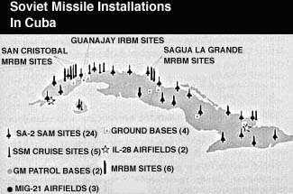

1965 – 1973 Vietnam War

Vietnam was divided at the 17th parallel in 1954. North Vietnam became a communist country under Ho Chi Minh and South Vietnam became a democratic country supported by the U.S. North Vietnam invaded and tried to take over South Vietnam. The U.S. sent combat troops to Vietnam to help the South Vietnamese and keep the country from becoming communist. U.S. troops left in 1973, and Vietnam became a communist country in 1975.

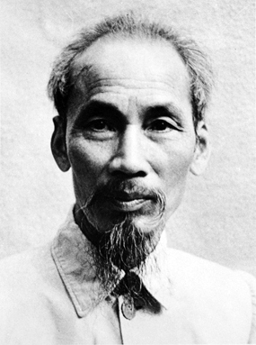
- The Vietnam War started long before American troops entered Vietnam in 1965. After WWII the Vietnamese fought the French colonial forces in the First Indochina War. This war lasted from 1945 – 1954, and ended in a French defeat. The French left in 1954, and Vietnam was divided at the 17th parallel. Basically, the Vietnamese just wanted their own country free from French colonization. Since the U.S. helped the French the Vietnamese turned to the leaders of the Soviet Union to help them and became communist.

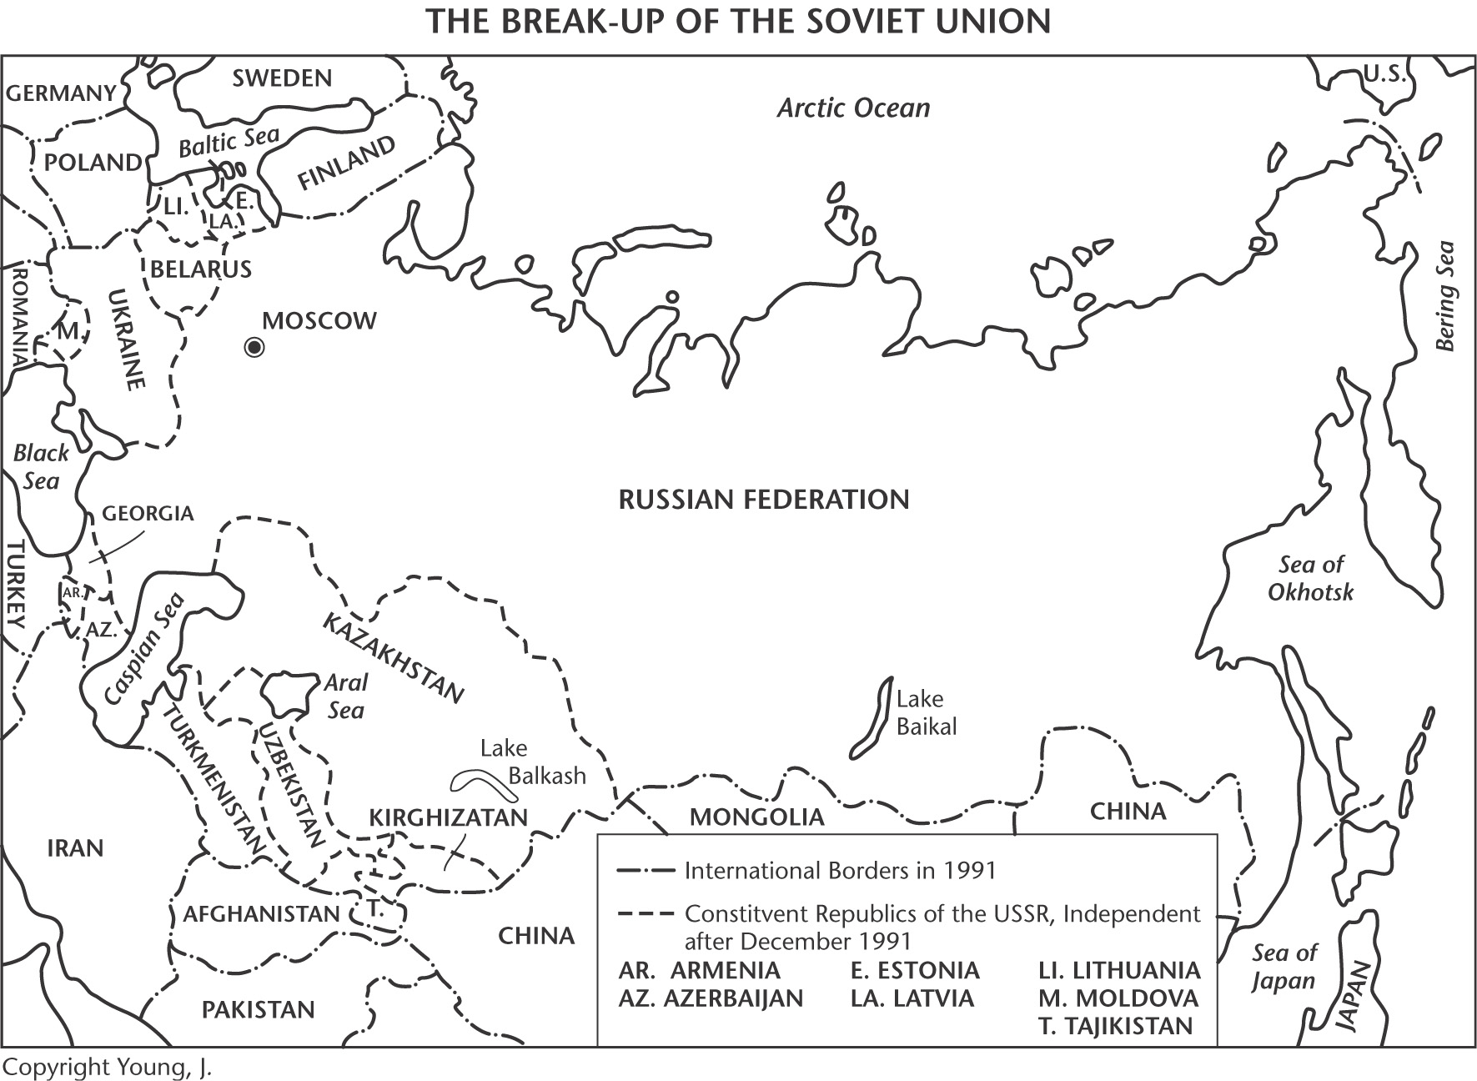

1991 Breakup of the Soviet Union

In 1991, the Soviet Union broke up because it’s economy could not compete with the United States. The countries of Eastern Europe declared independence from the Soviet Union and adopted democratic governments.

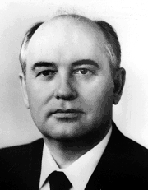
Mikhail Gorbachev – Gorbachev was the last General Secretary of the Communist Party in the Soviet Union. Basically, he was the last leader of the Soviet Union before it broke up and became democratic. Gorbachev tried to reform the economy and the political institutions of the Soviet Union. These reforms were called Glasnost and Perestroika.

China 1945 – Present

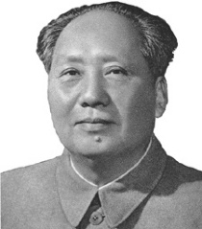
Before WWII the China was torn by civil war between the communist Chinese led by Mao Zedong and the nationalist Chinese led by Chiang Kai Shek. When the Japanese invaded China Mao and Chiang worked together to defeat the Japanese. At the end of WWII, the two factions started fighting again. The communist Chinese forces under Mao Zedong defeated the nationalist forces in 1949, and called China the People’s Republic of China, a communist country. Chiang and his followers fled to Taiwan and called it the People’s Republic of China. Chiang was supported by the United States and the U.S. refused to recognize China as a legitimate country because it was communist.

Figure 3 - Mao Zedong
Figure 3 - Mao Zedong

To this day China claims Taiwan as it’s territory and pursues a policy of “One China”. However, the Taiwanese do not want to be part of China since they have a democracy and good economy.

Communist China also helped the North Koreans during the Korean War.

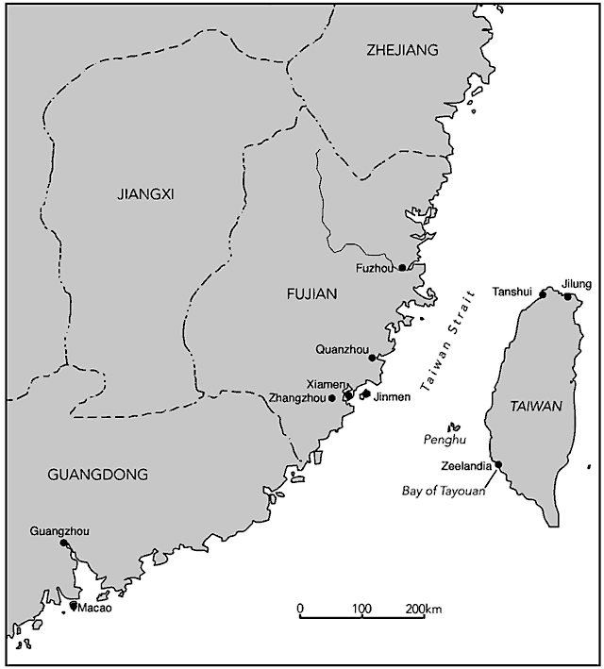
In the 1980s, the leaders of China started to open up the economy from a command economy to a free market economy. The leader who was instrumental in this policy was Deng Xiaoping. Today, the government of China is communist but the economy is more of a mixed free market economy that allows the ownership of private property. China has prospered economically since these changes and is one of the world’s largest and most powerful economies today with rising standards of living.

To the left is a map that shows how close Taiwan is to mainland China. Taiwan maintains a large navy and air force to protect its independence.

Israel 1945 – Present

Between WWI and WWII most of the Middle East was a Mandate region. This means the people in this area did not have countries or governments. They were ruled by the British and French. Slowly, the British and French granted these people independence and countries such as Iraq, Saudi Arabia, and Syria were created. Palestine was a special case because the country was split between Jewish and Muslim inhabitants. The Muslims, called Palestinians, did not want a Jewish state in the area while the Jews wanted a state. The British could not solve this problem so they let the United Nations make a decision. The United Nations decided to partition the area and make two countries, one called Israel and one called Palestine. Israel became a country in 1948, and was immediately invaded by neighboring Muslim countries such as Egypt, Syria, and Jordan. Israel won the war and over it’s history has fought three more wars with the Muslim countries. Here is a timeline of the wars:

- 1948 – War of Independence
- 1956 – Suez Canal Crisis
- 1967 – Six Day War (Israel gains Suez Canal, Sinai, West Bank, and Golan Heights)
- 1973 – Yom Kippur War

Ideas you should know about Israel

- After 1967, Israel occupied the West Bank, Gaza Strip, and Golan Heights.
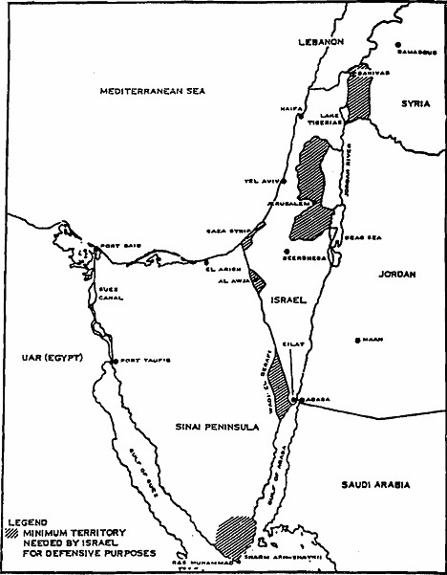
- Gamal Nasser was the president of Egypt during the 1967 Six Day War. He was a popular leader in the Muslim world and most Muslims across North Africa and the Middle East saw him as the leader of Pan-Arabism. Nasser allied Egypt with the Soviet Union, nationalized the Suez Canal in 1956, and built the Aswan Dam.
- Golda Meir was the first female Prime Minister of Israel. She was Prime Minister of Israel when it was attacked in 1973.
- Terrorism – After 1967, the Palestinians living in the West Bank organized terrorist groups such as Hamas led by Yasser Arafat. The goal of Hamas was to force Israel to grant the Palestinians independence by killing Israelis in suicide attacks
- Munich Massacre (1972) – Palestinian terrorists kidnapped Israeli athletes at the 1972, Munich Olympics in Germany. All of the athletes were killed.

India 1945 – Present

All of South Asia was a British colony until after WWII. After WWII, Britain was weak and did not have the military power to control South Asia. Indians organized a political party called the Indian National Congress and worked towards independence. Mohandas Gandhi advocated independence and also non-violent protest. Britain granted South Asia independence in 1947, and the area was partitioned along ethnic and religious lines creating the countries of Pakistan, Sri Lanka, India, and Burma. Later, Pakistan split in two and East Pakistan was renamed Bangladesh. Most Hindus moved to India while most Muslims moved to Pakistan or Bangladesh. Mohandas Gandhi was assassinated and Jawaharlal Nehru became the first Prime Minister of India. Nehru wanted to industrialize and modernize India to make it strong. The 1950 Constitution also tried to stop discrimination based on the caste system. Nehru’s daughter, Indira Gandhi, became the first female Prime Minister of India. She allied India with the Soviet Union and developed nuclear weapons.

Africa 1945 – Present

At the end of WWII, most of the countries in Africa were still colonies of European countries. Slowly, African countries gained independence either peacefully or through armed resistance. The independence movement in Africa was also exploited by the United States and Soviet Union during the Cold War. The Soviet Union promised African leaders military aid and money if they became communist and allied with the Soviet Union. The United States attempted to stop the spread of communism in Africa by arming rival groups. Here are some major ideas to know about Africa:

- Most of West Africa peacefully transitioned to independence from France and Britain
- Kenya gained freedom from Britain after a violent struggle led by Kenyatta
- Algeria gained independence from France after a violent struggle
- South Africa gained independence from Britain in the 1930s, but a system of apartheid developed between white and blacks. Basically, white South Africans controlled the government. Apartheid ended in the early 1990s and Nelson Mandela became the first Black President of South Africa.

