Israel Map Activity

Directions: Label the following items on the map below. Color all water blue.

Syria
Lebanon
Mediterranean Sea
Iran
Iraq
Straits of Tiran
Israel
Egypt
Jordan
Saudi Arabia
Red Sea
Kuwait
Suez Canal
Sinai Peninsula
West Bank
Gaza Strip
Gulf of Aqaba
Turkey

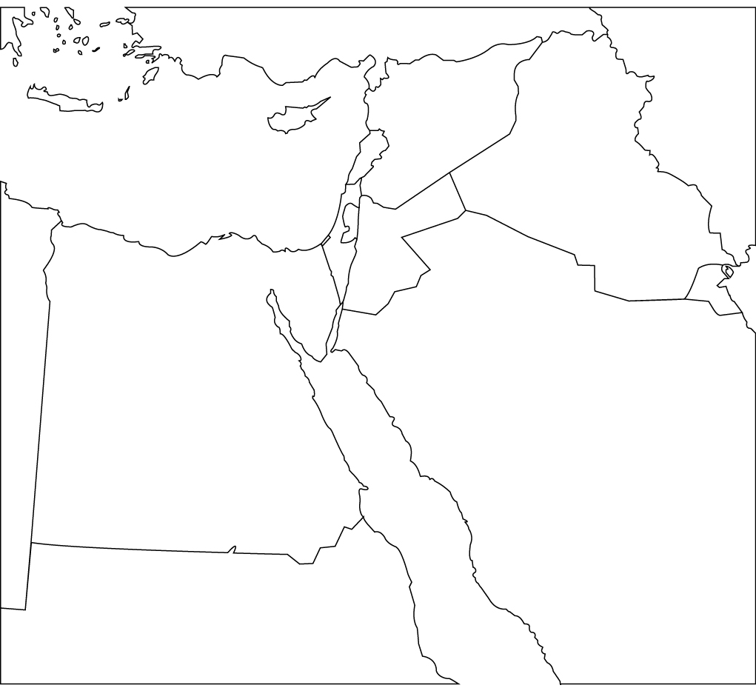

Israel Map Activity
Directions: Label the following items on the map below. Color all water blue.

Israel
West Bank
Jordan
Lebanon
Syria
Gaza Strip
Egypt
Gulf of Aqaba
Jerusalem
Tel Aviv
Golan Heights
Mediterranean Sea

