International Relations Systems Study Guide

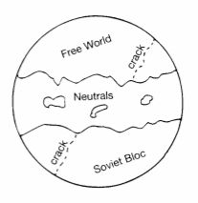 | Bipolar System  A bipolar system is characterized by two world powers. The best example of a bipolar world was from 1945 – 1991. From the end of WWII in 1945 to the end of the Cold War the world was dominated by two superpowers, the United States and the U.S.S.R. The cracks in this diagram represent internal disputes between NATO countries and Warsaw Pact countries.
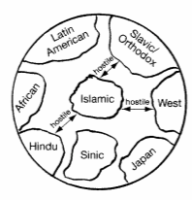 | Clash of Civilizations  Clash of Civilizations is a theory of international relations proposed by Samuel Huntington. He divides the world into eight major civilization groups based largely on religion. He argues that the primary conflicts in the world after the Cold War will be based on cultural and religious divides.
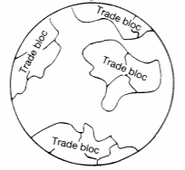 | Multipolar  Power is distributed between many different power centers. Some theorists say power can also be distributed between major trading blocks and the power struggle is mainly economic rather than military.
Globalized

Most countries cooperate in the world for economic gain. The idea is that the economies of all countries are so interdependent they will not risk going to war with each other and the system is stable.
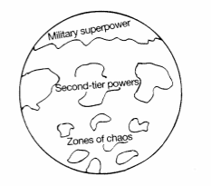 | Stratified  The United States is on top with the strongest military in the world but there is a second tier of major economic and military powers. Parts of the world are considered zones of chaos. Examples might be parts of Sub-Saharan Africa such as Somalia or war zones such as Afghanistan.
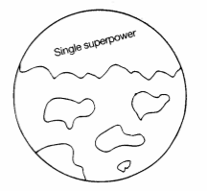 | Unipolar  Power is concentrated in a single power center. Some theorists claim the world after the end of the Cold War in 1991 is a unipolar world because the United States is the most powerful country in the world.
Vocabulary Associated with Balance of Power  Internal Balancing  External Balancing  Buck-Passing  Chain Ganging  Bandwagoning  Bloodletting | Balance of Power  Power is more or less divided evenly between many major powers and no one country can dominate the others. Balance of Power is a multipolar world where power is distributed evenly. Examples are Europe after the Congress of Vienna until WWI. The Balance of Power doctrine eventually led to alliances.

