World History Review

I. Maya, Aztec, Inca

Figure 1
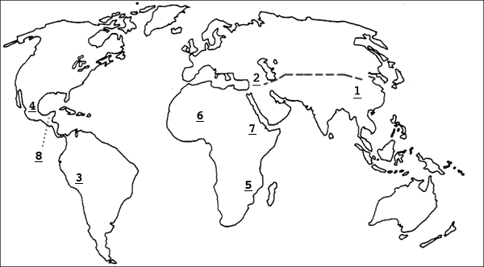

1. What number identifies the location of the Aztec culture?
2. What number identifies the location of the Maya culture?
3. What number identifies the location of the Inca culture?

For the following questions choose Aztec, Maya, or Inca (for some questions you can choose more than one answer)

4. What culture grew up in the Andes Mountains in South America?
5. What culture grew up in Central Mexico?
6. What culture had a capital called Tenochtitlan in the middle of a lake?
7. What culture relied on corn as a primary agricultural crop?
8. What culture did not have a form of writing?
9. What culture built pyramids for religious purposes?
10. Hernando Cortes conquered what culture?
11. Francisco Pizarro conquered what culture?
12. What culture built an extensive network of roads through the Andes?
13. What culture was located primarily in the rainforests of Southern Mexico and Central America?
14. What culture relied on potatoes as a primary agricultural crop?
15. What culture domesticated llamas and alpacas?

II. Japan and Africa

1. What number on the map identifies the location of Axum?
2. What number on the map identifies the location of Great Zimbabwe?
3. What number on the map identifies the location of Ghana, Mali, and Songhai?
4. What was the major religion in Axum?
5. What was the major religion in Great Zimbabwe?
6. What was the major religion in Ghana, Mali, and Songhai?
7. List one item that all African civilizations traded.
8. What African civilization was located between the Zambezi and Limpopo Rivers?
9. List an ethnic religion from Japan.
10. Why was Japan relatively isolated throughout its history?
11. What country had a large cultural influence on Japan?
12. Describe the physical geography of Japan.

III. Trade Routes

Trade Items, Innovations, and Religions

Gold
Ivory
Textiles
Spices
Slaves
Amber
Fish
Timber
Silk
Porcelain
Hinduism
Buddhism
Islam
Christianity
Shintoism
Taoism
Confucianism
Compass
Gunpowder
Paper
Waterwheels
Lateen Sail

Figure 2: Indian Ocean Trade
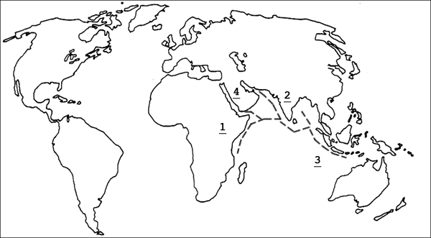

1. Use figure 2. What trade items most likely came from number 3?
2. Use figure 2. What trade items most likely came from number 1?
3. Use figure 2. What trade items, religions, and innovations came from number 2?

Figure 3: Silk Road
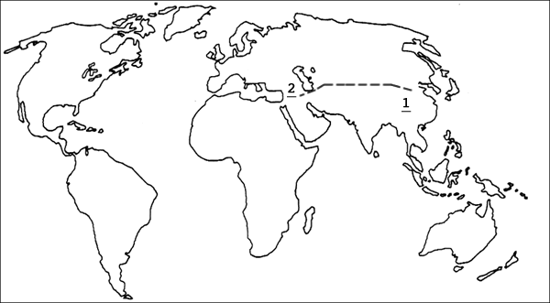

4. Use figure 3. What trade items and innovations came from number 1?

Figure 4: Northern European Trade
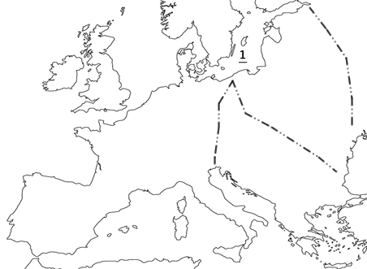

5. Use figure 4. What trade items came from number 1?
IV. Religion – Put each vocabulary word underneath the religion/religions it is associated with.

Polytheistic
Monotheistic
Mosque
Cathedral
Koran
Torah
New Testament
Old Testament
Upanishads
Vedas
Mecca
Dome of the Rock
Medina
Ganges River
Reincarnation
Karma
Jesus Christ
Nirvana
Japan
India
North Africa
Middle East
Europe
Icons
Pope
Sunni
Shia

Islam Christianity Hinduism Buddhism Judaism

