Vocabulary and Pictures for World Civilizations Chart

- Cuneiform
- Hieroglyphics
- Pharaoh
- Ziggurat
- Pyramid
- Hinduism
- Zoroastrianism
- Judaism
- Monotheistic
- Polytheistic
- Ideograms
- Vedas
- Upanishads
- Torah
- Fertile Crescent
- Atman
- Moksha
- Karma
- Reincarnation
- Great Road
- Rigid Social Structure
- Vizier
- Taoism
- Hammurabi’s Code
- Confucianism
- Great Wall of China
- Indus River Valley
- Ganges River
- Hindu-Kush
- Himalayas
- Porcelain
- Silk
- Ten Commandments
- Diaspora
- Ashoka
- Gupta
- Aryans
- Caste System
- Mauryans
- Mandate of Heaven

Picture 1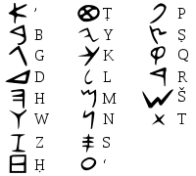 | Picture 2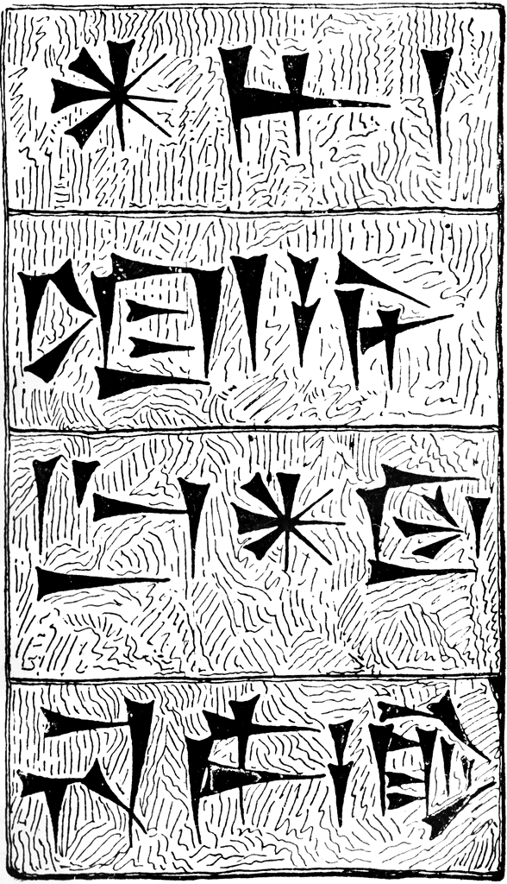 | Picture 3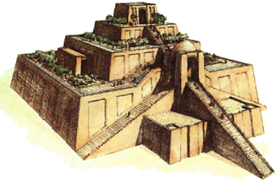
Picture 4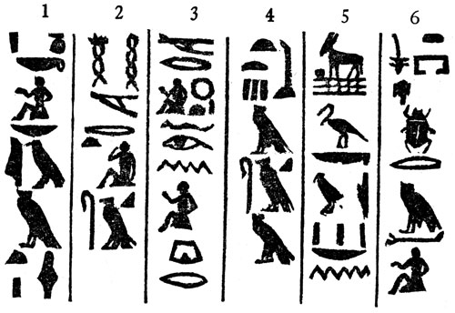 | Picture 5