Neuron
Directions: Read page 157 -158 about the neuron. Label, color, and describe the function of each part of the neuron. Draw a red arrow in the direction the message is being sent. Then answer the questions at the bottom of the page. 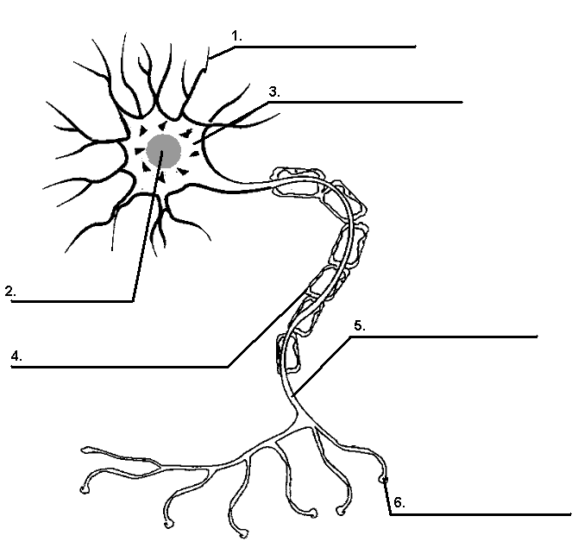
Questions:
1) Define neuron.
2) What happens if the myelin sheath is damaged?
3) Describe the Synapse
4) Describe the all-or-none response

Neurotransmitters
Neurotransmitter | Function | Malfunction
Norepinephrine

Acetylcholine

Dopamine

Serotonin

GABA

Glutamate

Endorphin

