Sensation Concepts
Station 1. Sensory interaction: What’s that White Powder?
When one sense affects another sense, sensory interaction takes place. That is why it is hard to taste when your nose is stopped up Sometimes it takes several senses to figure out what something is or to enjoy something. Imagine all of your favorite foods mixed up in a blender….not the same, huh?
Directions
A) Take the spoon and scoop out a small amount (¼ teaspoon) of the white powder and pour it in the circles of the paper provided.
B) Without tasting the substance, guess what the white powder is by using your other sensations.
Sound
Describe the sound you hear when the substance is poured out on the paper
A -
B -
C -
D -
Touch
Describe the texture of each substance
A -
B -
C-
D-
Sight
Describe what each substance looks like; how to they look different or the same?
A -
B -
C -
D-
Smell
Describe what each smells like
A-
B-
C-
D-

B) Perception: Before you taste the substances, what do you think each substance is? If you know, which sense helped you identify the substances the best? What experience helped you to identify the substances?
A -
B -
C -
D-

Taste – if you are brave taste them. None are harmful, and I am pretty sure no one would have an allergy to any of them. However, if you have an allergy, let me know so I can tell you if you should avoid one.
A -
B-
C-
D-
Station 2. Touch: Absolute Threshold: Are you touching me?
Is your skin equally sensitive all over your body? Find out the absolute threshold and the difference threshold/just noticeable difference on skin spots around the body.

Directions
A) You are going to lightly poke your partner with one and then two toothpicks on various places on their skin using the instruments. Her job is to tell you whether or not she feels one poke or two pokes. To make sure your partner is not cheating, they need to either wear a blindfold or keep her eyes closed. Also, try to trick your partner. Go back and forth.
B) Using the instruments, randomly poke your partner to see if and when your partner can distinguish between one or two pokes. You may want to test more areas of the body than what is listed below. However, use the toothpicks from the box to test the other areas. Throw them away when done. Some suggestions are: back of finger, back of hand, wrist, neck, stomach, top of foot, sole of foot, calf, thigh, forehead, nose, lip, and ear. Only appropriate areas, please.

C) Fill out the chart below by placing a check mark in the appropriate box of where they feel two pokes for the first time.

 | 1 | 2 | 3 | 4 | 5 | 6 | 7
Tip of finger
Palm of hand
Upper arm
Back

Cheek

Chosen Area:

Chosen Area:

Chosen Area:

Station 3. Bone Conduction: What’s that sound?
There are two types of hearing: air conduction hearing and bone conduction hearing. The way you hear to a person’s voice or music is through air conduction in which sound waves travel through the air. The other type of hearing, bone conduction, is how we hear ourselves eat, speak, or even hear under water. Sound vibrations travel through our skull to the fluid in the cochlea producing a sound. A cochlear implant uses bone conduction to help people who are deaf hear.

Directions
A) To experience bone conduction hearing, grab one of the hangers with strings on it. Put the ends of the strings between your ear lobule and targus (see below), closing your auditory canal. Have your partner use a pencil or pen to hit the bottom of the hanger. Then, hold the strings and hit the hanger with pencil.
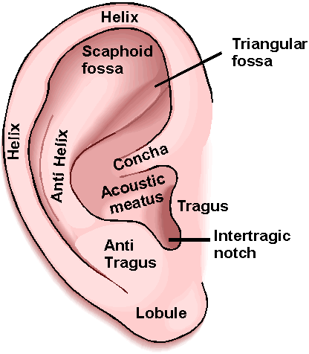
B) Describe how bone conduction hearing sounds different from air conduction hearing.

Station 4. Sensory compensation: Am I a super human?
No, you are not a super human. In all actuality, you are probably average. Sensory compensation is when other senses seemed heightened when one or more senses are silenced. Have you ever noticed that everything seems louder at night? For example, your fan, house settling, or the dog barking 2 miles away. The darkness “silences” your vision. Your sense of sight is number one as far as your brain is concerned, silence it and a whole other world of touch, hearing, taste, and balance are reviled. The concept of your vision being number one is called visual capture. Now let’s try to experience sensory compensation.
Directions
A) With a partner, take turns walking around the upstairs of the new building, once without a blind fold and then again with a blind fold. As you walk, pay special attention to your senses.
B) Describe your sensational experiences:
Senses | Blind Folded | Sighted
Hearing
Touch
Smell
Taste
C) Did you notice your superhuman powers when you were blindfolded? Yes or no? How was it the same of different?

