Altered States - “Drugs and Consciousness”
Webquest
Name: ___________________ Date: ____ Pd: ____
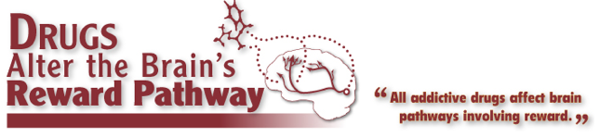

Goto: http://learn.genetics.utah.edu/content/addiction/

Explore, learn, record, and apply the information provided on the University of Utah’s website dedicated to the education and prevention of substance abuse. You will work with a number of “edu-tainment” modules to help comprehend the science and psychology of addiction.

Read each question carefully and be sure to answer all components of the question to earn full credit.

1. Read “Drug Use Changes the Brain Over Time” and answer the following questions. How do drugs influence the synapse? What region of the brain is greatly influenced by drugs?

2. Read “Beyond the Reward Pathway”. There is a ton of information on this page. Please summarize it below.

Brain pathway –

The Dopamine Pathway –

The Serotonin Pathways -
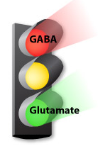

Glutamate and GABA -

5. Click on “DRUGS OF ABUSE” and complete this chart.

Name of Drug | How Taken | Nick  Name | Facts…Below is the Information You Need to find:  Classification  Effects on Body  Effects on Brain  Withdrawal Symptoms  Addictive Properties
Alcohol

Cocaine

Hallucinogens

Heroin

Inhalants

Marijuana

MDMA

Meth

Nicotine

Dissociative Drugs


6. Scroll to the bottom and click on “HOW DRUGS CAN KILL”. Complete the following chart.

Polydrug Cocktails | Heroin and Opiates
Alcohol | Nicotine
Cocaine | Amphetamine, Meth and MDMA

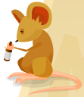
7. Click on “MOUSE PARTY”. Mouse party is designed to provide a small glimpse into the chemical interactions at the synaptic level that cause the drug user to feel “high”. Navigate through the mouse party and answer the following questions. (You might want to read “Neurons Transmit Messages in the Brain” as a review before you start.

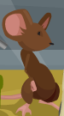
Eddie the Ecstasy Mouse

1) When the transporter takes in the ecstasy, what does it do with the excess serotonin?

2) How does ecstasy cause “the high”? In other words, how does it over stimulate the receptors?

3) What are the serotonin pathways responsible for that ecstasy effects?

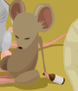
Annie the Alcohol Mouse

1) GABA Neurotransmitters are responsible for what?

2) What two things happen when Alcohol enters the brain?

3) Why is memory affected when people drink too much?

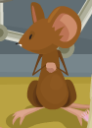
Carter the Cocaine Mouse

1) What happens when cocaine blocks the dopamine transporters?

2) Why are cocaine users so fidgety?



Miley the Marijuana Mouse

1) Cannabinoid receptors turn off the release of what?

2) What does THC do?

3) How are THC and anandamide similar? How are they different?

4) Name 2 parts of the brain marijuana affects.

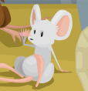
Lucy the LSD Mouse

1) Why does LSD have complex sensory effects?

2) What is the LC and what does it do?


Max the Meth Mouse

1) How does Meth get into your body’s cells?

2) What does the excess dopamine end up doing?

3) Why is Meth so addictive?

Henry the Heroin mouse

1) Heroin mimics natural opiates, does that make it an agonist or antagonist drug?

2) What is the effect of heroin binding to opiate receptors?

3) Why is Morphine used as a pain killer?

Now you are done!

