Fundamental of Economics 1.1

SSEF1 Explain why limited productive resources and unlimited wants result in scarcity, opportunity costs, and tradeoffs for individuals, businesses, and governments.

a. Define scarcity as a basic condition that exists when unlimited wants exceed limited productive resources.
- Define scarcity (BL)
- What are the scarce productive resources?
- What two characteristics make something scarce?
- What is an example of a scarce land resource?
- Define allocation (BL)
- How are scarce items allocated in a market economy?
- What is the typical relationship between scarcity and price?
- What is the difference between scarcity and a shortage of a good/service?
- Define shortage

b. Define and give examples of productive resources (i.e. factors of production): natural resources (i.e. land), human resources (i.e. labor and human capital), physical capital and entrepreneurship.
- Give examples of the four types of productive resources (FACTORS OF PRODUCTION) (BL)
  - Land:
  - Labor:
  - Capital:
  - Entrepreneurship:
- Define Human Capital (BL)
- Define Physical Capital (BL)

c. Explain the motivations that influence entrepreneurs to take risks (e.g., profit, job creation, innovation, and improving society).
- Becoming an __________________________________usually involves taking risks such as using one’s own ____________________________ resources to make a prototype of a product or buy the ________________________resources required to start the business.
- What is the primary factor that influences entrepreneurs to take risks? (PL)
- Explain the other incentives for entrepreneurs to take business risks? (PL)
  - Provide Jobs:
  - Innovation:
  - Improve society:

d. Define opportunity cost as the next best alternative given up when individuals, businesses, and governments confront scarcity by making choices
- Define economics
- Define opportunity cost. (BL)
- However, do note, that ________________________________ is only between ______________ items.
- In the example: what is the opportunity cost of choosing to study instead of going to the movies?
- To summarize: ______________________ leads to ___________________________ and trade offs.(DiL)

SSEF2 Give examples of how rational decision making entails comparing the marginal benefits and the marginal costs of an action.

a. Define marginal cost and marginal benefit.
- Define marginal
- Define marginal benefit (BL)
- Define marginal cost (BL)

b. Explain that rational decisions occur when the marginal benefits of an action equal or exceed the marginal costs.
- When are rational decisions made? (DiL)
- Define revenue
- Define profit
- What factors do business firms need to consider when deciding on how many workers to hire?
- Based on the business expenditures chart, how many workers should the firm hire, and why?

c. Explain that people, businesses, and governments respond to positive and negative incentives in predictable ways.
- Define incentives
- Give an example of a positive incentive (BL)
- Give an example of a negative incentive (BL)

SSEF6 Explain how productivity, economic growth, and future standards of living are influenced by investment in factories, machinery, new technology, and the health, education, and training of people.

a. Define productivity as the relationship of inputs to outputs.
- Define productivity (BL)
- What is an example of an input? (BL)
- What is an example of an output? (BL)
- The __________________________wants to produce the right amount of output at the right price so he can make a ___________________.
- List one way the baker could increase productivity?
- Based on the chart, how did the purchase of a high tech, large capacity oven improve production?

b. Explain how investment in equipment and technology can lead to economic growth.
- Give an example of investment in equipment? (PL)
- What kinds of investments can lead to economic growth? (DiL)
- Why do firms and the government invest in equipment and technology?

c. Explain how investments in human capital (e.g., education, job training, and healthcare) can lead to a higher standard of living.
- Define standard of living.
- How does one typically increase their standard of living?
- Give examples of investment in education or human capital (PL)
- Based on the Chart, chart is the relationship between level of education, earnings, and unemployment rate?

d. Analyze, by means of a production possibilities curve: trade-offs, opportunity cost, growth, and efficiency.

- What does the production possibilities model illustrate?

Graph 1 | Graph 2 | Graph 3
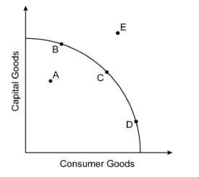 | 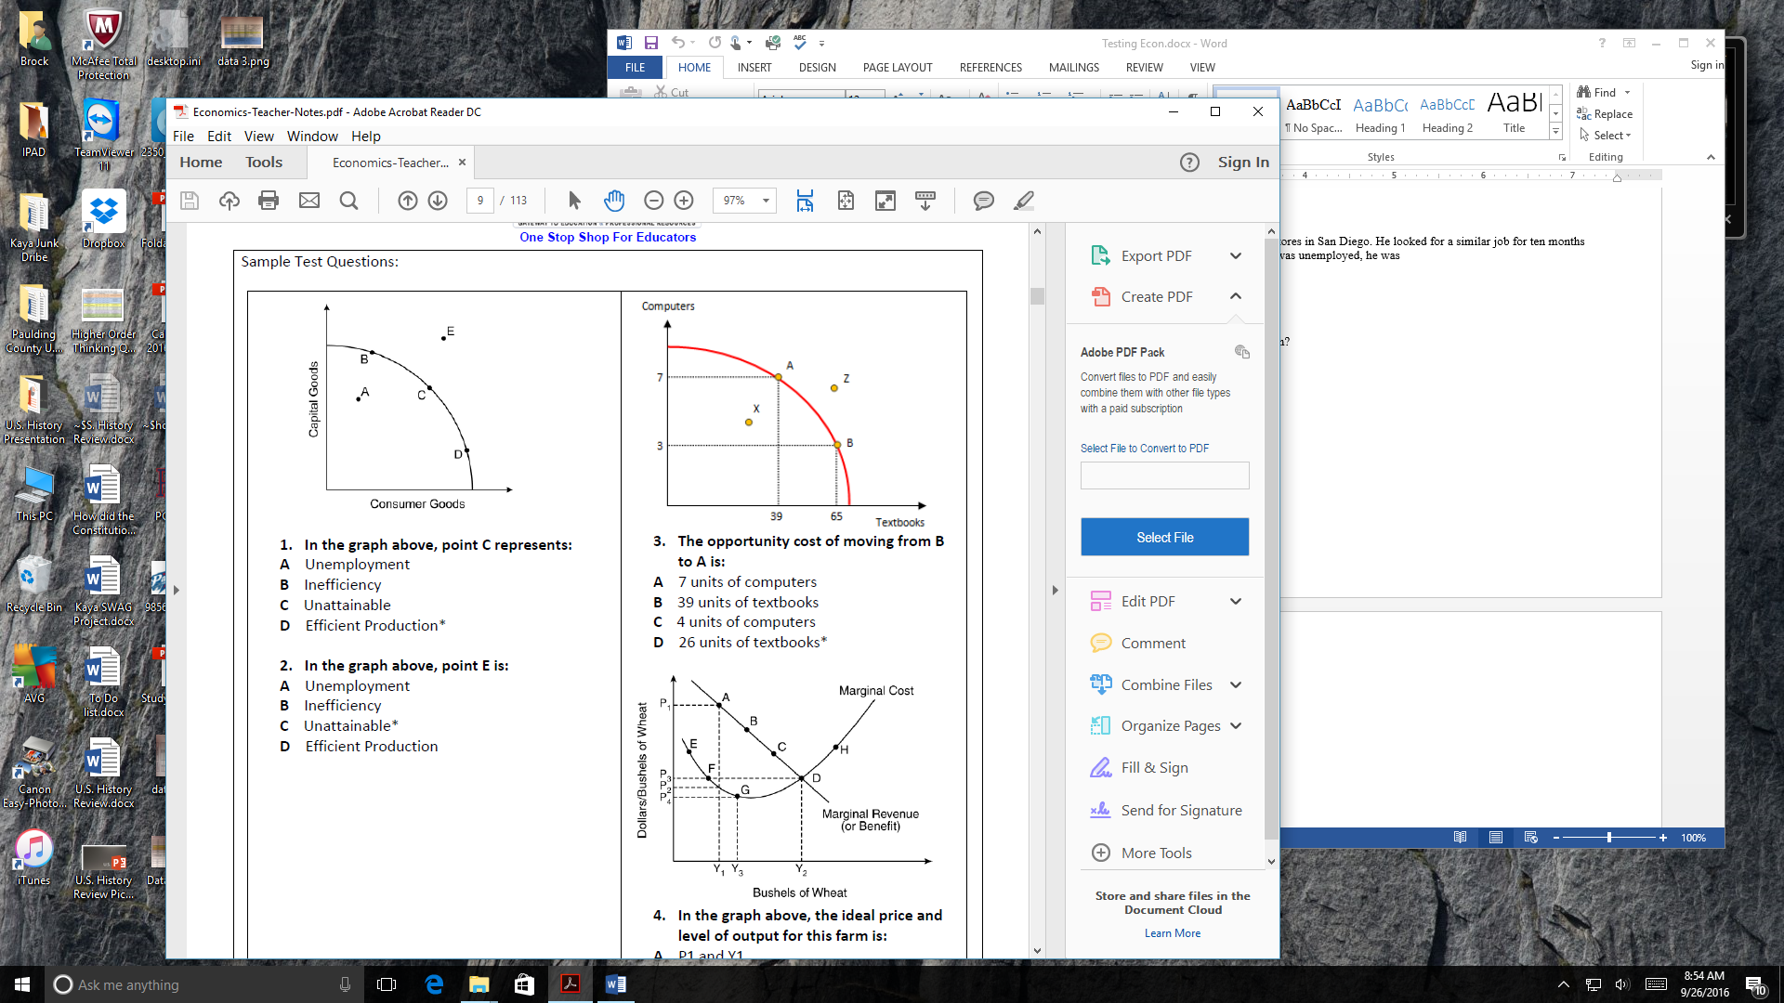 | 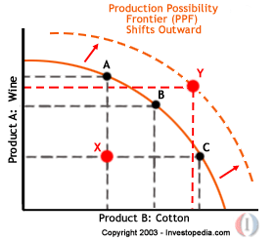

- Using graph 1, label the following concepts on the production possibilities curve? (DL)
  - Which letters represent Trade-offs:
  - Which letters represent Inefficient use of resources:
  - Which letters represent Efficient use of resources:
  - Which letters represent Unattainable use of resources:
- Using graph 2, what is the opportunity cost of choosing point A over point B?
- Using graph 2, what is the opportunity cost in choosing point B over point A?
- Which graph shows economic growth on the Production Possibility Curve?(PL)
- What kinds of investments can lead to economic growth? (DiL)

