Fundamentals of Economics: 1.1

SSEF1 Explain why limited productive resources and unlimited wants result in scarcity, opportunity costs, and tradeoffs for individuals, businesses, and governments.

Define scarcity as a basic condition that exists when unlimited wants exceed limited productive resources.

Scarcity should be defined as a basic condition that exists when unlimited wants exceed limited productive resources. The scarce productive resources (factors of production) are land, labor, capital, and entrepreneurship. Things that are scarce are both limited AND desirable. For example, crude oil is a land resource that is limited because there is only so much of it that can produced and made available to society at any given time. It is also desirable because it is used to produce goods and services. In market economies, things that are scarce are usually allocated (Distributed) by price. Items that are more relatively scarce (more limited and/or more desirable) will usually carry a relatively high price. In some cases, something that was once considered not scarce can become so. For example, there was a time when restaurants had to pay companies to haul away used cooking oil (undesirable). Now used cooking oil is often purchased by biofuel companies because it can be used in production. The cooking oil has become both limited AND desirable. There are also a small number of “free” goods that are desirable but not limited. For example, we can enjoy the sunshine outside or breathe the oxygen around us without paying for it.
Not everything that is scare is tangible. A good example of this phenomenon is time. At some point, all of us wished that we had more time for something like studying, working, spending time with friends/family, etc.
However, you must recognize the difference between scarcity and a shortage. Scarcity always exists while a shortage is temporary. Shortages occur when a resource, good, or service becomes unavailable for a period of time due to circumstances affecting the market. For instance, if a gasoline pipeline is damaged and has to be shut down for repair, geographic areas that get fuel from that pipeline may find their gas stations temporarily out of fuel. Gasoline is always scarce (limited and desirable). However, in this example, the market for gasoline is experiencing a temporary shortage until the pipeline is repaired.

Define and give examples of productive resources (i.e. factors of production): natural resources (i.e. land), human resources (i.e. labor and human capital), physical capital and
entrepreneurship.
Productive resources, also known as factors of production, are scarce items used in the production of goods and services in an economy. The four factors of production are land, labor, capitol and entrepreneurship. Natural resources, also known as land resources, are the gifts of nature we use to produce goods and services. For example, a tree is a natural resource used in the production of goods like lumber or paper. Labor (EX. janitor, teacher) are the people involved in the production of goods and services. Labor offer their time to production as well as their physical abilities, knowledge, and skills. In economics, capital (hammer, pencil) is the tool or equipment used to produce goods and services. The abilities (knowledge, skils) each person brings to the production process is known as their human capital. Producers of goods and services need physical capital too. Physical capital refers to tools, machines, and structures used over and over again in the production of goods and services. While natural, human, and capital resources are essential to production, we rely on the fourth productive resource, entrepreneurship, to bring the resources together in innovative ways to produce a product. An entrepreneur is a person who takes risks such as using one’s own financial resources to make a prototype of a product or buy the capital resources required to start the business.

Explain the motivations that influence entrepreneurs to take risks (e.g., profit, job creation, innovation, and improving society).

Becoming an entrepreneur usually involves taking risks such as using one’s own financial resources to make a prototype of a product or buy the capital resources required to start the business. Some entrepreneurs may have to quit jobs from which they receive a relatively secure, predictable income in order to have enough time to invest in their new enterprise. In most cases, entrepreneurs begin new businesses because they believe the potential rewards of success outweigh the potential costs associated with the risks. The motivations of entrepreneurs include profit, job creation, innovation, and improving society. Traditionally, the field of economics sees the profit motive as the primary driver of entrepreneurship. Those who start private firms believe they can operate the business in a way that the revenues (price times the quantity of goods/services sold) they receive will be greater than the costs (costs of production plus the
income they gave up to start the business). In very basic terms, profit is equal to a firm’s revenue minus its costs. Entrepreneurs may also be motivated by the opportunity to create a successful business that can provide jobs for people in the industry. According to a 2015 report by the Kauffman Foundation, new businesses accounted for ALL net new job creation and 20 percent of gross job creation. Innovation is another key motivation. Many successful entrepreneurs work as employee experts in their industry before venturing out on their own. During their time as employees, they often see ways companies could improve efficiency or production. They may apply their expertise to new products during their non-working hours. At some point, the desire to put their ideas to the test may become greater than their need for the security of a regular salary. Finally, some entrepreneurs start for-profit companies or non-profit organizations because they believe their product or service will improve society. For example, there are microfinance companies linking individual lenders to individual borrowers. This service provides financial resources to people who would be unlikely to qualify for traditional bank loans and a return to lenders who would like to see their money help grow the businesses of others.

Define opportunity cost as the next best alternative given up when individuals, businesses, and governments confront scarcity by making choices.

The study of economics is all about the choices made by individuals, businesses, and governments. From an
economist’s view, all choices involve both benefits and cost. The value of one’s next best alternative given up when a choice is made is called opportunity cost. For example, if you have the choice of going to the movies with your friends or studying for your economics quiz tomorrow. Since your choose to study, because you care about your grade very much and wouldn’t want to disappoint me, the opportunity cost of your decision is going to the movie. However, do note, that opportunity cost is only between two items. If you have more than two options the opportunity cost is ONLY between the two most desirable options, not any of the other ones. Opportunity cost can also be in monetary form. For example, if your choice is between mowing your neighbors lawn for $25 or going fishing and you choose fishing, then the opportunity cost of that decision is $25. Additionally, the cost could include the cost of what option you choose. For instance, if the choice is between mowing your neighbors yard, again for $25, or going to buy a new fishing pole for $50. If you chose to buy the pole, your opportunity cost is $75 because you must add the cost of the pole to what you would have gained by mowing the lawn. To summarize: scarcity leads to opportunity costs and tradeoffs

SSEF2 Give examples of how rational decision making entails comparing the marginal benefits and the marginal costs of an action.

Define marginal cost and marginal benefit.

Marginal is defined in economics as small or incremental change. Marginal benefit refers to the additional positive value one receives from undertaking one more unit of an action. For example, the marginal benefit of running one more mile after running the previous two miles could be the additional calories burned. Marginal cost refers to the additional amount of effort, expense, or time one incurs from undertaking one more unit of an action. For example, the marginal cost of running one more mile after running the previous six miles could be eight minutes of time one could have devoted to another pursuit such as studying for an exam or reconsidering why you decided to run cross country in the first place.

Explain that rational decisions occur when the marginal benefits of an action equal or exceed the marginal costs.

Rational decisions should be made with marginal benefits exceed marginal cost. In microeconomics, one benefit a firm receives from selling a product is the revenue (price times the quantity). One cost associated with producing a product is the cost of the human resources required to make the product. A rational firm wants to know how many workers it should hire to maximize its profit. Profit is revenue minus costs. An economist would tell the firm to hire the number of workers at which the marginal revenue generated by the human resource is equal to the marginal cost of hiring the human resource. Consider an example in which the wage for each worker you hire is $10.00 an hour and the price of your product is $2.50. In the table below, the marginal revenue (benefit) of each additional worker is equal to the marginal cost of each additional worker when the firm hires worker #3. A rational firm would not hire the 4th worker because the marginal cost of that worker is greater than the marginal benefit.

Number of Workers | Total Units Produced | Marginal Number of Units Produced | Price of Each Unit Produced | Total Revenue for the Units Produced | Marginal Revenue for Generated by Each Additional Worker | Marginal Cost of Hiring Each Additional Worker
0 | 0 |  | $2.50 | 0
1 | 6 | 6 | $2.50 | $15.00 | $15.00 | $10.00
2 | 11 | 5 | $2.50 | $27.50 | $12.50 | $10.00
3* | 15 | 4 | $2.50 | $37.50 | $10.00* | $10.00*
4 | 18 | 3 | $2.50 | $45.00 | $7.50 | $10.00
5 | 20 | 2 | $2.50 | $50.00 | $5.00 | $10.00
6 | 21 | 1 | $2.50 | $52.50 | $2.50 | $10.00

Explain that people, businesses, and governments respond to positive and negative incentives in predictable ways.
In the study of economics, an incentive motivates individuals, businesses, and/or governments to undertake an action or avoid an action. Positive incentives are when these actors in the economy choose an option associated with a perceived benefit or gain. An example of a positive incentive would be getting a job to earn money. Negative incentives are sometimes called disincentives, when actors in the economy avoid a

particular option because they associate it with a cost that is too high. An example of a negative incentive would be committing a crime and going to jail. Traditionally, the field of economist believes individuals, businesses, and governments will respond predictably to positive and negative incentives.

SSEF6 Explain how productivity, economic growth, and future standards of living are influenced by investment in factories, machinery, new technology, and the health, education, and training of people.

Define productivity as the relationship of inputs to outputs.
Productivity looks at the relationship between inputs and outputs. An input is something that goes into making a good or service. For example, to make a cookie, a bakery must have ingredients like flour and sugar that come from natural resources like wheat and sugar cane. The baker must have capital resources like ovens and mixers to process the cookie dough. The baker needs labor resources to run the machines and serve the customers. The labor resources must have the appropriate human capital such as the ability to read the recipe, make decisions about when the baking of the cookies is complete, and how to package the cookies for sale to customers. If the baker is the owner of the bakery, he or she is the entrepreneurial resource who must choose to take a risk and decide how best to run the business. An output is the amount of a good or service produced. In the case of the baker described above, the cookie is the output. The baker wants to produce the right amount of output at the right price so he can make a profit. Increases in productivity occur when producers can produce more output with fewer inputs. This could occur because an entrepreneur finds ways to use his inputs more efficiently. For example, productivity might increase by using a recipe that requires less sugar, rearranging the production line to be more efficient, training labor resources to specialize in specific jobs, reducing the amount of inputs that are wasted in the production process, adding new, more efficient machinery or technology, or finding ways to motivate labor resources to produce more quickly.

Productivity Using Conventional Oven | Productivity After Introducing High Tech, Large Capacity Oven
Productivity = Number of Cookies Baked  Number of Minutes to Bake Cookies  Productivity = 24 cookies = 2 cookies per  12 minutes minute | Productivity = Number of Cookies Baked  Number of Minutes to Bake Cookies  Productivity = 48 cookies = 8 cookies per  6 minutes minute
The investment in the high tech, large capacity oven increased productivity from 2 cookies per minute baked to 8 cookies per minute baked. This is a 400% increase in productivity.

Explain how investment in equipment and technology can lead to economic growth.

For the purposes of this element, investment refers to the introduction of machines and equipment, the building of new factories, and/or the purchasing and implementation of new production technology. Both firms and government entities invest in equipment and technology leading to economic growth. Consider again the example of the bakery from the last element. The productivity increase from the new oven applied only to the bakery. Imagine the effect on the economy if many firms made similar investments leading to large increases in productivity. Consider a scenario in which governments also invest in equipment and technology, increasing productivity in public goods and services. If this increased productivity across the economy happens while keeping prices of goods and services relatively stable, there will be economic growth. Remember, we measure economic growth by the change in the real GDP from one period to
the next. If the total value of final goods and services produced within the country’s borders and adjusted for changes in
the price level increases from one period to the next, there is economic growth in the country.

C. Explain how investments in human capital (e.g., education, job training, and healthcare) can lead to a higher standard of living.

Standard of living refers to the material well-being people in an economy enjoy. Usually, the higher the real GDP per capita a country has, the higher the standard of living of the people in that country will be. Remember, real GDP per capita is the value of final goods and services produced per person in an economy in a particular time period. As the output per person in the country increases, an economist would expect the amount of goods and service each person can consume to increase. In market leaning economies, the benefits of increases in real GDP per capita, are unequally distributed among the population of the country. The change in the standard of living for individuals in the economy will often depend upon the amount of human capital the individual members of the economy possess. Healthy, skilled, and well-educated participants in the economy are likely to enjoy a greater share of any increases in standard of living. For example, the chart below shows the relationship between educational attainment, weekly median wages, and unemployment. In most cases, the higher the education level, the higher the wage and lower the likelihood of unemployment. Since wages play a large role in determining the amount of goods and services individuals can consume, it is clear that more education means a better material well-being.

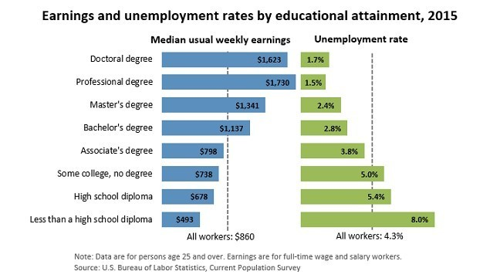

Bureau of Labor Statistics. (2016, March 15). Earnings & Unemployment Rates by Educational Attainment, 2015 [Digital image]. Retrieved April 10, 2017, from https://www.bls.gov/emp/ep_chart_001.htm

Analyze, by means of a production possibilities curve: trade-offs, opportunity cost, growth, and efficiency.
A production possibilities curve is an economic model used by economists to illustrate all possible combinations of efficient production available to an individual, firm, or country given the resources available to produce the two goods or services shown on the graph. The model shows the amount of one good or service sacrificed to produce additional units of the other good or service. The model also shows the production combinations that are inefficient or impossible given current resources. The example below demonstrates the analysis required.

Graph 1 | Graph 2 | Graph 3
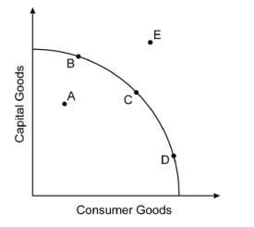 | 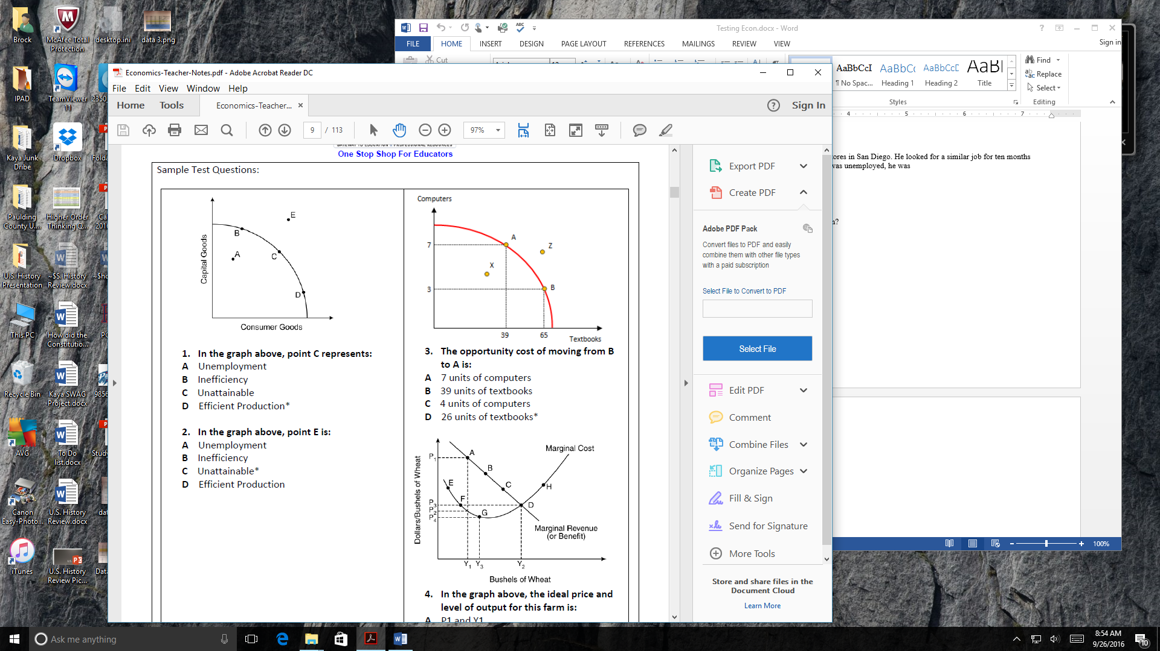 | 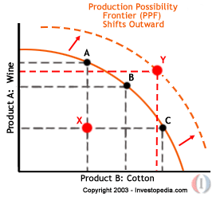

Reading the Production Possibilities Graph

On Graph 1, points B, C, and D indicate examples of trade-offs. A trade-off is any choice that could be made. Any point on the curve falls into this category.

On Graph 1, points B, C, and D indicate examples of efficient production combinations of capital goods and consumer goods. Any point on the curve falls into this category.

On Graph 1, point A is an example of an inefficient production combination of capital and consumer goods. This point also represents unemployed resources and/or recession in the economy. This combination is possible, but undesirable given underutilized resources.
On Graph 1, point E is an example of an unattainable production combination of capital and consumer goods because there are not enough factors of production to produce at this point.

Graph 2 shows the opportunity cost of choosing a particular combination of textbooks and computers over another possible combination. The opportunity cost of choosing point A over point B is 26 textbooks. The marginal benefit of moving from point B to point A is 4 computers. The opportunity cost of choosing point B over point A is 4 computers. The marginal benefit from point A to point B is 26 text books

Graph 3 illustrates economic growth on the production possibilities model. Curve shows the economy’s original efficient combinations of Wine and Cotton goods production. Curve shows the production possibilities curve for the economy following investment in physical capital and technology. For example, the U.S. economy experienced a shift outward like this after the construction of the interstate highway system in the 1950s. The interstate system was a government investment in physical capital that allowed more production of other capital goods and consumer goods. This happened because interstates made the transportation of inputs and outputs cheaper and faster for firms in the economy. Large-scale adoption of computers by industry in the 1990s would be another example of investment in physical capital and technology leading to economic growth

