International Economics 5.1

SSEIN1 Explain why individuals, businesses, and governments trade goods and services.

Define and distinguish between absolute advantage and comparative advantage.
A good way to think of Unit 5 is “macro-macroeconomics.” While microeconomics covers the interaction of a single market and macroeconomics views the larger national picture, international economics views an even larger picture: how the various national economies interact to form a world economy. The growth of massive multinational corporations is one sign that the world’s economy is becoming more interconnected each year. As national economies become more interconnected, international economic issues such as trade agreements and trade barriers become more important.

International trade allows a country to concentrate on what it does best and trade for what it can’t or doesn’t produce. In effect, trade allows a country to specialize in certain goods, which leads to more efficient production.

When a country has an absolute advantage over another country, it simply means that the country can produce more of a good than another country. Absolute advantage refers to an individual, firm, or country using the fewest inputs to produce the same amount of output or the individual, firm, or country producing the largest number of units of output given the same productive resources.

While large countries will probably have an absolute advantage in production over smaller countries, when any two countries are producing two goods (like cars and sugar), one country will always have a comparative advantage over the other in the production of one of the two goods. Comparative advantage in production of a good or service exists when one individual, firm, or country has the lowest opportunity cost for producing the good or service.

Explain that most trade takes place because of comparative advantage in the production of a good or service.
Most trade between counties takes place because of comparative advantages. The country with the lowest opportunity cost for producing a good or service should specialize in that good and then trade with another country for the other good. By producing those goods for which it has the lowest opportunity cost, countries can consume beyond the production possibilities of their own country. Specialization allows countries to allocate resources to their best possible use and creates greater economic efficiency.

Define balance of trade, trade surplus, and trade deficit
A country’s balance of trade refers to the value of its exports minus the value of its imports for measurable during a specific time. Remember, this is the calculation used to determine the value of the Net Exports component of GDP. If the value of a country’s exports exceeds the value of its imports, the country enjoys a trade surplus. If the value of a country’s exports fall short of the value of its imports, the country has a trade deficit.

SSEIN2 Explain why countries sometimes erect trade barriers and sometimes advocate free trade.

Trade Barriers limit the flow of goods, services, and productive resources between countries. Free trade refers to the unrestricted flow of goods, services, and productive resources between countries. While the field of economics generally regards free trade as positive for countries, specific political, ideological, and economic factors affecting a country may incentivize the erection of trade barriers.

Define trade barriers such as tariffs, quotas, embargoes, standards, and subsidies.
Trade Barriers are laws passed or actions taken by the government of a country with the intention of restricting the flow of goods and services between itself and another country or countries. Except for embargoes, the motivation for trade barriers is protection of a domestic industry or domestic jobs. The most common trade barriers are tariffs, quotas, embargoes, standards, and subsidies. A tariff is a tax placed on goods imported into a country. A quota limits the quantity of a good imported into a country. Embargoes completely ban trade with a country usually due to political disputes. Standards are requirements a good must meet before it can enter the country as an import. Subsidies are government payments transferred exporting companies allowing the companies to compete with other nations at the international market price without having to incur the costs associated with selling at the lower price.

Identify costs and benefits of trade barriers to consumers and producers over time.
When a country imposes trade barriers, some people benefit and others incur costs. A general concern about using any trade barrier is the possible retaliation of the other country. If a country decides to use a tariff, the benefits include providing revenue to the importing country’s government as it collects the tax and protecting the domestic producers of the good by effectively increasing the price of imported goods. Costs of tariffs include higher prices for consumers and inefficiently producing goods for which the country does not have a comparative advantage.

Quotas benefit domestic producers by limiting the number of foreign goods with which they must compete. The cost is that consumers who want the imported good cannot get it once the quota is met no matter how high a price they are willing to pay. The country’s resources are allocated toward goods for which it does not have a comparative advantage.

Embargoes are politically motivated. An embargo could successfully influence another country to behave according to the embargoing country’s wishes, benefitting the embargoing country. However, the individuals and firms in the embargoing country can no longer enjoy the goods the embargoed country produces and may encounter higher prices from less competition in the market. The individuals and firms in the embargoed country will incur significant costs without the economic activity with customers in the embargoing country.

By placing standards on a good, a country can exclude the goods of foreign producers who are unable to meet the
importing country’s requirements. When used appropriately, standards can benefit domestic consumers by protecting them from substandard or dangerous products. Some countries impose unattainable standards for foreign producers simply to force them out of the domestic market despite the products not posing any threat to domestic consumers. This hurts domestic consumers by increasing prices and hurts the foreign producer who has lost a market for the product.

Subsidies benefit domestic producers by allowing them to compete at the lower market price established by their foreign competition. This keeps prices low for domestic and foreign consumers, protects domestic jobs, and helps firms stay profitable. Subsidies damage industries and workers in other countries that would have a comparative advantage in production if the subsidy were not in place.

Describe the purpose of trading blocs such as the EU, NAFTA, and ASEAN.
Trading blocs refer to free trade agreements among countries in a region. The goals for trading blocs may include reducing or eliminating trade barriers, increasing specialization and efficiency in production, allowing free movements of workers within the bloc, establishing a common currency, and/or coordinating infrastructure projects to facilitate efficient trade among members. Three examples of trading blocs are the EU, NAFTA, and ASEAN. As of May 1, 2017, the European Union (EU) had 28 member countries. Some of the bigger EU countries are France, Germany, Spain, Italy and Luxembourg. Of the 28, 19 use the common currency the Euro and 26 enjoy the border-free movement of goods and people from country to country. Currently, the United Kingdom intends to leave the European Union within about two years. The North American Free Trade Agreement (NAFTA) is an agreement among the United States, Canada, and Mexico. This agreement allows for the free trade of many goods among the countries, encourages efficiency and specialization in production, and involves coordination among countries. NAFTA countries do not share a common currency or border free movement of goods and people. The Association of Southeast Asian Nations (ASEAN) is a trade bloc of 10 Southeast Asian countries. Myanmar, Thailand, Cambodia, Singapore, Vietnam, Indonesia and other countries make up ASEAN. Like the NAFTA countries, the ASEAN countries promote free trade, specialization, and coordination among members, but do not have a common currency or border- free travel.

World Trading Blocs
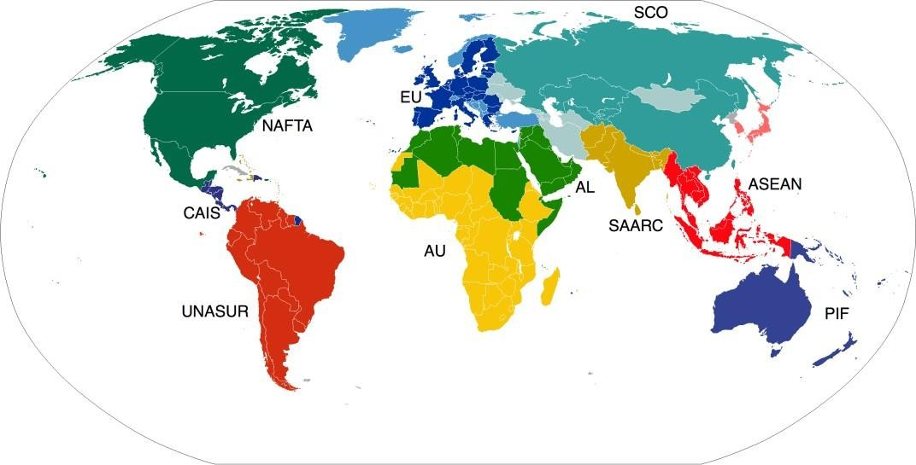

Evaluate arguments for and against free trade.
Arguments in Favor of Free Trade:
• Free trade increases competition, which reduces costs for buyers and improves quality of goods.
• Free trade allows for domestic goods to be sold all over the world and protects export industries.
• Free trade allows the country to exercise comparative advantage through specialization

Arguments against Free Trade, or Promoting Restricted Trade
• Infant industries (new industries in the early stage of development) are protected by trade barriers. This allows infant industries to grow.
• Free trade hurts domestic workers. Companies may move oversees to utilize cheaper labor and increase profits.
• Labor standards are not the same in all countries. Some countries may treat their workers poorly.
• Some industries are critical to the country’s national security. These industries should be protected even if they cannot compete internationally.

SSEIN3 Explain how changes in exchange rates can have an impact on the purchasing power of groups in the United States and in other countries.
An Exchange Rate refers to the price of one country’s currency express in terms of another country’s currency. Anyone buying products from another country, selling products to people in other countries, traveling to other countries, or depending on travelers from other countries cares about changes in the exchange rate. For people to do business with people in other countries, they must acquire the currency accepted by people in those countries. As the price of a currency rises and falls relative to another currency, people who buy, sell, and earn in that currency will experience a change in how much of the other country’s currency they can buy.

Define exchange rate as the price of one nation’s currency in terms of another
nation’s currency.
An Exchange Rate refers to the price of one country’s currency express in terms of another country’s currency. For
example, on April 27, 2017, the price of one dollar expressed in euros was .92 euros.

Interpret changes in exchange rates, in regards to appreciation and depreciation of
currency.
Most exchange rates between currencies fluctuate based on supply and demand. The terms appreciation and depreciation describe changes in the value of one currency in terms of another. Appreciation refers to an increase in the value of a currency relative to another. Depreciation refers to a decrease in value of one currency relative to the other. In the table below shows the price of the U.S. dollar expressed in terms of other currencies for Year 1 and Year 2. In Year 1, a dollar cost .49 pounds. In Year 2, a dollar cost .52 pounds. Since the dollar was more expensive for people holding British pounds in Year 2 than in Year 1, the dollar appreciated against the pound. In Year 1, a dollar cost 5.17 Danish krone. In Year 2, a dollar cost 4.83 krone. Since the dollar cost less for people holding Danish krone in Year 2 than in Year 1, the dollar depreciated against the krone.
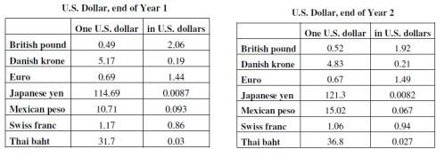

Explain why some groups benefit and others lose when exchange rates change.
When a country’s currency appreciates against another currency, it means those who hold the appreciated currency can
buy more of the other country’s currency. If a country’s depreciates, those who hold the depreciated currency can buy less of the other country’s currency. For example, assume the United States and Japan are trading partners. Due to the popularity of Japanese Anime in the United States, people in the U.S. demand for yen because they need Japanese currency to buy Japanese goods. As the demand for yen rises, the yen appreciates in the foreign exchange market. The higher price of yen will make Japanese goods more expensive for U.S. consumers and Japanese exports to the United States will decrease. However, the higher value of the yen will allow people in Japan to import more goods, more cheaply from the United States. Therefore, while the appreciation of the yen hurts Japanese exporters, U.S. exporters to Japan benefit from the increased Japanese consumption of U.S. goods. U.S. tourists visiting Japan are harmed by the increased price of the yen, but Japanese tourists coming to the U.S. are helped because they can buy more.

