Microeconomics 3.1
SSEMI1 Describe how households and businesses are interdependent and interact through flows of goods, services, resources, and money.
a. Illustrate a circular flow diagram that includes the product market, the resource (factor) market, households, and firms.
- What are the two main sectors of the economy?
- _________________________ need businesses to purchase ______________________ from them in exchange for _________________ and to make goods and services for the households to purchases.
- Businesses need ______________________ to sell their resources to firms so they will have the _______________________ required to make ________________and _____________________.
- _______________________ need households to purchase the goods and service they produce so the business can take in _________________________ (price times the quantity sold) and return a ________________ to the entrepreneur(s) who own the business.
- Businesses use __________________ to pay households for their ___________________ and households use the money they earned as ______________________ to purchase goods and services.
- Define Economic Interdependence (BL)
- Define factor or resource market (BL)
  - Where households are owners of _______________________________
  - Where business are the consumers of _________________________________
- Define product market(BL)
  - Where households are consumers of ________________________________ in the circular flow model
  - Where business are the producers of _________________________ in the circular flow model
b. Explain the real flow of goods, services, resources, and money between and among households and firms.
- What flows from business to the factor or resource market?
- What flows from households through the resource market to the business?
- Give example of a factor or resource market (PL)
- Spending flows from households to the ___________________________becoming the revenue that flows from the product market to the ___________________________.
- Give example of a product market(PL)
- Identify (DRAW and LABEL) the flow of goods and services between individuals and businesses on a circular flow diagram(DL)
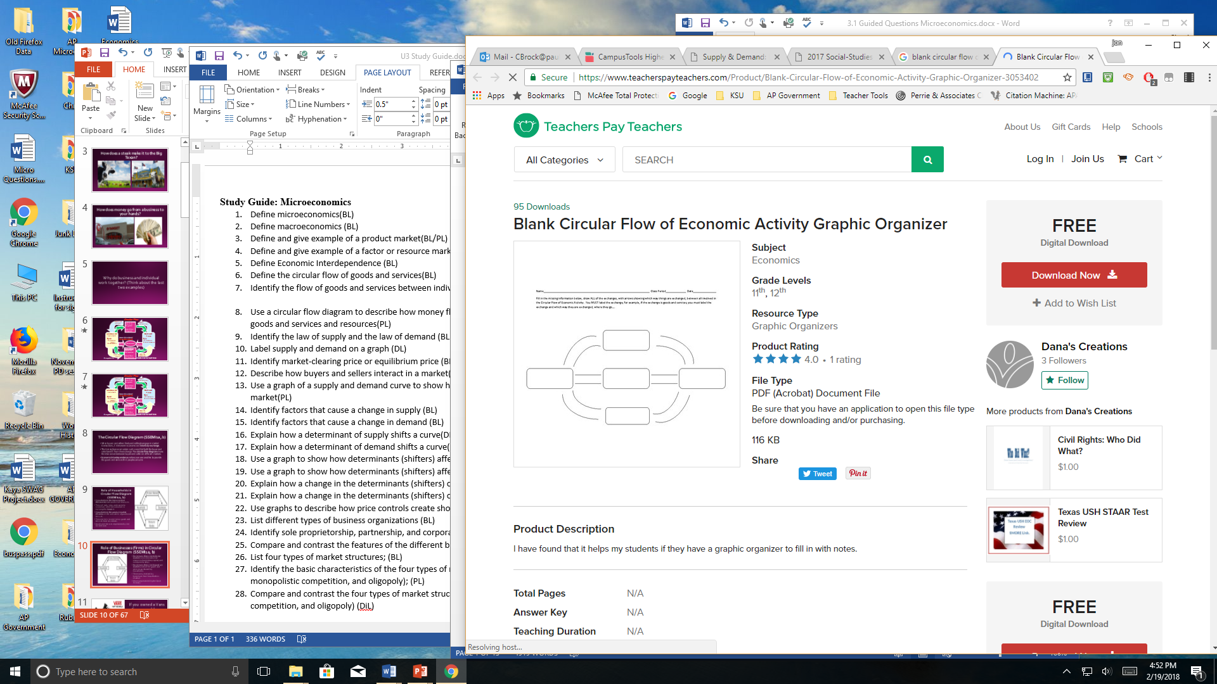
SSEMI2 Explain how the law of demand, the law of supply, and prices work to determine production and distribution in a market economy.
- Define demand
- Define supply
- What is the market equilibrium price
- What sends a signal to buyers and sellers about how much they should be willing and able to buy and sell?
a. Define the law of supply and the law of demand.
- Define law of supply (BL)
- Define law of demand (BL)
b. Distinguish between supply and quantity supplied, and demand and quantity demanded.
- Define quantity supplied
- Using the supply schedule, what happens quantity supplied as the price goes up? (Quantity Supplied Does Down, Quantity Supplied Goes Up)
- Defined quantity demanded
- Using the demand schedule, what happens quantity demanded as the price goes up? (Quantity Demanded Does Down, Quantity Demanded Goes Up)
- Draw and label supply on a graph (DL)
- Draw and label demand on a graph (DL)

Supply Curve | Demand Curve

c. Describe the role of buyers and sellers in determining market clearing price (i.e. equilibrium).
- The market clearing price is also the point at which the quantity demanded by consumers is equal to the quantity supplied by producers.
- How do buyers help determine price?
d. Illustrate on a graph how supply and demand determine equilibrium price and quantity.
- Draw and label the market-clearing price or equilibrium price graph (BL/PL)
Market Clearing Price (Equilibrium) Graph

