Microeconomics 3.1
SSEMI1 Describe how households and businesses are interdependent and interact through flows of goods, services, resources, and money.
a. Illustrate a circular flow diagram that includes the product market, the resource (factor) market, households, and firms.
Within an economy, there are sectors that have specific roles to play in economic activity. These sectors depend upon each other to play each role effectively. The two main sectors are households and businesses (firms). Households need businesses to purchase resources from them in exchange for income and to make goods and services for the households to purchases. Businesses need households to sell their resources to firms so they will have the inputs required to make goods and services. Business need households to purchase the goods and service they produce so the business can take in revenue (price times the quantity sold) and return a profit to the entrepreneur(s) who own the business. Businesses use money to pay households for their resources and households use the money they earned as income to purchase goods and services.

The Circular Flow Diagram is a model economists use to show the characteristics of and relationships that exist between households and businesses in the economy. The Circular flow charts shows economic interdependence. Economic Interdependence is when business and individuals work together to meet the needs of society
Households, in the Resource Market (factor market), are the owners of the productive resources (factors of production) in the circular flow model. They sell their land, labor, capital, and entrepreneurship to businesses (firms) in the Resources Market in exchange for income payments.
Households, in the Product Market, are consumers of goods and services in the circular flow model. They buy goods and services from businesses. They spend the income they earned in the Resource Market to buy these goods and services. Consumer “expenditures” is a fancy word for spending.
Businesses (firms) in the Resource Market are the consumers of the productive resources (factors of production) in the circular flow model. They purchase the use of land, labor, capital, and entrepreneurship from households in the Resource Market (Factor Market) using the revenue they earned in the product market.
Businesses (firms) in the Product Market are producers of goods and services in the circular flow model. They sell goods and services to households. They earn revenue in exchange for their goods and services. EXAMPLE: Walmart, Kroger, Home Depot

b. Explain the real flow of goods, services, resources, and money between and among households and firms.
In the circular flow diagram below, businesses and households are the sectors of the economy located across from each other on the diagram. The resource and product markets are also located opposite from each other on the diagram. In between the sectors and markets, there are flows of goods and services, resources, and money payments.

The Circular Flow Chart
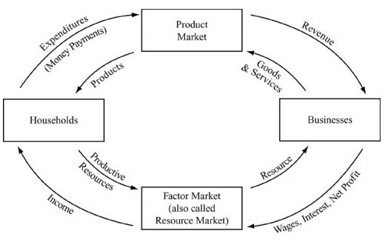
Businesses need productive resources in order to produce goods and services. They go to the factor or resource market to buy productive resources from households. Wages, interest, rent, and profit flow from businesses to the resource market, becoming the flow of income from the resource market to the households. Land, labor, capital, and entrepreneurship flow from households through the resource market to the businesses. EXAMPLE: Unemployment Office
On the other side of the diagram, households use their income for spending or “expenditures” in the product market. Spending flows from households to the product market becoming the revenue that flows from the product market to the businesses. Goods and services flow in the opposite direction from businesses to households through the product market.
It is important to note that the arrows on the inside of the diagram all flow in the same direction, making a circle. This is true for the arrows on the outside too which flow in the opposite direction from those on the inside. On the example diagram shown, notice that the inside circle flows are goods, services, or resources and the outside circle flows are all money payments.

SSEMI2 Explain how the law of demand, the law of supply, and prices work to determine production and distribution in a market economy.
In a market economy, consumers decide what to produce, firms decide how to produce, and the price system decides who will get the items produced. Consumers of goods, services, and resources behave according to the law of demand. Demand is the quantity a consumer is willing and able to purchase at each price. The law of demand says that as the price of a good rises the quantity of the good consumers are willing and able to buy will decrease. Supply is the quantity a seller is willing and able to sell at each price. The law of supply says that as price rises the quantity a seller is willing and able to sell will increase. A market or equilibrium price is one where the quantity of a good that buyers are willing and able to buy matches the quantity of a good that producers are willing and able to sell. As the market/equilibrium price in the market changes, it sends signals to buyers and sellers about much they should be willing and able to buy and sell.

a. Define the law of supply and the law of demand.
The law of supply says that as price rises the quantity a seller is willing and able to sell will increase. The graph below illustrates this law.

The law of demand says that as the price of a good rises the quantity of the good consumers are willing and able to buy will decrease. The graph below illustrates this law.

b. Distinguish between supply and quantity supplied, and demand and quantity demanded.
The market supply curve refers to all the quantities of a good, service, or resource sellers are willing and able to sell at each price. The quantity supplied is the amount of a good, service, or resource sellers are willing and able to sell at one specific price. In the graph below, the quantity supplied at a price of $1 is 100 units of the good. The market supply includes the quantities supplied at $1, $2, $3, and all other prices found along the curve. The table in the example below is the Supply Schedule and provides the data you use to create a supply curve
Supply Schedule | Supply Curve
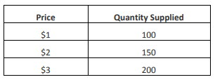 | 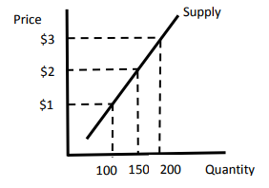

The Market demand curve refers to all the quantities of a good, service, or resource buyers are willing and able to buy at each price. The quantity demanded is the amount of a good, service, or resource buyers are willing and able to buy at one specific price. In the graph below, the quantity demanded at a price of $1 is 200 units of the good. The market demand includes the quantities demanded at $1, $2, $3, and all other prices found along the curve. The table in the example below is the Demand Schedule and provides the data you use to create a demand curve.
Demand Schedule | Demand Curve
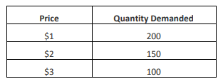 | 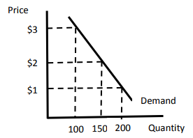

c. Describe the role of buyers and sellers in determining market clearing price (i.e. equilibrium).
The market clearing or equilibrium price is the point of intersection between the market demand curve and market supply curve. The market clearing price is also the point at which the quantity demanded by consumers is equal to the quantity supplied by producers. Buyers help determine this price by buying a smaller quantity of a good when they view the price charged by sellers as too high. Sellers respond by lowering the price. When buyers perceive a price as lower than equilibrium price, they will buy all of the available items as quickly as possible. Sellers will notice they are having trouble keeping the item in stock or lack the capacity to provide as many services as consumers want. Sellers will raise the price of the product. Through these interactions between buyers and sellers, price will work its way toward equilibrium.

d. Illustrate on a graph how supply and demand determine equilibrium price and quantity.
Market Clearing Price (Equilibrium) Graph
