Personal Finance: 2.1

SSEPF1 Apply rational decision making to personal spending and saving choices.
A rational decision making model refers to a process individuals, firms, and governments use to evaluate the costs and benefits associated various options when making a choice. The model consists of the possible options evaluated against a set of desirable criteria identified by the decision maker who chooses the option most closely aligned to the criteria. Two life choices demanding a rational decision making model include major spending decisions and major saving decisions.

a. Use a rational decision making model to evaluate the costs and benefits of post-high school life choices (i.e., college, technical school, military enlistment, workforce participation, or other option).
All high school students choose a post-high school path. Using a rational decision making model makes the costs and benefits of this choice easier to evaluate. For example, a hypothetical student chose his or her own criteria and assigned a score based on his or her own research. The student also should chose the weights for the criteria according to his or her own values and priorities. The results will vary greatly from student to student. Some students will choose to improve his or her potential earning by pursuing college, technical school, military enlistment, and workforce participation.

b. Create a budget that includes a savings or financial investment plan for a future goal.
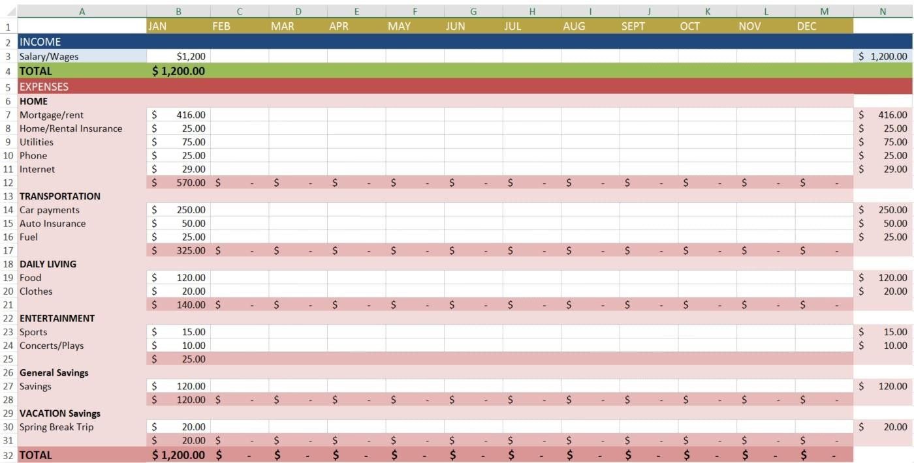
A budget is a document listing all the income a person makes each monthly and the expenses a person must pay each month. A budget allows people to make a plan for the money they earn, keep track of their spending, and plan for future expenses. The original template contained additional categories and was modified to reflect the expenses of a hypothetical college student. As you can see the student has budgeted 10 percent of income for general savings to use in case of unexpected expenses and has a specific savings goal category, his or her spring break trip.

SSEPF2 Explain that banks and other financial institutions are businesses that channel funds from savers to investors.
Banks and other financial institutions are businesses. Like other businesses, banks must be profitable to operate. While banks collect revenue from a variety of activities, their traditional source of revenue comes from their role as a financial intermediary. This means taking the deposits from one group of customers and loaning a portion of deposits to other customers. Banks make revenue by charging borrowers a higher rate of interest than they are paying to depositors. This is called the “spread”.

a. Compare services offered by different financial institutions, including banks, credit unions, payday lenders, and title pawn lenders.
There are many types of financial institutions and they offer a variety of services. Potential customers must compare services to determine which option fits their needs. The financial institutions detailed in this course include banks, credit unions, payday lenders, and title pawn lenders.
Bank—For most consumers, banks provide a safe means to store earnings. Typically, banks also offer direct deposit (where a person’s paycheck goes directly into his or her account), check-writing services, debit and credit cards, loans of all sorts (personal, home equity, business), and a host of other services.
Credit Union—Credit unions provide services similar to a bank; the main difference is that a credit union only provides these services to its members. Members own and control the institution. Credit unions often offer higher interest rates on deposits and lower interest rates on loans than banks.
Payday Loan Company—Suppose you need $50 on Wednesday but won’t get paid by your job until Friday. To solve this temporary problem, a payday loan company will give out small loans in return for a portion of the upcoming paycheck. This means the person will get $50 on Wednesday, but come Friday, $55 of his or her paycheck will go to the payday loan company. Payday loan companies generally charge much higher interest on loans than other institutions.
Title Pawn Lender – Title pawn lenders provide short-term loans to individuals facing a gap between their income and expenses. Usually, those accessing loans through title pawn lenders lack access to other types of short-term loans like credit cards. Title pawn lenders make loans based on an individual’s collateral. Collateral is an item of value one owns like a car. Lenders can sell the collateral to cover the value of an outstanding loan if the borrower cannot repay. Like payday loans, the fees associated with title pawn loans are usually much higher than those a bank would charge. In the case of title pawn loans, the inability to repay the loan could result in the loss of the vehicle put up as collateral.

b. Explain reasons for the spread between interest charged and interest earned.

Commercial banks, and other financial institutions offering loans, are businesses. They must make a profit if they expect to continue operating. One primary way banks make profits is by taking the money deposited by bank customers and loaning out a portion to people who want to borrow. By charging interest on the loans, banks make money. The more money on deposit, the more loans they can make, which is why some banks offer very generous checking account services. The interest on the loans is always more than the interest paid out to depositors. If banks did not have this “spread” between interest earned and interest charged, they would go out of business very quickly. NOTE: As provisions of the Glass-Steagall Act have eroded, commercial banks have increasingly added very lucrative investment banking services to the traditional role of taking deposits and making loans. Banks also earn interest on required and excess reserves they deposit with the Federal Reserve.

d. Evaluate the risk and return of a variety of savings and investment options, including: savings accounts, certificates of deposit, retirement accounts, stocks, bonds, and mutual funds.

Five Saving and Investment Strategies

Savings Accounts - Savings accounts are bank accounts in which people put savings to which they need easy access. The Federal Deposit Insurance Corporation (FDIC) most types of bank deposits up to $250,000. There is virtually no risk that the depositor will lose his or her money. The only risk comes from inflation risk. This means that the interest earned on the savings is less than the rate of inflation. Therefore, money held in a very low interest savings account is likely to erode in value over time. Since savings accounts are very low risk, the rate of return is very low as well. Most bank pay less than 1% interest on savings.
Certificates of Deposit – Certificates of Deposit (CDs) are products offered by banks. Buying a CD means you will earn a higher rate of return than on a regular savings account. The higher rate of return results from the saver agreeing to keep the funds in the CD for a specified period, usually between 1 months to 10 years. The longer the period, the higher the interest rate. People who save in CDs and need to withdraw their funds early will pay a fee for early withdrawal.
Retirement Accounts – Saving for retirement is a key goal for many people in the United States. Very few employers offer traditional defined benefit pensions and most retirees will need to live off their savings to maintain their standard of living. There are a number of retirement account options for workers. The most common account is a 401K. This is provided through an employer which will sometimes offer a percentage of matching funds. Individuals can also establish their own Individual Retirement Accounts through an investment bank. They usually have a choice between a Roth IRA and a traditional IRA. Roth IRAs allow contributors to pay taxes today and withdraw the funds they contributed tax-free
in the future. The contributor will still have to pay taxes on any “gaines” they withdraw from their account in retirement. A traditional IRA allows contributors to put money away before taxes are paid. The taxes are paid on the money when it is withdrawn during retirement. All of these retirement account options offer portfolios with mixed investment options. People can chose high risk, high return stock funds or low risk, low return bond funds. Finally, the U.S. government has a program called MyRA for workers whose employers do not have a 401K. It allows workers to contribute up to $15,000 before having to roll it over into an account with an investment bank. The funds can be withdrawn as needed without penalty and are guaranteed by the U.S. government, causing the return to be small.
  - Treasury Bonds – Purchasing a U.S. Treasury Bond means you have loaned the U.S. government money. The government pays you a guaranteed rate of return. Since the U.S. government repays its debts, the rate of return is low. For example, the interest rate on a 5-year treasury bond on April 27, 2017 was 1.822%. The interest rate on 10-year treasury bonds was 2.3%. Bonds are safe but also carry an inflation risk if interest paid is not higher than the inflation rate.
Stock Mutual Funds – While individual company stock is relatively risky, many people choose to play the stock market by purchasing mutual funds. Mutual funds provide more protection against loss because the investment is spread across many different companies rather than just one company. You may also select funds that reflect specific levels of risk or your values. Long term mutual fund investing tends to give a greater return in the stock market than short-term investing. Over a 20- year period, the stock market returns on average 7-8%. However, when holding stocks for only 5 to 10 years, the average rate of return drops to 1- 2%.

Stock – Purchasing stock of individual companies is one of the more risky ways to invest. When purchasing stock in large stable companies (blue chip stocks), your investment could be safer, but your rate of return is likely to be lower. With stocks, if you invest in companies with a shorter history or a brand new product, the potential return is generally high if the company succeeds, but you are much more likely to lose your investment because of the high rate of new business failures.

c. Give examples of the direct relationship between risk and return.
The risk in an investment is what you could lose and the reward is what you could gain. The relationship between risk and return is that the higher the potential return offered by a savings or investment opportunity, the more risky the savings or investment usually is. Therefore, if someone offers a 20% return and no risk, the person is most likely not being very honest.

SSEMA1 Illustrate the means by which economic activity is measured.

Give examples of who benefits and who loses from unanticipated inflation.
One of the reasons price stability is good for an economy is that it allows households, firms, governments, and the financial sector to make decisions in the present with confidence about the price level in the future. Inflation is the overall rise in prices in the market. Two groups with an eye on changes in the price level are borrowers and lenders. Households, firms, governments, and financial institutions act as borrowers in the economy. Households take loans for major purchases like cars, college, and homes. Firms borrow to cover expenses in difficult times and to expand operations when the future looks bright. Governments borrow to fund shortfalls in tax revenue needed to provide public goods and services to citizens. Even financial institutions borrow overnight funds to cover their reserve requirements and take longer-term loans to fund expansion projects. All of the sectors act as lenders too. Anyone who holds a bond has lent funds to one of these sectors. Households, businesses, and banks lend to government when they buy Treasury or Municipal bonds. They lend to businesses when they buy corporate bonds. The price of borrowing money is the interest charged over the life of the loan. When lenders make a loan, they agree to a price for the loan. When making loans at fixed rates, an unanticipated rise in price level by more than the lender anticipated hurts the lender since the money repaid will have less purchasing power. Unanticipated inflation hurts lenders who lend at fixed rates. Borrowers who borrow at fixed rates will benefit from unanticipated inflation. Their interest rates remain stable as price rise and they pay back their loan with money that has less purchasing power than the money they borrower

SSEPF4 Evaluate the costs and benefits of using credit.
Credit refers to borrowing money. People borrow money for a variety of reasons. When considering a loan, borrowers identify the benefits and the cost of using credit. If the benefits of using credit outweigh the costs, taking a loan is rational. If the costs of borrowing outweigh the benefits, the loan should be avoided.

a. Describe factors that affect credit worthiness and the ability to receive favorable interest rates including character (credit score), collateral, and capacity to pay.

As a rule, we should spend only what we earn and avoid borrowing. However, some purchases are very difficult to make without the use of credit and the benefits of making those purchases using credit may outweigh the costs in the long- run.
For example, if someone cannot go to college without a student loan, the higher future income potential and lower risk of unemployment may make the student loan a wise idea. If someone lacks a reliable car to get them to a great job, the benefits of a low-interest car loan may outweigh the costs because of the higher income earned at the new job.
The key is to be wise in borrowing. Do not borrow more than you need and make sure the payments are affordable given your income. If you want to secure a loan from a financial institution like a bank, your credit rating must be good. Credit worthiness is a measure of a variety of factors used to determine whether a person will repay a loan. While there is no guarantee a person making $400,000 annually will pay a $2,000 loan, evaluation of their credit worthiness indicates they have the income required to handle the loan. Annual earned income is a major factor in determining credit worthiness. If income is high, lenders believe the borrower can use some of that income for debt repayment.
However, the amount of current debt is another big factor affecting credit worthiness. Making $400,000 a year is less attractive to lenders if you already owe $500,000.
The “Three C’s of Credit” are character, capacity, and collateral. Since most lenders do not know potential borrowers personally, they evaluate a potential borrower’s character using the information on the borrower’s credit report. A credit report is available through three main private companies: Transunion, Equifax, and Experian. It details a person’s borrowing and repayment history for the last seven years reported to the company’s by a person’s previous and current lenders. Potential lenders request credit reports on potential borrowers to assess the borrower’s character and capacity.
A potential borrower who has “paid as agreed” on all credit accounts has good credit character. The credit report also shows some aspects of capacity. While income is one factor in assessing capacity, the amount it takes to service current debt is also a concern. If debt to income ratio is high, the borrower may not be able to handle additional debt payments.
Finally, collateral is something of value a borrower can use to back the loan if the borrower can no longer pay the scheduled payments. For example, a home mortgage is available to people with lower incomes because the bank can seize the home if the mortgage is not paid.
Many people obtain a credit card to start building a positive credit history. To get low interest rates for borrowing and sometimes even to get a job, people need a good credit report and good credit score. In some cases, no credit history affects people negatively just as a poor credit history does. A credit score is a number calculated by the credit reporting companies based on a variety of factors. While the exact calculation is proprietary, the companies release general guidelines about how the score is calculated. Payment history, amount of open credit used, and the number of open credit accounts are some of the factors determining a credit score. By making small purchases and paying the entire amount each month, a potential borrower shows a lender how they use credit wisely. The image below shows a general breakdown of a credit score.
Using credit wisely and sparingly is essential to a healthy financial life. Some people find they are unable to make wise credit use decisions. Using credit cards impulsively, some find they are unable to pay the entire amount owed month and begin to accrue high amounts of interest on the unpaid balance. As the balance owed increases, it takes years to pay the loan for a small purchase. If borrowers have late payments, interest rates skyrocket and lenders charge late fees. Current law requires credit card companies to show borrowers the difference in total payments they will make if they pay only the minimum payment due versus paying the debt within three years.

