Where are the Climate Regions?

Directions:
On the provided world map, color Vladimir Koppen’s Climate Regions. Make a key on the bottom to indicate which climates coincide with each color.

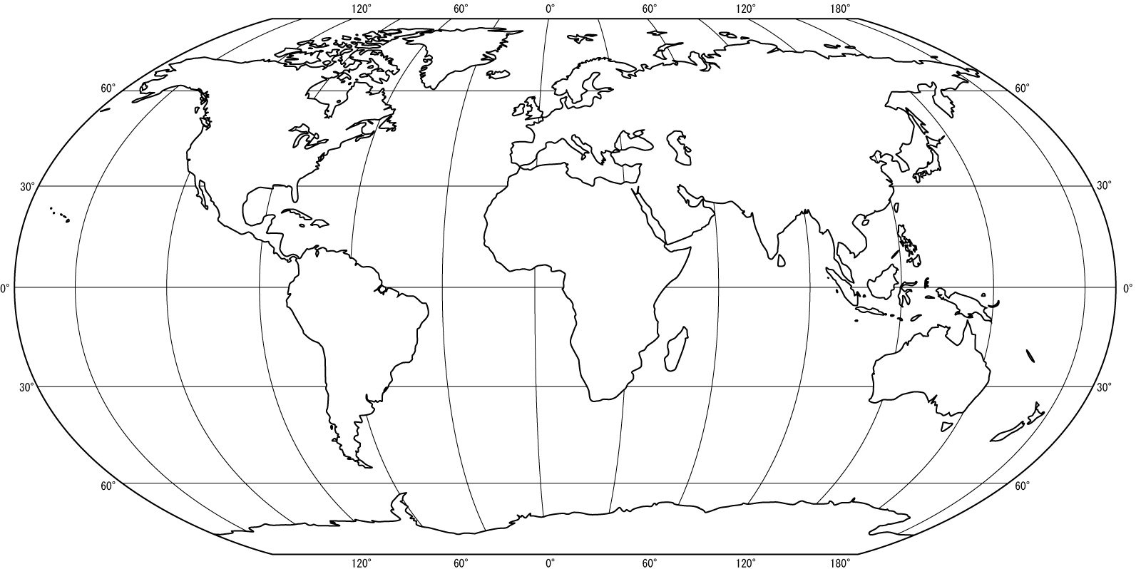
Where are major Biomes of the world?

Directions:
On the provided world map, color the Robert Whittaker’s Riome regions. Make a key at the bottom to indicate which biome coincides with each color.

Whittelsey’s Agricultural Regions: Where are Agricultural Regions in More Developed Countries?

Directions:
On the provided world map, label the following types of commercial agriculture found in MDCs:

- Mixed crop and livestock farming
- Dairy farming
- Grain farming
- Livestock ranching
- Mediterranean agriculture
- Commercial gardening and fruit farming
- Plantation farming

After labeling the above on the world map, write a brief description of each type of commercial agriculture. Be sure to include an explanation of the type of climate needed for the above activities; briefly explain the reason for the spread of this type of activity and the impact this activity has on the environment..

Whittelsey’s Agricultural Regions:Where are Agricultural Regions in Less Developed Countries?

Directions:
On the provided world map, label the following types agricultural activities found in LDCs:
- Shifting cultivation
- Pastoral nomadism
- Intensive subsistent agriculture
After labeling the above on the world map, write a brief description of each type of agricultural activity. Be sure to include an explanation of the type of climate needed for the above activities; briefly explain the reason for the spread of this type of activity and the impact this activity has on the environment.

Conclusion: When you are done, argue how Whittlesey’s Agricultural Regions map is evidence for possiblism or environmental determinism.

