State Shapes
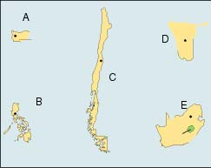
Name _____________________________________

- Name the type of state represented by each letter

- ___________________________________
- ___________________________________
- ___________________________________
- ___________________________________
- ___________________________________

Directions: Use the internet, or one of the geography book in class, to look up each country to determine the type of state each of these countries may be (some may have more than one, list all). For 1 example of each different type explain what this means in terms of their internal communication and relationships with other states.

- Afghanistan
- Azerbaijan
- Bhutan
- Greece
- Italy
- Kenya
- Malawi
- Mexico
- Norway
- Democratic Republic of the Congo

- Sierra Leone
- Slovakia
- Swaziland
- Turkey
- Uganda
- United Kingdom
- United States
- Vatican City
- Vietnam

