Territorial Morphology and Boundary/Security Issues
Introduction

Territorial morphology is a geopolitical term for the shapes of states which can be categorized as compact, prorupt, elongated, fragmented, and perforated (Figure
1). Compact states have a round shape and therefore enclose the maximum area with the minimum perimeter. Prorupt states have an extension or extensions out from an otherwise compact shape. Elongated states have a much longer length than width. Fragmented states consist of at least two non-contiguous territories. Mainland-mainland, mainland-island, and island-island represent the potential geographic combinations of fragments. Perforated states enclose or surround another state or states. There are numerous “real world” examples suggesting a correlation between shape and border tensions.

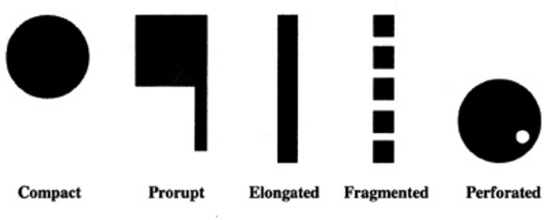
Figure 1. State Shapes

Learning Activity
1) Access one of the reference maps: http://www.worldatlas.com/aatlas/world.htm, or http://www.infoplease.com/atlas/mapindex.html. Click on “Africa” to view the political map.
2) Indicate the most appropriate shape(s) that describes the countries listed in
Table 1. More detailed (larger scale) maps are available by clicking on the
countries in the Africa political map.
State | Shape
1) Angola
2) Botswana
3) Dem. Rep. of Congo
4) Malawi
5) Mozambique
6) Namibia
7) Zambia
8) Zimbabwe
Table 1. State Shapes of Central and Southern Africa
3. Navigate to the International Boundary News Database https://www.dur.ac.uk/ibru/news/. Retrieve database records using country names as search terms. For example, enter the search terms <Botswana Namibia>, check “Search Boundary Field only,” and “Search.” The search results will include boundary-related news reports spanning the last decade. Run additional searches for all countries sharing international boundaries, sometimes this is given if you just search the country you are searching. Examine the search results for reports suggesting a possible linkage between a state’s shape and boundary and security issues. Focus on those news records that suggest a possible connection between proruptions, fragments, or perforations with border incidents. Cut and paste or otherwise highlight records that illustrate the point that specific state shapes often contribute to border tensions. Using this set of records, proceed to item 4.

4. List some factors where specific state shapes contributed to or exacerbated border tensions. Record results in Table 2.
Shape | Border | Security Issue
Compact
Protruded
Elongated
Fragmented
Perforated
Table 2. Shapes and Boundary and Security Issues

