Chapter 7: Ethnicity Reading Guide
Rubenstein
Ethnicity: Key Issue 1
WHERE ARE ETHNICITIES DISTRIBUTED Rubenstein, pp. 206-217_______________
- DISTRIBUTION OF ETHNICITIES WITHIN THE UNITED STATES
1a. Define ethnicity:

1b. Define race:

1c. Ethnic identity is immutable. What does that mean? p. 208 intro
2.Below are 4 of the largest ethnicities found in the USA. Label the %.
Hispanics/Latinos | %
African Americans | %
Asian Americans | %
American Native Indians | %
3.Where are Hispanics/Latinos clustered?
- Identify the region of the USA:_________________
- 4 states of region above: __________, _________, ___________, ________
- 1/5 are found in _____________________________________
- 1/6 are found in ______________________ and ______________________
4.Where are African Americans clustered?
- Identify the region of the USA: _______________
- ¼ are found in 5 states:_________________________________________
- 1/3 in ______________
- Opposite, 9 states in upper _________ and _______ have less than 1%.
5. Where are Asian Americans clustered?
- Region of the USA:___________________
- 40% of population in ____________________.
- 1/2 of all Asians Americans live in _____________________ (12%)
- ¼ are _______________.
- 1/5 are __________________ and __________________
- 1/10th are ________________ and __________________
6. American Native Indians and Alaska Natives
- Contiguous 48 states have Native Americans in ____________ & _________
- Name 2 tribes of Alaska: ____________________ & ___________________ 3
7. Provide an example to illustrate that 90% of African-Americans or Hispanics in the USA are more urbanized (likely to live in cities than whites). p. 210

8. For descendants of Europeans immigrants in the USA, ethnic identify is more likely to be retained through 3 ways: ______________ ______________ ______________________
9. Complete the table below to summarize the historic migration patterns of African Americans.
Forced Migration from Africa | Migration to the North | Migration within cities(ghetto

- DIFFERENTIATING ETHNICITY AND RACE p. 213
10. What is the “problem” with the way the US Census Bureau defines “Asian”?

11. What is the difference between “African-American” and “black”?

12. How does the US Census Bureau consider Hispanic/Latino?

13. What is racism?
14. What is a racist?
15. Describe each of the following concepts dealing with the geography of race.
- Separate BUT Equal
- White Flight 4

- Blockbusting

16. According to the US Bureau of Census, there are ____ race identification for Americans.
Division by Race in South Africa
17. Define apartheid.

18. Complete the following timeline of South African history and explain why these dates are important.
- 1652:

- The Boers were:

- Afrikaans were:

- 1795:

- 1948:

- Afrikaners vowed_________________________________________________________
- South African government designed ten _________________________________.
- Why ten?

- 1991:

- 1994:

- Nelson Mandela became the first ______________________________________.
- In South Africa under apartheid, a newborn baby was classified as being 1 of 4 races:
- b. c. d.

- Although apartheid has been dismantled, there are 2 problems for the black majority:

WHY HAVE ETHNICITIES BEEN TRANSFORMED INTO NATIONALITIES? 1
Rubenstein, pp. 217-224________KEY ISSUE #2__________________________
1. Define nationality:

2. Though they are very similar, use the table below to show how nationality differs from ethnicity. (2nd paragraph of reading p. 217).
Ethnicity | Nationality
Rise of Nationalities p. 217 bottom

3. Define race:

4. Define nation-state:

5. Define self-determination:

6. Use the table below to note briefly how some European examples of nationalities dealt with the issue of statehood and the pursuit of the nation-state ideal. p. 217-218

Denmark | Germany
*  *  *  *  *  * | *  *  *  *  *  *

7. Define nationalism:

8. How do state/countries foster/promote nationalism? p. 219 top of page
a.
b.
c.

9. Define centripetal force: 2
10. Define centrifugal force:

11. The chart below will be filled out during class time with Mrs. Tweed and Mr. Long.
Centripetal Forces | Centrifugal Forces

12. Define multiethnic states:

USA is the largest multiethnic state.

13. Define multinational states:

14. Explain why the United Kingdom is a multinational state:

15. Explain why the Soviet Union was the largest multinational state before the collapse of Communism in 1989?

16. How many nation-states were formed after the fall of the Soviet Union? __ List the five groups below: p. 220
a. 3 Baltic:___________________________ d. 3 Caucasus:_______________________
b. 3 European: _______________________
c. 5 Central Asian: write below e. Russia (answer provided)

17. Explain why Russia is now the largest multinational state. p. 221 3

18. Why are independence movements flourishing in Russia?

19. Why would Russia not allow Chechyna to be independent? 2 reasons. p. 221
a.
b.

20. Note the major religion and language of each of these Baltic nation-states.
a. Estonia: ________________________ and ___________________________
b. Latvia: ________________________ and ___________________________
c. Lithuania: _______________________ and ___________________________

21. The ethnic divisions among the Eastern European states are blurred for what reasons?

22. Why has the Crimean Peninsula of the Ukraine been a problem? (esp. in 2014)

23. What did the majority of Moldovans want when they gained independence? Who opposed this?

24. In the Caucasus region, there have been problems with the new nations and ethnicities. Summarize the main problems and note specifics of regions and people.
AZERIS (Azerbaijan) | GEORGIANS (Georgia) | ARMENIANS (Armenia)
4 facts | 4 facts | 4 facts
Revival of Ethnic Identity p. 223-224
25. List 3 centripetal forces Communist Soviet Union used to keep ethnicities together?

26. Why is Slovenia a good example of a nation-state that was carved from the former Yugoslavia in the 1990s? p. 224
KEY ISSUE #3 Why Do Ethnicities Clash? 1
Rubenstein pp. 224-229 ________________________
Ethnic Competition to Dominate Nationality - Case Study of AFRICA
1. Label and shade in: Ethiopia, Eritrea, Sudan (N and S - look on Internet map), Somalia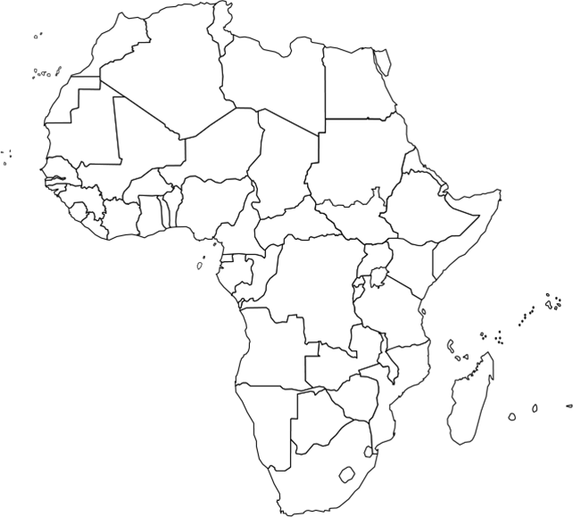
2. Explain the problems between Ethiopia and Eritrea.

3. Sudan is now divided into North and South. Our textbook is not current. Info will be provided by Mrs. Tweed/Mr. Long

4. Explain problems in Somalia. p. 225

5. Explain the ethnic competition in Lebanon.
Include info about Muslims, Christians, Maronite, Greek Orthodox, Shiite, and Druze.
Muslims/Shiite/Druze:

Christians/Maronite/Greek Orthodox: 2

6. How did Lebanon's 1943 constitution seek to solve the religion problem?
- the president:
- the premier:
- the speaker of the Chamber of Deputies:
- the foreign minister:
7. What was the agreement that ended Lebanon's civil war in 1990?
Diving Ethnicities Among more Than One state p. 226
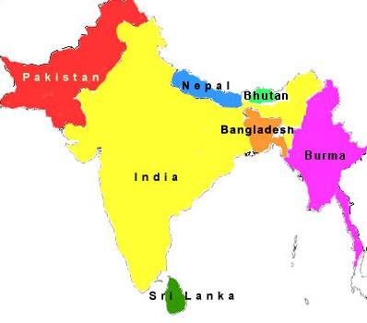
8. When the British ended colonial control of South Asia in 1947, what they did they do in the region?
a. politically?

b. ethnically (religiously)?

9. Forced migration followed in East and West Pakistan as well as India:
a. How many people found themselves "on the wrong side of the boundary" in the 1940s?
b. How many Muslims migrated from India to West Pakistan (Pakistan today)?

c. How many Muslims migrated from India to East Pakistan (Bangladesh today)?
d. How many Hindus migrated from East and West Pakistan into India? 3

e. What happened to many of the refugees as they traveled?

10. Why is the region of Kashmir a problem? p. 228
a. politically?

b. in terms of religion?

11. Turn to the Case Study: Dividing the Kurds p. 227.
a. Kurds are an example of____________________________________________

b. Where do they live?

c. What language?

d. Kurds are distinctive in ___________, ________________, _______________

e. The Kurds were once a nation-stated called ___________. Ended in 1923.

f. How many Kurds today? ____ million

g. List the countries where they reside and their population #
1.
2.
3.
4.
12. Explain the major conflicts between Sinhalese and Tamil in Sri Lanka - 6 main facts
a.

b.

c.

d.

e.

f.
My LDC country is what kind of state? ______________________________________ My MDC country is what kind of state? _____________________________________
Key Issue #4: What is Ethnic Cleansing? Europe and in Central Africa 1
Rubenstein pp. 229-235____________________________________________________

1. Define ethnic cleansing:

2. How is ethnic cleansing different from regular warfare?

3. When boundaries were redrawn in Europe after WWII, what was the effect on various ethnic groups?

Ethnic Cleaning in YUGOSLAVIA p. 229-230
4. List the countries of the Balkan Peninsula p. 230 at the bottom map. 8 of them.

5. Josip Tito was the iron dictator that keep Yugoslavia and all the ethnicities together.
a. List 5 nationalities:

b. List 4 languages:

c. List 3 religions:

d. List 2 alphabets:

e. List the 7 neighbors.

f. List the 6 republics within Yugoslavia:

6. What ethno-political problems did Yugoslavia face after the death of Tito in the 1980s and the fall of communism in the 1989/90?
a.
b.
c.

7. Why Did Serbs and Croats in Bosnia (now called Bosnia-Herzogovina) ethnically cleanse themselves of Bosnian Muslims?

8. What was agreed upon at the accords signed between these rival 2 ethnicities in Dayton, Ohio, in 1996?

9. Who got the best deal? The worst? Explain.

Ethnic Cleaning in KOSOVO p. 232
10. a. What country and ethnicity controls it today?

b. What ethnic group lives in Kosovo (and what %0)?

c. With the breakup of Yugoslavia, what began to happen in Kosovo?

d. How did the U.S. and United Nations respond?

11. What is the meaning of the terms:
balkanized:

balkanization:

12. Turn to pg. 234. Read the Caste Study: Documenting Ethnic Cleansing.
Explain the FOUR steps of ethnic cleansing.
a.

b.

c.

d.

3

