- What position did the U.S. take as conflict engulfed Europe during World War I?
  - sided with Germany
  - sided with Italy
  - declared war with Germany
  - remained neutral

- High casualties and poor morale in the Russian army led to
  - the defeat of the Bolsheviks.
  - restrictions on civil liberties in Russia.
  - Russia’s withdrawal from World War I.
  - the death of Czar Nicholas.

- Which empire was still intact after World War I?
- German
- British
- Ottoman
- Austro-Hungarian

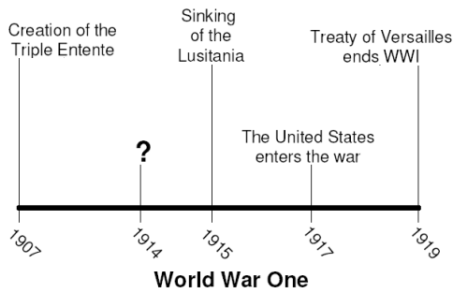

- Based on information in the timeline, which event correctly completes the timeline?
- First crisis in the Balkans
- Creation of the Triple Alliance
- Russia signs Treaty of Brest-Litovsk
- Assassination of Archduke Ferdinand

- Which statement best describes the relationship between the Russian Revolution and World War I?
- WWI restored confidence in the Czar, helping to end the Russian Revolution.
- WWI gave Russia’s army the experience to suppress the revolution.
- WWI created conditions within Russia that helped lead to a revolution.
- The Russian Revolution inspired its citizens and allies to win World War I.

- The man who succeeded Vladimir Lenin as the leader of Russia was
- Karl Marx.
- Joseph Stalin.
- Leon Trotsky.
- Adam Smith.

- Who were two major leaders during World War I?
  - Franklin D. Roosevelt and Harry Truman
  - Kaiser Wilhelm II and Woodrow Wilson
  - Harry Truman and Joseph Stalin
  - Nicolas II and George MacArthur

- Lenin’s promise of "peace, land, & bread” during the Bolshevik Revolution of 1917 was made in an effort
- to end France’s occupation of Russian territory.
- to restore Czar Nicholas back to the throne.
- to gain popular support to take control of the government.
- to resolve conflicts between the farmers and the ruling class.

- Which nation helped organize the League of Nations, yet was not a member?
- Italy
- United States
- Germany
- Austria-Hungary

- Which best identifies the major flaw in the League of Nations, leading to its failure?
- Signing of the Kellogg-Briand peace pact
- Germany’s admission to the League
- Renunciation of war by every country in the world
- Its inability to act as an enforcer because it had no armed forces

- What term describes a region of the Middle East controlled by victors of WWI?
- alliance
- mandate
- state
- reparation

- One reason the U.S. ended its policy of isolation and entered World War I was the
- fall of the Ottoman Empire.
- Japanese invasion of Manchuria
- truce between revolutionary Russia and Germany.
- unrestricted submarine warfare by Germany.

Causes | Results
No power to enforce decisions  United States did not participate | Failure

- What organization does this table describe?
  - Congress of Vienna
  - Continental Congress
  - Counter Reformation
  - League of Nations

- The Mandate System was established by the
  - Soviet Union
  - Ottoman Empire
  - Congress of Vienna
  - League of Nations
- A series of proposals for the Treaty of Versailles called the Fourteen Points was drawn up by:
  - George Clemenceau of France.
  - Woodrow Wilson of the United States.
  - David Lloyd George of Great Britain.
  - Vittorio Orlando of Italy.

- What was a major cause of World War I?
  - Rebellions in colonial lands of Africa and Asia
  - Expansion of communism into western Europe
  - Militarism in the nations of Europe
  - Inability of the League of Nations to keep the peace

- Growing nationalism and militarism in Europe and the creation of secret alliances were
  - reasons for the rise of democracy.
  - causes of World War I.
  - requirements for economic development.
  - reasons why European nations became imperialist.

- What was the goal of Lenin’s New Economic Policy (NEP)?
  - Force peasants to give their food to the communists
  - Allow capitalism in order to give incentives for food production
  - Rapidly industrialize Russia
  - Give free education to all citizens

- The leader of the Bolsheviks was
  - Vladimir Lenin.
  - Joseph Stalin.
  - Franz Ferdinand.
  - Tsar Nicholas II.

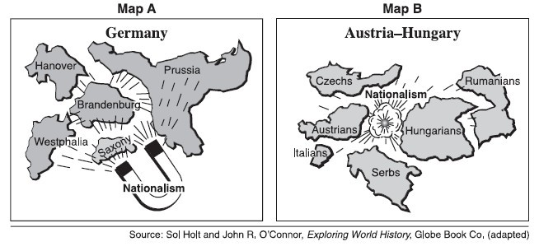
- ________________ was a powerful force in Europe in the 19th century as illustrated by the two maps.
  - Imperialism
  - Capitalism
  - Secularism
  - Nationalism

“If I should die, think only this of me: That there’s some corner of a foreign field, that is for ever England. There shall in that rich earth a richer dust concealed; A dust whom England bore, shaped, made aware, Gave, once, her flowers to love, her ways to roam, A body of England’s, breathing English air, Washed by the rivers, blest by suns of home…”
---Rupert Brooke, ‘The Soldier’

- Which idea is expressed in the excerpt of Brooke’s poem?
  - Isolationism
  - Nationalism
  - Pacifism
  - Secularism

- ___________________________
  - Formation of alliances
  - Conflict over peoples in Africa
  - Military build ups
  - Assassination of Archduke Ferdinand
- Which title would complete the above partial outline?
  - Scramble for Africa
  - Causes of World War I
  - Outcomes of World War I
  - Reasons for the Congress of Vienna

- Which provision was a part of the treaty that ended World War I?
- Appropriation of Britain’s colonies
- German payment of $32 billion in war reparations
- Demilitarization of France
- U.S. chartering of the League of Nations

- Which nation pulled out of the war in 1918 by signing the treaty of Brest-Litovsk with Germany?
- U.S.
- Great Britain
- Russia
- France

- Which term means "money paid for war damages"?
- Reparations
- Collective bargaining
- Credit
- Diplomacy

- Who became the “mandatory powers” in the Middle East?
- Germany and Russia
- United States and Great Britain
- Canada and Mexico
- France and Great Britain

- Which best identifies the major flaw in the League of Nations, leading to its demise?
- Kellogg-Brand peace pact
- Germany’s admission to the League
- renunciation of war by every country in the world
- inability to act as an enforcer because it had no armed forces
- What was the purpose of the Mandate System?
- Administer colonies of the defeated powers after WWI
- Unite nations
- Preserve peace in the Middle East
- Collect war reparations after WWI

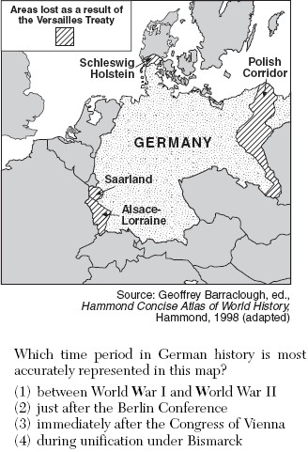
- Which time period in German history is most accurately represented on the map?
  - Between World War I and World War II
  - Just after the Franco-Prussian War
  - Immediately after the Congress of Vienna
  - During unification under Bismarck

Use this historical document to answer Questions 30 and 31:

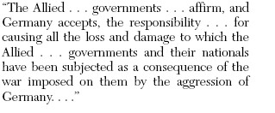
- What was a result of the provisions of this historical document?
  - Allied governments helped rebuild the German economy.
  - Resentments about the provisions contributed to the growth of Nazism in Germany.
  - The ideas in these provisions served as the basis for all future alliances.
  - The provisions resulted in lasting peace in Germany.

- This passage is taken from which historical document?
  - Charter of the League of Nations
  - Treaty of Versailles
  - Magna Carta
  - Edict of Nantes

- What event was the start of the worldwide depression of the 1930’s?
- Treaty of Versailles
- Stock Market Crash of 1929
- Dawes Act
- Election of 1928
- What was a cause of the worldwide depression after World War I?
- high protective tariffs
- failure of banks to expand credit opportunity
- low unemployment
- industry failure to produce enough supply to satisfy demand

“No country is exempt. The privation [hardship] and …anxiety which exists today in
millions on homes all over the world is extreme…probably 12 million industrial workers
stand idle.”--John Maynard Keynes

- The above quotation best describes the
- Stock Market Crash
- Great Depression
- Boxer Rebellion
- Bolshevik Revolution

- Why did Germany experience rapid inflation soon after World War I?
- Allies blockaded German ports.
- The Allies continued to occupy the western part of the nation.
- Germany had to pay high protective tariffs.
- Germany was required to make large reparation payments.

- What political changes resulted from the worldwide depression?
- rise of totalitarian dictatorships
- spread of democracy
- spread of isolationist policies
- increase in personal liberties

- Why did Adolf Hitler’s Nazi party receive support from the German people?
- It followed the provisions of the Treaty of Versailles.
- It advocated against anti-Semitism.
- It planned to create a more democratic government.
- It promised to improve Germany’s economy.

- During the interwar period, which Italian leader formed the Fascist party?
- Vladimir Lenin
- Victor Emmanuel
- Count Cavour
- Benito Mussolini

- Who was the prime minister of Britain during its battle with Germany?
- Neville Chamberlain
- George Marshall
- Winston Churchill
- Joseph Luftwaffe

- Which event brought the United States into World War II?
- Japanese bombing of Pearl Harbor
- British refusal to trade with United States
- Communist overthrow of Russian government
- German submarine attacks against United States shipping
- President _________ described December 7 as “a date which will live in infamy.”
- Harry Truman
- Dwight Eisenhower
- Franklin Roosevelt
- Theodore Roosevelt

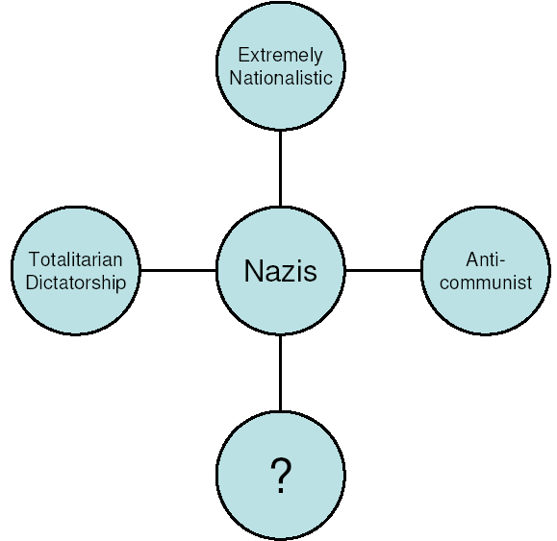
- Which of the following correctly completes the above chart?
- Anti-Semitic
- Tolerant
- Democratic
- Russian

- Which of the following is an incorrect match?
- Douglas MacArthur—U.S. General
- Hirohito—Japanese General
- Winston Churchill—British Prime Minister
- Adolf Hitler—Nazi Dictator of Germany

- What nation did Germany invade which ended the appeasement policies of Britain and France as they declared war?
- USSR
- Italy
- Belgium
- Poland

- Who made the decision to drop the bomb on Hiroshima and Nagasaki?
- Roosevelt
- Truman
- Eisenhower
- Churchill

- Despite a non-aggression pact, which nation did Hitler invade in 1941?
- Poland
- Britain
- U.S.
- USSR
- What was the Allied invasion to take back occupied France?
- Battle of Britain
- Attack on Pearl Harbor
- D-Day
- V-E Day

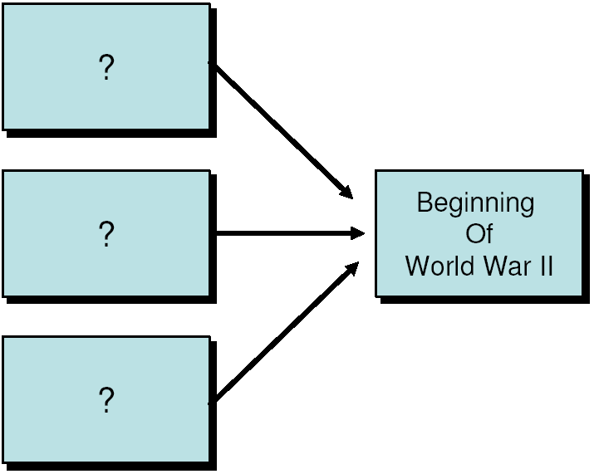

- Which statement does NOT accurately complete the above chart?
- policy of appeasement by the British and French
- aggressive German expansion into eastern Europe
- Germany successfully paid World War I reparation
- Japanese expansion through imperialistic policies

1. Atomic Bombs dropped on Hiroshima.
2. Allies invade Europe on D-Day.
3. British forces driven out of France.
4. Japanese attack Pearl Harbor.

- Which sequence shows the correct chronological order of the above listed World War II events, from earliest to latest?
- 1, 2, 3, 4
- 3, 4, 2, 1
- 2, 1, 4, 3
- 4, 3, 2, 1

- Which geographic factor played the greatest role in preventing Russia from being conquered by both Napoleon and Hitler?
  - Deserts
  - Rivers
  - Climate
  - Mountains

- The imperialist policies followed by Japan after World War I were based on a desire to
  - convert other Asians to their religion.
  - acquire markets for its oil industry.
  - compete with Chinese trade policies
  - obtain raw materials for manufacturing
- The systematic and purposeful destruction of a racial, political, religious, or cultural group is called
- enslavement.
- segregation.
- genocide.
- germ warfare.
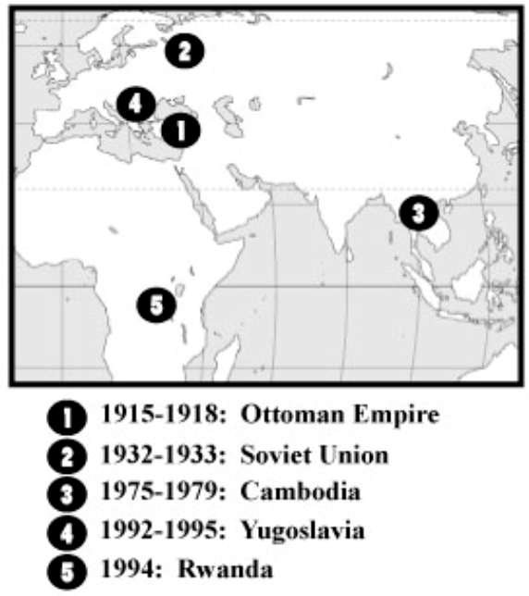
- What is the BEST title for the above map?
- 20th Century Communist Revolutions
- Locations of 20th Century Genocides
- Years Under the U.S. Marshall Plan
- 20th Century Nazi Party Headquarters

- Which example of genocide is NOT correctly matched with the country where it occurred?
- Armenians—Ottoman Empire
- Tutsi minority—Ghana
- Muslim and Croats—Yugoslavia
- Government leaders—Soviet Union

- What was the focus of the Great Purge?
- removal of American forces from the USSR
- removal of all opposition to the chairman of the communist party
- bring together members of the communist party for policy debate
- eliminate the people of German decent from Soviet territory

- Who committed genocide against Muslims and Croats in the former Yugoslavia?
- Armenians
- Pol Pot
- Bosnian Serbs
- Stalin

- In the decades after World War II, both West Germany and Japan
- were divided into Communist and anti-Communist nations.
- allied themselves with the Soviet Union.
- were allowed to retain a ceremonial emperor.
- became economic powers in their region.
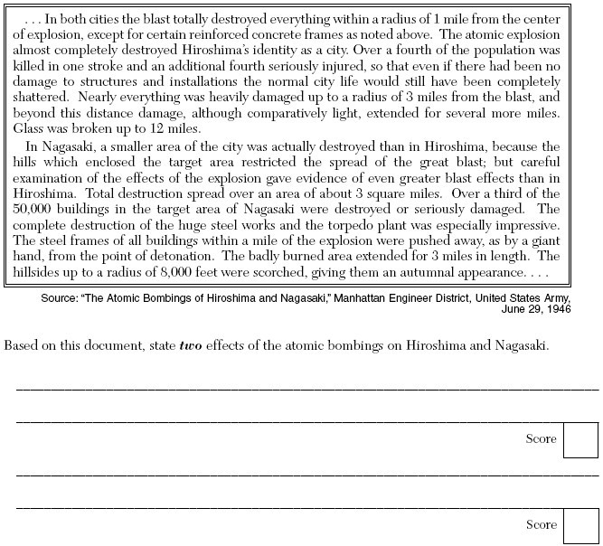
- Which event is described in the above excerpt?
  - German invasion of Poland
  - Russian defense of Stalingrad
  - U.S. bombing of Hiroshima and Nagasaki
  - Japanese invasion of Manchuria

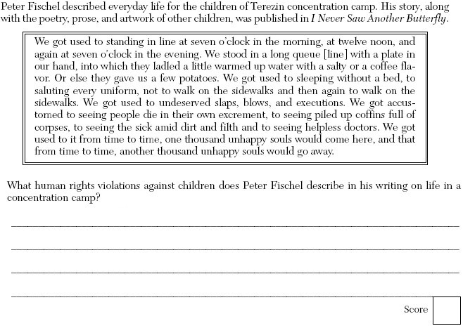
- The treatment described in the above excerpt was a result of Hitler’s plan known as the
  - Great Purge
  - Fascist Agenda
  - Armenian Massacre
  - Final Solution

- What was true of postwar Japan?
- The destruction during the war triggered a 20-year economic depression.
- Japan attempted to rebuild its empire by invading Korea in 1950.
- The new democratic government was overthrown by Communists in 1949.
- The military was limited and a democratic government began with US help

- The Marshall Plan, the Iron Curtain, and the Berlin Airlift are events associated with _____.
- World War I
- the Great Depression
- the Cold War
- New Imperialism
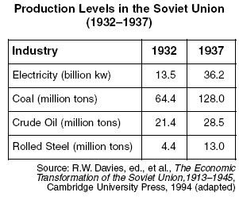
- Which policy is illustrated in the above chart?
  - Final Solution
  - Five Year Plan
  - Mandate System
  - Westernization

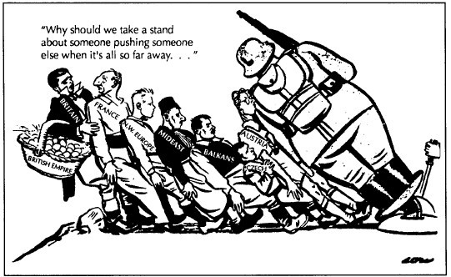

- Which British foreign policy regarding Germany does the above cartoon suggest?
  - Appeasement
  - Imperialism
  - Nationalism
  - Isolationism

- An International Military Tribunal representing 23 nations put Nazi war criminals on trial in what city?
  - Nuremburg, Germany
  - London, England
  - Brussels, Belgium
  - Vienna, Austria

- The Cold War was a
- series of military skirmishes between the United States and Germany.
- technological war between the United States and Japan.
- conflict between the United States and Iraq.
- philosophical war between the United States and the Soviet Union.

- What are the two ideologies which created conflict between the two superpowers?
  - Capitalism and Communism
  - Absolute monarchy and Democracy
  - Protestantism and Catholicism
  - Nazism and Fascism

Tearing down the Berlin Wall
Breakup of the Soviet Union
Soviet economic collapse

- The events in the above box were the result of
- a worldwide depression following World War II.
- an invasion of Moscow by Poland with support from NATO.
- the collapse of communism in the Soviet Union and Eastern Europe.
- free democratic elections in the Soviet Union.

- The Truman Doctrine and the Marshall Plan were designed to
- end German demands for the territory of Poland.
- restore a balance of power after Napoleon’s rule.
- promote economic and political stability in Europe.
- prevent Iraq’s takeover of Kuwait and its oil supply.

- During most of the Cold War period, which two nations were divided into communist and non-communist parts?
- China and Mongolia
- Vietnam and Korea
- Pakistan and Ireland
- Poland and Cuba
________?________
tension between the 2 superpowers
conflict between capitalism & communism
military build up and arms race
competition for third world countries

- What is the appropriate heading/topic for the characteristics listed above?
- World War II
- Great Depression
- Imperialism
- Cold War

- The purpose of the Truman Doctrine and the North Atlantic Treaty Organization (NATO) was to provide
  - economic and military support to European nations to stop the spread of communism.
  - military troops to end ethnic warfare in the former Yugoslavia.
  - humanitarian aid for starving people in Ethiopia and Sudan.
  - rights of freedom of speech and the press to Turkish citizens.
- What “symbol” of the Cold War describes the division of Europe, after World War II, into Soviet-dominated Communist countries and Western democracies led by the United States?
  - Berlin Wall
  - Great Wall of China
  - Warsaw Pact
  - Iron Curtain

- One reason the USSR formed the Warsaw Pact was to
  - ease the transition to democracy.
  - help institute capitalism in Eastern Europe.
  - limit the threat of invasion from Western Europe.
  - challenge the economic successes of the Common Market.

“The Parties agree that an armed attack against one or more of them in Europe or North America shall be considered an attack against them all and consequently agree that, if such an armed attack occurs, each of them, in exercise of the right of individual or collective self defense… will assist the Party or Parties so attacked…”
- Which organization includes the above excerpt in its charter?
- Warsaw Pact
- United Nations
- Organization of American States
- North Atlantic Treaty Organization

- The purpose of the Marshall Plan was to
  - restore Japanese economic development.
  - provide military aid to Middle Eastern allies.
  - assure nationalist success in the Chinese civil war.
  - provide for economic recovery in Europe.

- One reason for the construction of the Berlin Wall in 1961 was to
  - promote reunification of East and West Germany.
  - keep East Germans from fleeing to the Western sector of Berlin.
  - complete the post-WWII rebuilding of Berlin
  - meet the requirements of the North Atlantic Treaty Organization (NATO).

“United States Airlifts Supplies to Berlin”
“U-2 Spy Plane Shot Down Over the USSR”
“Soviet Missiles Placed in Cuba”

- The headlines above discuss events during
- Stalin’s Purges.
- World War II.
- the Cold War.
- the post-Cold War era.

- The violence and destruction that occurred during World War II led to the
  - expansion of colonial empires in Africa.
  - formation of the United Nations.
  - signing of the Treaty of Versailles.
  - unification of Germany.
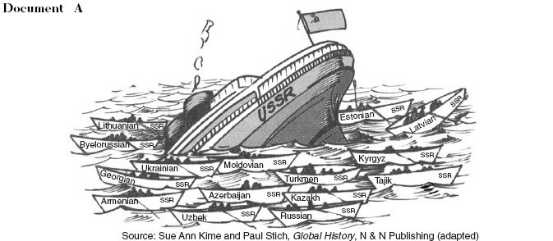

- Which event does the above cartoon best illustrate?
- Formation of the North Atlantic Treaty Organization
- Division of Germany after World War II
- Stalin’s Purges
- Collapse of the USSR

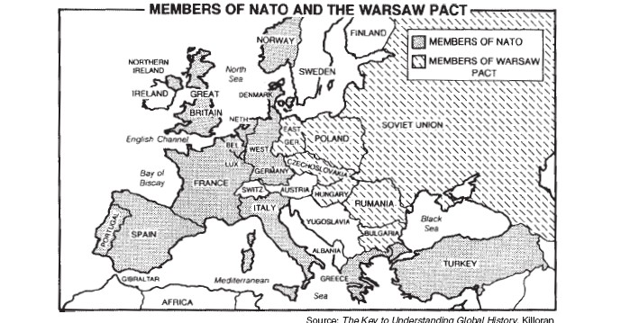

- Both alliances shown on the above map were formed after World War II primarily to
  - increase military defense.
  - promote democracy in Europe.
  - compete in the global economy.
  - expand trade between the members

- The destruction of the Berlin Wall in 1989 is symbolic of the
  - end of the Soviet domination of Eastern Europe.
  - declining power of the North Atlantic Treaty Organization (NATO).
  - fall of the Weimar Republic.
  - collapse of the European Union.

- Who was the leader of the communists in China?
- Mohandas Gandhi
- Mao Zedong
- Fidel Castro
- Ho Chi Minh

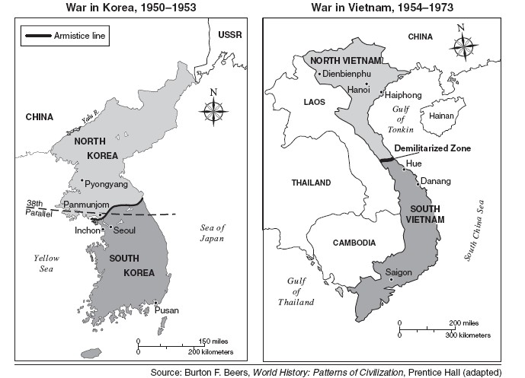

- Based on the information shown in the above maps, what is one similarity in the way the Cold War affected Korea and Vietnam?
- An armistice line was created in both nations.
- The demilitarized zones in both nations were about the same size.
- Both nations were united under communist leadership.
- Both nations were divided into separate governments in the north and south.

- The current status of Vietnam today is that the nation is
- divided into a North & South Vietnam.
- reunited as a communist nation.
- divided into West & East Vietnam.
- reunited as a democratic nation.

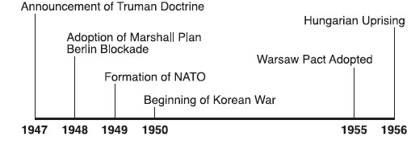
- All of the events on the timeline show actions taken during the
  - policy of appeasement.
  - Cold War.
  - decline of nationalism.
  - Bolshevik Revolution.

- What was the main goal of the United States in Vietnam?
- reunification of Vietnam
- upholding of the Yalta Agreement
- containment of communism
- negotiation of a cease fire in the North
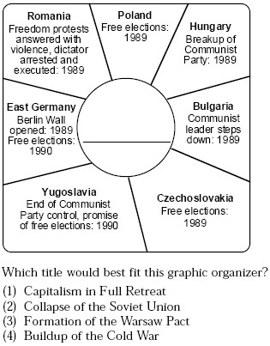
- Which title would best fit the above graphic organizer?
- Capitalism in full retreat
- Collapse of communism in Eastern Europe
- Formation of the Warsaw Pact
- Buildup of the Cold War

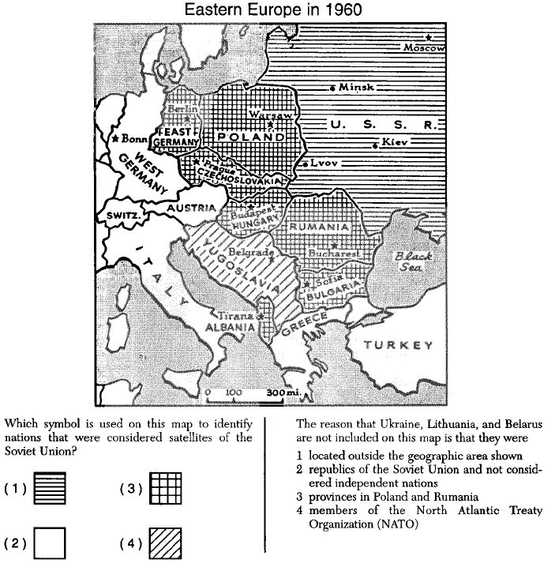
- What symbol is used on the above map to identify nations that are considered satellites of the USSR?

- Which event is generally considered to be the confrontation which most nearly led to nuclear war?
- construction of the Berlin Wall
- Cuban Missile Crisis
- Soviet invasion of Afghanistan
- United States financing the Marshall Plan
- After WWII, the U.S. provided financial aid to West Germany because this nation was
- newly independent.
- attempting to re-unite with East Germany.
- facing possible communist threats.
- threatening to ally itself with the Soviets.

“From Stettin in the Baltic to Trieste in the Adriatic, an iron curtain has descended across the continent.”
-Winston Churchill (1946)

- The above statement refers to the
  - beginning of the Cold War.
  - unification of Germany.
  - end of World War I.
  - Russian Revolution.

- All of the following are outcomes of the Indian independence movement EXCEPT:
  - political divisions between Pakistan and India.
  - end of British rule in India.
  - creation of new states like Bangladesh.
  - collapse of trading posts in Sri Lanka.

- Mohandas Gandhi is best known for his:
  - desire to establish an Islamic nation.
  - opposition to Hindus holding political office.
  - encouragement of violence to end British rule.
  - use of passive resistance to achieve independence

- Which new state was created in the Indian sub-continent to replace East Pakistan?
  - Pakistan
  - Sri Lanka
  - Iran
  - Bangladesh

- The greatest influence in the partition of India into two nations was:
  - the formation of the Muslim League.
  - British desire to leave India.
  - fear that the Hindus and Muslims would never be able to live together in peace.
  - the assassination of Mohandas Gandhi.

- Which country gained its independence through war with France?
  - Libya
  - Kenya
  - Algeria
  - Ghana

- Why did independence movements in Africa gain success after World War II?
  - resentment toward imperial rule and economic exploitation
  - pride in British heritage and aid from their political stability
  - influence of superpower rivalry during World War II
  - Charter of the European Union guaranteed self-determination

- One similarity between the Sepoys in India, the Boxers in China, and the Mao Mao in Kenya is that these groups:
  - tried to drive Europeans out of their countries.
  - depended on Western support for their success.
  - adopted Marxist economic and political principles.
  - sought independence through non-violence.

- The African country of Kenya won its independence through a violent struggle under the leadership of:
  - Mohandas Gandhi.
  - Nelson Mandela.
  - Jomo Kenyatta.
  - Louis Mountbatten.

- The charter of what organization guaranteed colonial populations like those in Africa the right to self-
determination?
  - European Union
  - League of Nations
  - North Atlantic Treaty Organization
  - United Nations

- One characteristic of apartheid, which was practiced in South Africa, is:
  - forced migration of blacks to other nations.
  - integration of all races in society.
  - an open immigration policy.
  - segregation of the races.

- The mandate system was established by what organization after World War I?
  - United Nations
  - League of Nations
  - North Atlantic Treaty Organization
  - Triple Entente

- Mandates in the Middle East were granted independence after what war?
  - Cold War
  - World War I
  - World War II
  - Vietnam War

- The mandate system was phased out after World War II, creating new states in the Middle East and leading to major ongoing conflicts created by:
  - over population
  - religious differences.
  - minority control.
  - poverty.

- Jordan and Palestine were mandates of what country?
  - Great Britain
  - France
  - Spain
  - Germany

Use this map to answer the next question.
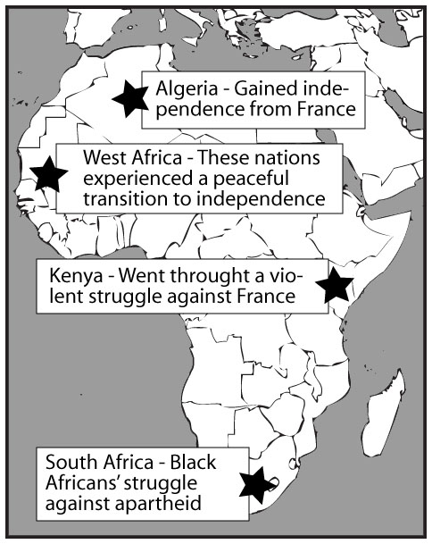

- This map shows important events in Africa's independence from European countries. Which area's description is FALSE?
  - Kenya.
  - South Africa.
  - Algeria.
  - West Africa.

- Which of the following is a characteristic of developed nations?
  - High infant mortality rate
  - High literacy rate
  - High illiteracy rate
  - Low per capita income

- Which of the following is a characteristic of developing nations?
  - Many households with access with the internet
  - Numerous highways, rail systems, airports etc.
  - A large number of high tech industries and heavy industries
  - Many people with no health care and poor nutrition

- Which of the following is a challenge faced by the world in both developed and developing nations?
  - Refugees running away from religious and ethnic conflicts
  - Widespread literacy
  - Democratic institutions
  - Decreasing pollution

- What is the most likely reason a nation might allow guest workers?
  - To socialize the workers so as to create labor stable societies in the guest workers homeland
  - To provide the host country with cheap labor and to fill positions which the natives of the country will not take
  - To provide political asylum to many without offending the country of origin of the guest workers
  - To spread the political philosophy of the host country
- The immigration of ________ from developing nations has led to ethnic conflict in several European countries.
  - women
  - guest workers
  - Communists
  - Ranchers

- What is the major reason for the differences in economic prosperity in various areas of the world today?
  - an unequal distribution of resources
  - the success of nationalist movements
  - religious unity between some nations
  - membership of the United Nations

- How has new technology created opportunities but at the same time created challenges?
  - It has moved all people forward at the same rate so that economic differences remain
  - It has only benefited the developed countries
  - It has led to the dissolution of all traditional values
  - It has created widespread but unequal access to computers and instantaneous communications which has widened the gap between the rich and poor

- Multinational corporations such as Honda, Volvo, Nestle, and Mitsubishi establish plants in selected countries that:
  - can provide skilled labor and a growing economy
  - have raw materials and a sound economy
  - can provide raw materials and the cheapest labor
  - can produce parts and assemble the product

- What is the connection between economic development and political freedom?
  - Most economic development takes place in countries with political freedom for its citizens
  - Most economic development occurs in countries with limited amounts of political freedom
  - Political freedom jeopardizes the economy
  - There is no consistent between political freedom and economic development

- Which of the following is NOT an indicator of the economic development of a nation?
  - educational activities
  - human influence over environment
  - major religion
  - percentage of urban/rural population

- Study the following chart. Which country has the least people working in agriculture?

  - Country A
  - Country B
  - Country C
  - Country D

- Which term can be described as nations sharing in a technology and communication revolution that has made people increasingly reliant on each other?
  - interdependence
  - interventionism
  - neocolonialism
  - reformation

Socioeconomic Status of Asian Countries
Country | Per Capita GDP | Life Expectancy | Infant Mortality  (per 1,000 births)
Bangladesh  India  Philippines  Japan  Thailand | 200  270  860  19,800  1,800 | 55  58  63  79  68 | 107  78  51  4  37
Country | % Urban Population | % Literate | Birthrate  (per 1,000 births)
Bangladesh  India  Philippines  Japan  Thailand | 14  26  44  77  19 | 47  48  88  99  89 | 35  28  27  10  19
(Source: The World Almanac Book of Facts, 1995)

- According to the chart above, which of these Asian nations is the least urbanized and the least industrialized country?
  - Bangladesh
  - Philippines
  - India
  - Thailand

Country | Life  Expectancy | Literacy  Rate* | % of Workers in  Agriculture** | % Urban Pop. | Per Capita GDP***
Malaysia | 71 | 93% | 21% | 53% | $11,000
Philippines | 66 | 95% | 43% | 54% | $3,200
Singapore | 78 | 91% | 1% or less | 100% | $24,600
South Korea | 74 | 98% | 21% | 61% | $13,700

- Study the chart above. Which country most likely has the highest standard of living?
  - Malaysia
  - Philippines
  - Singapore
  - South Korea

