American Heroes of the 1920s
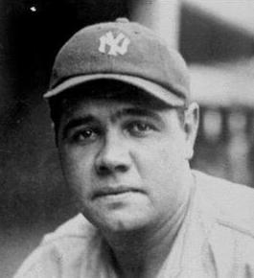
Babe Ruth: played baseball from 1914-1935; spent most of his career with the Boston Red Sox and New York Yankees. Babe Ruth hit a record-breaking 29 home runs in a single season making him an American hero.
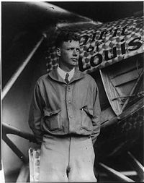
Charles Lindbergh: aka Lucky Lindy; made the first solo, non-stop, trans-Atlantic flight in 1927 in his plane, “The Spirit of St. Louis.” Afterwards, he became the world’s best known aviator and a media sensation.

American Literature of the 1920s
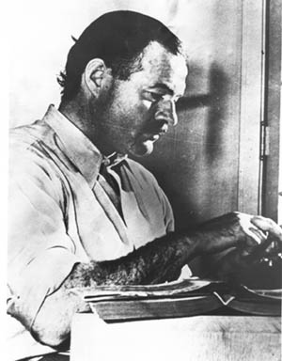
The Lost Generation: a group of American literary notables who lived in Paris in the 1920s. Significant members included Ernest Hemingway (who wrote The Sun Also Rises, the Old Man and the Sea) and F. Scott Fitzgerald (who wrote The Great Gatsby). Their writing reflected disillusionment resulting from the casualties of WWI as well as the overconsumption/massive social change that occurred during the 20s.
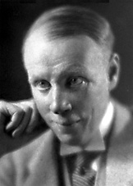
Sinclair Lewis: won the Nobel Prize for Literature for Main Street, a novel that depicted young women growing up in his hometown. The novel is significant as a vivid example of how life changed as America’s values changed.

