IM Injection Sites
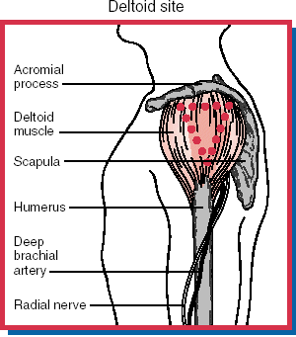
Return to Top
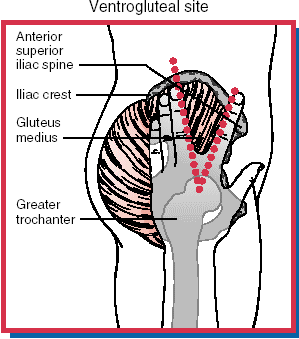
Return to Top
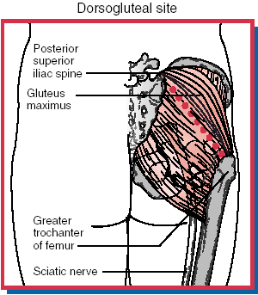
Return to Top
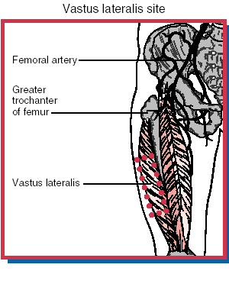
Return to Top

Disclaimer
F.A. Davis Company - Independently Owned and Operated Since 1879

