Change Case
- Set up a 3 column header on THIS DOCUMENT as follows:
  - Student Name on the left
  - Class name in the middle
  - Change Case on the right
- Make sure the margins are set to Normal.
- Change Case refers to UPPER CASE and lower case letters. MS Word has a tool that will change the case of a word or group of words automatically.
- The Change Case tool is found on the Home Ribbon, Font group.
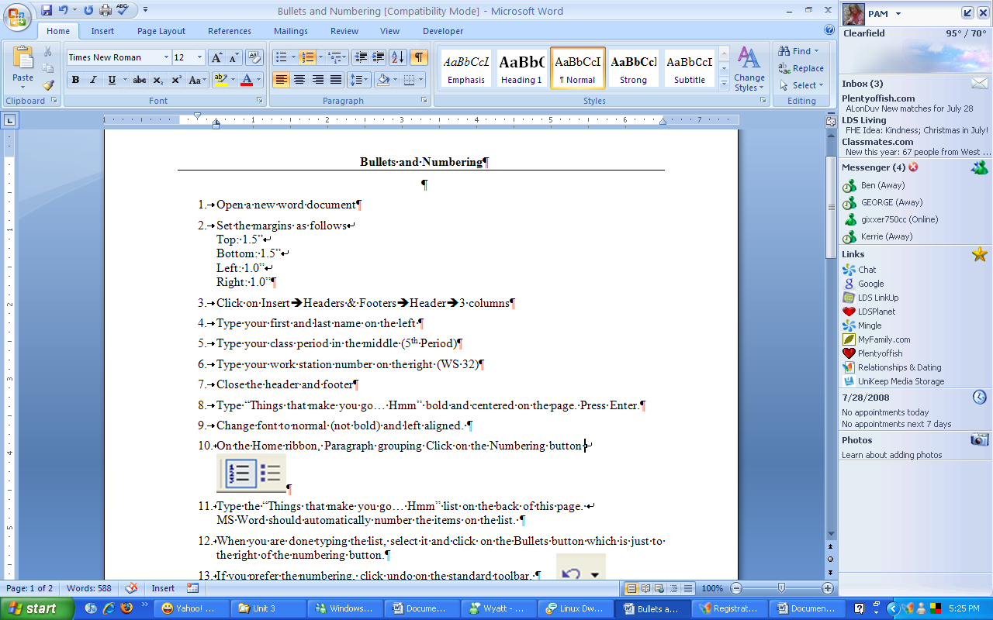
- To change the case of a word or group of words select the words
you want to change and then click on the Change Case tool.

- Select the case you would like to use and then click OK
- For each sentence or group of sentences below, change the case as directed.

- sentence case is the way we are taught to write sentences and paragraphs. the initial letter of each sentence is capitalized, and the rest of the sentence is in lower case. change this paragraph to sentence case.
- LOWER CASE IS USED FOR LISTS OR OTHER GROUPS OF WORDS THAT YOU WANT TO APPEAR IN ALL LOWER CASE. sOMETIMES THIS TOOL CAN BE USED IF YOU ACCIDENTALLY HIT THE CAPS LOCK BUTTON WHILE YOU ARE TYPING AND TYPE SEVERAL LETTERS OR WORDS IN UPPER CASE. cHANGE THIS PARAGRAPH TO LOWER CASE.
- Upper Case Is Used To Emphasize A Word And It Is Also Used Occasionally For Titles And Headings. Be Careful About Using Upper Case For Email, Chat Rooms, Or Im. It Is Considered Impolite To Type In All Caps. Change This Paragraph To Upper Case.
- CAPITALIZE EACH WORD IS GENERALLY USED FOR TITLES. BEGIN WITH AN INITIAL CAPITAL LETTER FOR EACH WORD IN THE PHRASE. VERY SHORT AND COMMON WORDS LIKE “AND”, “THE”, AND “OF” ARE NOT CAPITALIZED. HOWEVER, MS WORD DOES NOT RECOGNIZE THESE WORDS AS BEING DIFFERENT AND WILL CAPITALIZE THE INTIAL LETTER OF EVERY WORD. CHANGE THIS PARAGRAPH TO CAPITALIZE EACH WORD.
- Toggle case is just the opposite of sentence case. The initial letter of each sentence will be in lower case with the rest of the letters in upper case. It is difficult to read and should be used sparingly. Change this paragraph to toggle case.
- Save the document in your WP folder in your S: drive as Change Case xx.doc.

