Text Alignment Activity
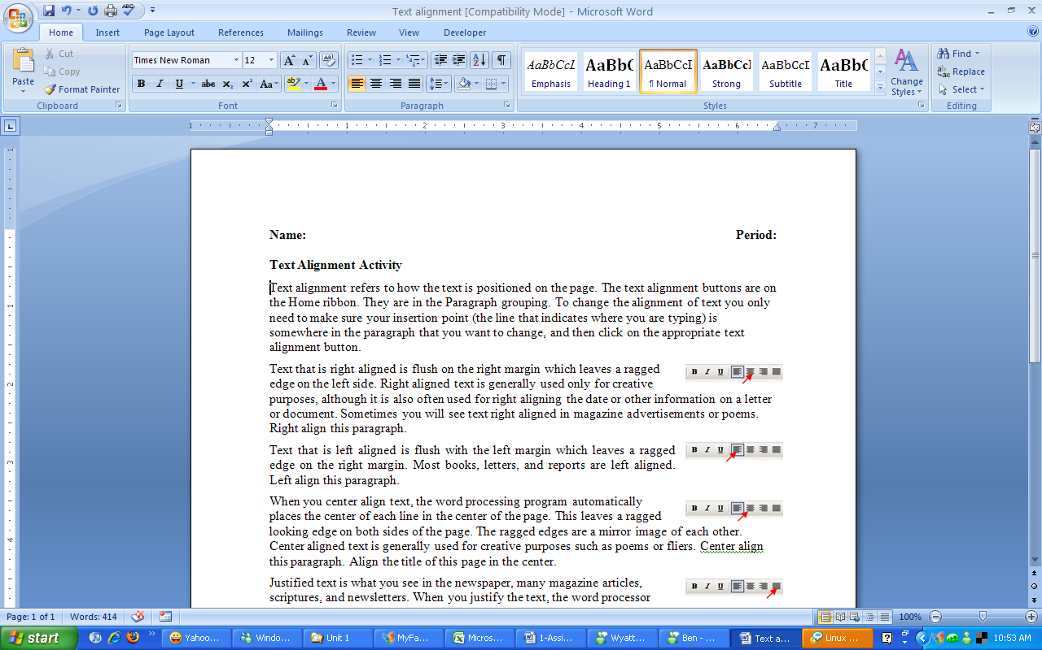
Text alignment refers to how the text is positioned on the page. The text alignment buttons are on the Home ribbon. They are in the Paragraph grouping. To change the alignment of text you only need to make sure your insertion point (the line that indicates where you are typing) is somewhere in the paragraph that you want to change, and then click on the appropriate text alignment button.
Text that is right aligned is flush on the right margin which leaves a ragged edge on the left side. Right aligned text is generally used only for creative purposes, although it is also often used for right aligning the date or other information on a letter or document. Sometimes you will see text right aligned in magazine advertisements or poems. Right align this paragraph.
Text that is left aligned is flush with the left margin which leaves a ragged edge on the right margin. Most books, letters, and reports are left aligned. Left align this paragraph.
When you center align text, the word processing program automatically places the center of each line in the center of the page. This leaves a ragged looking edge on both sides of the page. The ragged edges are a mirror image of each other. Center aligned text is generally used for creative purposes such as poems or fliers. Center align this paragraph. Align the title of this page in the center.
Justified text is what you see in the newspaper, many magazine articles, scriptures, and newsletters. When you justify the text, the word processor adjusts the spacing of each line so that the edges on both sides are flush. It makes nice neat columns of text with straight lines of white space in between them. Justify the text in this paragraph.
This line of text should be left aligned.
Align this row of text in the center of the page.
Now right align this line of text.
If you worked for a newspaper agency, you would need to justify. Justify this line of text. Justify only works if the line is complete or goes all the way across the page.
Right align this line.
Left align this line.
Left again.
Center this one.
Right align this line.
Center align again.
Here is a line for you to justify. Notice that when you justify a line of text, the last line of the paragraph is left aligned instead of spread out across the page.

