Margins and Line Spacing
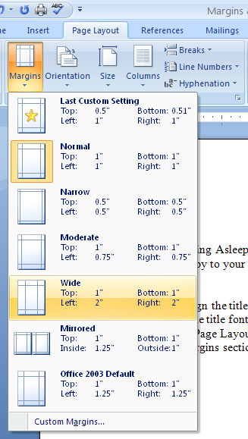
Open Falling Asleep.doc from the Students (S :) drive
- Save to your S: drive, in the Word Processing folder.
Setting Margins
- Center align the title
- Change the title font to Arial Black, size 16, a dark shade of purple.
- Click on Page Layout ribbon and the Margins icon in the Page Setup grouping.
- Select Wide from the drop down menu which will set the top and bottom margins to 1” and the left and right margins to 2”.

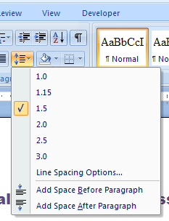
Line Spacing
- Select the body of the poem (From “I fell asleep” to “out the door”) by clicking and dragging
- On the Home ribbon in the Paragraph grouping click the drop down next to the line spacing icon.
- From the drop down menu, select 1.5. This will make the line spacing between single spaced, and double spaced.
If you wanted to double space, you would select 2.0, triple spaced would be 3.0, etc.
- Type your name at the bottom of the document.
- You may format your name to your liking. Keep the document on one page.
- Check the key on the S: drive
  - From the desktop, double click on My Computer
  - Go to the S: drive, Keyboarding folder
  - Open the Margins and Line Spacing Key
- Turn on the formatting marks, and raise your hand to have the document checked.

