Bullets and Numbering
- Open a new word document
- Set the margins to the Normal setting (all 1” margins).
- Click on Home➔Styles➔No Spacing
- Click on Insert➔Headers & Footers➔Header➔3 columns
- Type your first and last name on the left
- Type your class name in the middle (Keyboarding)
- Type the document name on the right (Things)
- Close the header and footer
- Type “Things that make you go… Hmm” bold and centered on the page. Press Enter twice.
- Change font to normal (not bold) and left aligned.
- On the Home ribbon, Paragraph grouping Click on the Numbering button
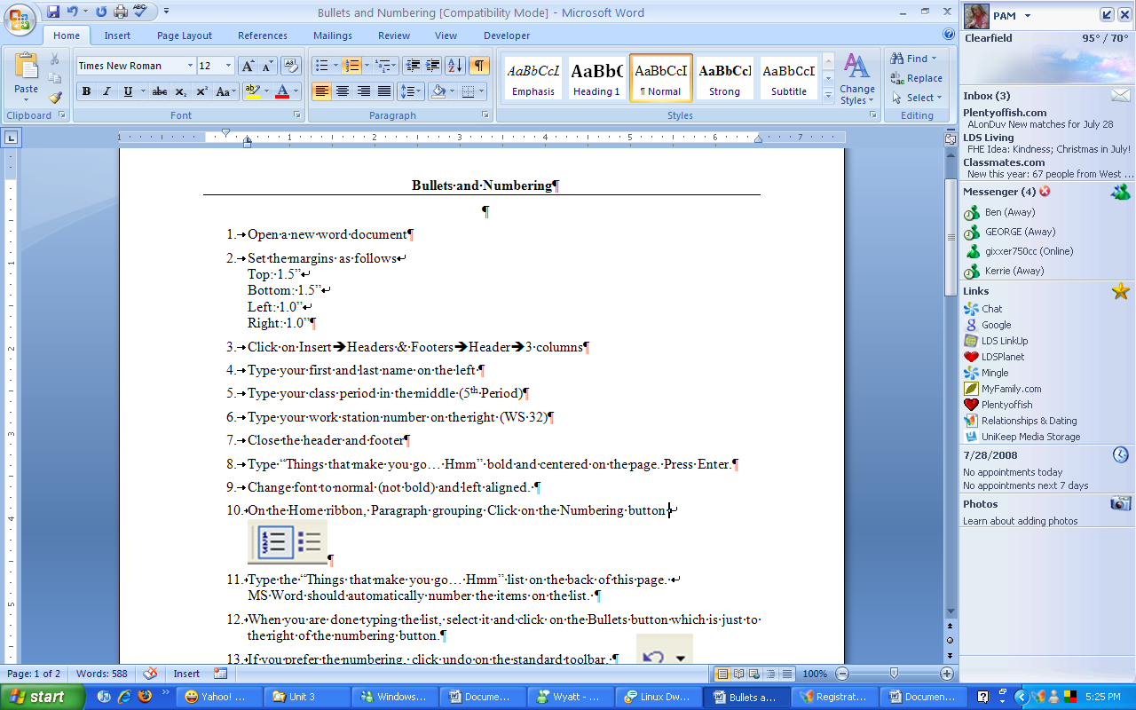
- Type the Things that make you go… Hmm list pictured on the next page. MS Word should automatically number the items on the list.
- When you are done typing the list, select it and click on the Bullets button which is just to the left of the numbering button.
- If you prefer the numbering, click undo on the Quick Access toolbar.
- Decide which format you like best (numbers or bullets)
- You may also change the font, as long as the entire document stays on one page.
- Spell and grammar check the document.
- Save the document as thingsxx.
- Check the Key on the board.
Things that make you go… Hmmm

- If pro is the opposite of con, what is the opposite of progress?
- Why do you pay extra to get something put on your sandwich but don't get a discount when something is taken off?
- If scientists were ever going to figure out how to travel through time, wouldn’t we now be seeing people from the future?
- How is it that we put man on the moon before we thought to put wheels on luggage?
- If you are born on February 29 of a leap year, when is your birthday?
- If you had x-ray vision and could see through anything, wouldn't you see through everything and actually see nothing?
- Speaking of Superman, why do people in Metropolis get excited if they really thought they saw a bird or plane?
- What's the difference between partly cloudy and partly sunny?
- If it's zero degrees outside today and it's supposed to be twice as cold tomorrow, how cold is it going to be?
- If a person owns a piece of land, do they own it all the way down to the core of the earth?
- Why are Christmas lights packaged with the warning "For indoor or outdoor use only"? Where else would you put them?
- Why do drugstores make the sick walk all the way to the back of the store to get their prescriptions while healthy people can buy cigarettes at the front?
- How can bottled water go out of date?
- Why does lemon dish soap contain real lemons, but lemon juice is artificial flavoring?
- If the professor on Gilligan’s Island can make a radio out of coconut, why couldn't he fix a hole in a boat?
- If a truck is loaded with Helium, would it weigh less than when it was empty? Wouldn't it get better fuel mileage?
- Why doesn't Tarzan have a beard?
- If Wile E. Coyote had enough money for all that Acme crap, why didn't he just buy roadrunner for dinner?
- What should you do if you see an endangered animal eating an endangered plant?
- Why do drive-thru ATMs have Braille code on them?

