Focus assessment
Guidelines for interviewing the patient with a respiratory problem.
Ask the following questions of any patient who has nursing diagnosis or medical diagnosis indicating a respiratory problem:
- When did the respiratory problem beginning? Where you exposed to infection? What are the symptoms? Do you have shortness of breath?
- Do you have allergies? Sinusitis? Asthma? And asthma? Chronic bronchitis? Exposure to dust or other irritants?
- Do you smoke? How many packs per day and for how many years? Have you had exposure to industrial air pollutants? Have you been exposed to tuberculosis?
- What type of cough do you have? When does it occur? Is it productive of sputum? What color is the sputum?
- When does shortness of breath occur? Is there wheezing?
- What measures ease your breathing or your cough? What medications are you taking?
- How much fluid are you drinking?
- Do you have any heart problems?
Auscultate the lungs each shift along with the assessment of other respiratory status parameters. Carefully document findings to allow other nurses to compare later data and detect subtle trends or deterioration. Respiratory assessment is intertwined with cardiac assessment because, if the heart is not functioning properly, oxygenated blood will not be delivered to the tissues in adequate amounts. Check equipment and settings of respiratory equipment at least once a shift.

Lung assessment
- Auscultate posterior lung sounds
- Auscultate anterior lung sounds
  - Tracheal
  - Bronchial
  - Bronchial Vesicular
  - Vesicular
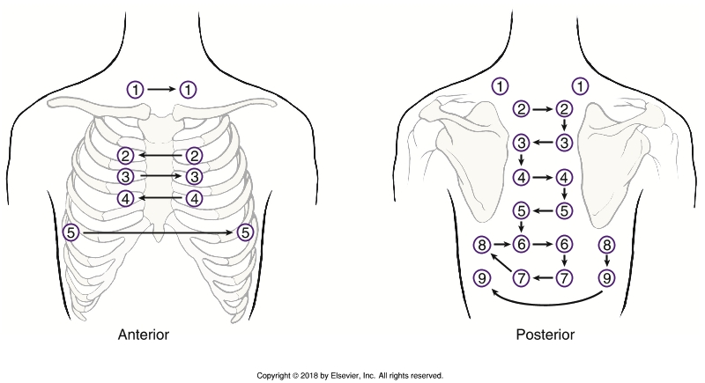
  - o Bronchial
Vesicular
Bronchovesicular
Bronchial
Tracheal

Tracheal Breath Sounds: heard over the trachea.
- They are equal in length for inspiration and expiration with a slight pause between them.
- The sounds are course and loud.
Bronchial Breath Sounds: heard over the upper chest area
- Shorter on inspiration than exploration with a pause between them.
- The sounds are harsh and loud.
Bronchovesicular breath sounds: heard over the central chest and back
- Equal in length during inspiration an expiration with no pause between them.
- Medium and tonality and loudness
vesicular breath sounds: heard in the periphery of the lung fields .
- Longer on inspiration than exploration with no pauses between them
- Soft, rustling sounds

There are nine locations to auscultate on posterior lung sounds.
Do not auscultate over Bony areas place the stethoscope between the scapula, beside the vertebrate, and between the ribs.
Move from side to side for constant comparison between the right and left lung.
There are five locations to auscultate on anterior lung sounds.
Listen between the women's breast and men's . Lift the breast when necessary.
Have the patient breathe in through their nose and out through their mouth slowly. Listen to both the inspiration and expiration before moving to the next area to auscultate.
Give the patient rest breaks during the assessment if needed.
As the patient if they are feeling lightheaded or dizzy during the assessment as needed.
Keep the deep breathing they will do for you slow to avoid the Lightheadedness or dizziness.

ABNORMAL LUNG SOUNDS
SOUND | DESCRIPTION
WHEEZES | WHISTLING, MUSICAL, HIGH PITCH SOUND PRUDUCED BY AIR BEING FORCED  THORUGH A NARROWED OR PARIALLY OBSTRUCTED AIRWAY.
GURGLE OR LOW-PITCHED WHEEZES | COARSE, LOW PITCHED, SONOROUS, RATTLING SOUNDS CAUSED BY SECRETIONS IN THE LARGER AIR PASSAGES; SOMETIMES CALLED RHONCI
CRACKLES | FINE OR COARSE NON-MUSICAL SOUNDS. FINE CRACKLES ARE HIGH IN PITCH. COARSE CRACKLES ARE LOUDER AN LO IN PITCH. CRACKELS ARE SIMILAR TO THE SOUND PRODUCED BY RUBBING HAIRS BETEEN THE FINGERS CLOSE TO THE EAR
STERTOR | SNORING SOUND PRODUCED BY INABILITY TO COUGH UP SECRETIONS FROM THE TRACHEA OR BRONCHI
STRIDOR | CROAKING OR CROWLING SOUND HEARD WHEN THERE IS PARTIAL OBSTRUCTION OF THE UPPER AIR PASSAGES
PLEURAL FRICTION RUB | PLEURAL FRICTION RUB PRODUCES A SCRAPING, RASPY SOUND THAT OCCURS AT THE END OF YOUR INHALATION AND THE BEGINNING OF YOUR EXHALATION. IT COMES FROM THE AREA DIRECTLY OVER THE PLEURAL INFLAMMATION CASUED WHEN IRRITATED PLEURAL MEMBRANES RUB OVER EACH OTHER

