Directions: Solve the problem using Dimensional Analysis and label your answers (example: tab, mL, etc). Round to the tenth (10th) place as needed. Place your answer in the space provided. Show your work.

  - Order: Ampicillin 250 mg
Available:

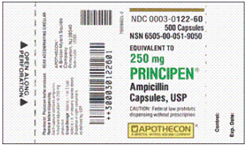

Administer: ____________

Directions: Solve the problem using Dimensional Analysis and label your answers (example: tab, mL, etc). Round to the tenth (10th) place as needed. Place your answer in the space provided. Show your work.

  - Order: Synthroid 0.1 mg
Available:

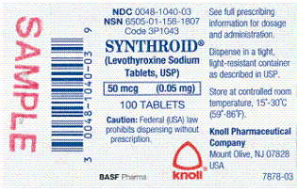
Administer: ____________

Directions: Solve the problem using Dimensional Analysis and label your answers (example: tab, mL, etc). Round to the tenth (10th) place as needed. Place your answer in the space provided. Show your work.

  - Order: Zovirax 600 mg
Available:

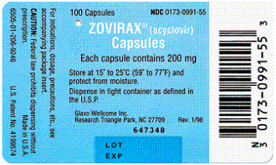

Administer: ____________

Directions: Solve the problem using Dimensional Analysis and label your answers (example: tab, mL, etc). Round to the tenth (10th) place as needed. Place your answer in the space provided. Show your work.

  - Order: Lanoxin 0.375 mg
Available:

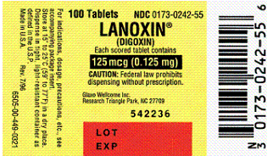
Administer: ____________

Directions: Solve the problem using Dimensional Analysis and label your answers (example: tab, mL, etc). Round to the tenth (10th) place as needed. Place your answer in the space provided. Show your work.

  - Order: Hydrochlorothiazide 0.025 g
Available:

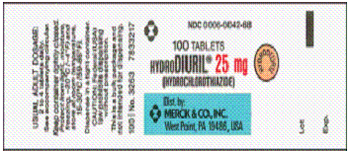

Administer: ____________

Directions: Solve the problem using Dimensional Analysis and label your answers (example: tab, mL, etc). Round to the tenth (10th) place as needed. Place your answer in the space provided. Show your work.

  - Order: Thorazine 85 mg
Avail1able:

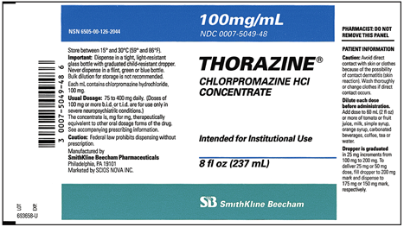
Administer: ____________

Directions: Solve the problem using Dimensional Analysis and label your answers (example: tab, mL, etc). Round to the tenth (10th) place as needed. Place your answer in the space provided. Show your work.

  - Order: Mycostatin 200,000 units
Available:

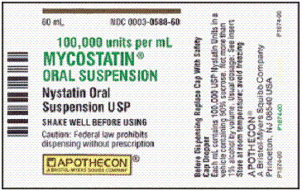
Administer: ____________

Directions: Solve the problem using Dimensional Analysis and label your answers (example: tab, mL, etc). Round to the tenth (10th) place as needed. Place your answer in the space provided. Show your work.

  - Order: Epivir 190 mg
Available:

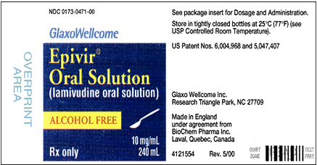
Administer: ____________

Directions: Solve the problem using Dimensional Analysis and label your answers (example: tab, mL, etc). Round to the tenth (10th) place as needed. Place your answer in the space provided. Show your work.

  - Order: Prozac 55 mg
Available:

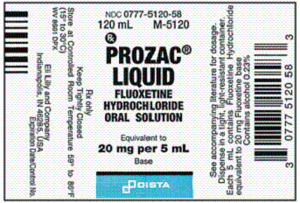
Administer: ____________

Directions: Solve the problem using Dimensional Analysis and label your answers (example: tab, mL, etc). Round to the tenth (10th) place as needed. Place your answer in the space provided. Show your work.

  - The recommended pediatric dosage for a drug is 5 to 8 mg/kg/day.
What is the safe dosage range for a child weighing 33 lb? _______________.

