Male and Female Class A Uniform
The Class A uniform is generally worn for inspections in the winter. The Class A uniform is also worn during ceremonies, social functions, and formal inspections. The tie or neck tab must be worn with this uniform and all buttons must be buttoned. Underneath the jacket, the cadet will wear the AG 344 or the AG 415 shirts.

Army Green Garrison Cap
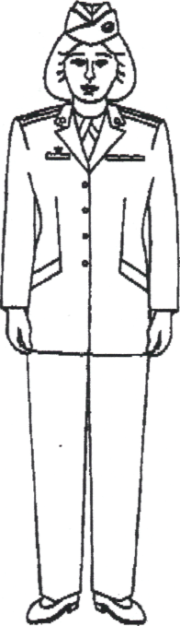
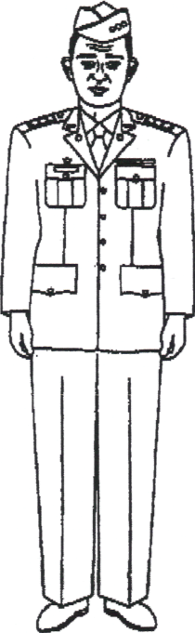
Army Green Coat
Shoulder Marks
Army Green Short Sleeve Shirt
Black Necktie
Black Neck tab
Black Belt with Brass Buckle
Army Green Slacks
Army Green Trousers
Black Socks
Black Low Quarter Shoes (or Pumps)

Officer
Enlisted

Male and Female Class B Uniform
The Class B uniform is generally worn for inspections in the summer months and in the late spring. The Class B uniform is always worn under the Class A uniform. You do not have to wear a tie or a neck tab with this uniform unless it has long sleeves or with the Class A uniform coat. The placement of awards and ornamentation in the pocket areas is the same as on the Class A uniform.

Army Green Garrison Cap
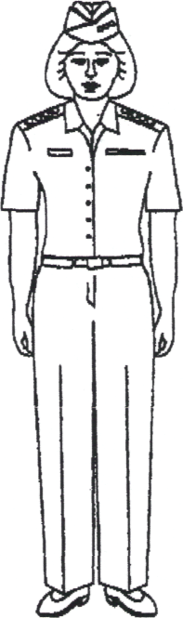
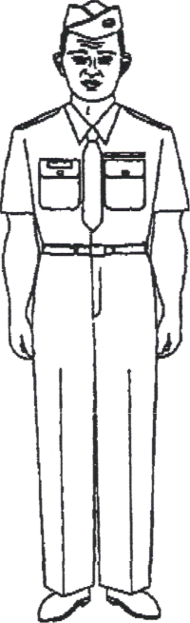
Shoulder Marks
Army Green Short Sleeve Shirt
Black Belt with Brass Buckle
Army Green Slacks
Army Green Trousers
Black Socks
Black Low Quarter Shoes (or Pumps)
Black Necktie/tab (optional)

Officer
Enlisted

PROPER PLACEMENT OF INSIGNIA

THE ARMY GARRISON CAP

Before positioning the appropriate cadet officer or cadet enlisted insignia on the garrison cap, you should first know how to wear it. Place it on top of your head with the front vertical crease of the cap centered on your forehead in a straight line with your nose. Tilt the cap slightly to your right, but do not let it touch or rest on the top of your ear. Do not crush or shape the garrison cap to form peaks at the top front or top rear of it.

As shown above, cadet officers wear grade insignia on the garrison cap while enlisted cadets wear the ROTC insignia. Position either insignia on the left side of the cap one inch from the crease and centered vertically between the top braid and the bottom of the cap.

CLASS A AND CLASS B UNIFORMS

Insignia of Grade

To wear the grade insignia on long or short sleeve JROTC shirts, you normally wear shoulder marks (rank or shoulder boards). For cadet officers, place the narrow, pointed end toward the collar and the flat end toward the edge of the shoulder; for enlisted cadets, place the side with the pointed chevron (stripe) toward the collar.

However, the wearing of grade insignia for certain enlisted grades, such as cadet private and cadet private first class, may differ between schools. In some units, those cadets may wear non-subdued pin-on grade insignia on both shirt collars or pinned to blank shoulder marks.

Place these insignia centered on the collar, with the centerline of the insignia bisecting the point of each collar and one inch up from the edge of the collar point.

The area of both shirt pockets is where you place your nameplate, honor unit insignia, and personal awards. For female cadets, the pocket area (since those shirts do not have pockets) is where you also position these items. First, imagine a horizontal line slightly above the top button on your shirt or one to two inches above the top button on your shirt. This imaginary line allows you to properly align your awards, insignia, and nameplate in the same manner as male cadets do.

Nameplate

Center the nameplate on the right pocket between the top pocket seam and the top of the pocket buttonhole. On the female uniform center the nameplate horizontally on the right side with the bottom of the nameplate on the imaginary line.

Honor Unit Insignia

Center the Honor Unit Star one-fourth of an inch (1/4”) above the top seam of the right pocket. You can wear the Honor Unit Star either by itself or joined with the Academic Achievement Wreath. In either case, you center them as described.

Awards and Decorations

Pin individual awards for academic, athletic, and military excellence on the left pocket (or left pocket area). You cannot wear both the ribbon and the medal for the same award at the same time.

Center your ribbons on the pocket button one-eighth of an inch (1/8”) above the top seam of the left pocket (centered above the horizontal line for female cadets). Place awards of this type no more than four across. Do not start a second row until you have four or more ribbons. Plus, the first and second rows must have the same number before you can start a third row. Center the top row on the row beneath it. Wear your ribbons in order of precedence from top to bottom and from your right to left in one or more rows.

Wear medals and/or place badges for excellence in marksmanship, one-eighth of an inch (1/8”) below the top seam on the left pocket flap (or in a similar position for female uniforms), again in the order of precedence from your right to left.

When not wearing medals, center your badge or badges, or space them equally from left to right on your pocket flap. The upper portion of the badge or badges should be one-eighth of an inch (1/8”) below the top seam of the left pocket. If you only have one medal or badge, center it from left to right on your left pocket flap. Place the top of it one-eighth of an inch (1/8”) below the top seam of the pocket.

Wear two medals or badges equally spaced from left to right on the left pocket flap. Keep the top portion of them one-eighth of an inch (1/8”) below the seam, at least one inch between them, and special skill badges to the right. The illustration for wearing two medals or badges is shown below.

If you are wearing a special medal with one or more marksmanship badges, equally space all awards (but not more than three) from left to the right on the left pocket flap. Place the upper portion of the medals one-eighth of an inch (1/8”) below the top pocket seam. Wear the special medal to your right of any marksmanship badges.

These same rules apply for female cadets, except that they wear medals and/or marksmanship badges one-fourth of an inch (1/4”) below their bottom row of ribbons.

Miscellaneous Uniform Accessories

Certain units may authorize the wearing of approved unit crests. You can wear these crests in one of two places on the uniform.

- The first option is on both shoulder marks, midway between the button and the insignia of grade. However, enlisted cadets who wear pin-on grade insignia on their collars would center these crests on blank shoulder marks.

- The second option is to center the unit crest below the button on the right pocket, between the bottom of the pocket flap and the bottom seam of the pocket (see below).

At the discretion of the senior Army instructor, you may wear scholar or service program insignia, such as national or local military honor societies, centered on the left pocket between the bottom of the pocket flap and the bottom pocket seam. The instructor staff may authorize you to wear shoulder cords for participation in certain JROTC activities, including the color/honor guard, drill team, and rifle team. Wear one cord by itself on the left shoulder, and any other cord on the right shoulder. When wearing cords with a ferrule (metal tip), keep the ferrule to the front. Otherwise, wear these cords based on the procedures of your local unit.

Guidelines for Wearing Your JROTC
Uniform

Wear a clean and neatly pressed uniform.

Tuck shirt into trousers; keep its seam aligned with the seam of the zipper flap of the trousers and the edge of the belt buckle (gigline).

Male cadets wear a T-shirt under the Class A and B uniforms. Male and female cadets wear a T-shirt under BDUs and as a physical
training uniform. Wearing T-shirts prevents underarm perspiration from affecting your uniform.

With the exception of the top or collar button of the shirt, button all buttons..

Clean, polish, and properly display all brass on the uniform.

Push the belt through the left front loop of the trousers first and adjust to allow only the tip of the belt to protrude from the buckle.

Wear only issued socks and shoes with the uniform.

The wearing of a wrist watch, a wrist identification bracelet, and not more than two rings is authorized with Army uniforms (unless prohibited for safety or health reasons) as long as the style is conservative and in good taste.

Female cadets may also wear small circular earrings (not to exceed 1/4" in diameter).

Do not carry bulky objects in any pocket of the uniform.

Wear the hat at all times when outdoors.

POLISHING YOUR IMAGE
Guidelines for Care and Cleaning of Your JROTC Uniform

Place coats on hangers wide enough to keep the shoulders of the coat in shape. It is best to not use wire hangers.

Keep shirts on hangers to prevent creasing.

Clean and shine shoes and boots.

Keep trousers and slacks on hangers that allow them to hang at full length. Use a clothes brush with stiff bristles to loosen dust and dirt.

Dry clean wool uniforms at a competent cleaner to take out stains or spots.

of the belt shows. This makes the
Guidelines for Taking Care of
Brass Articles

Brightly polish the lapel insignia, belt buckle, and cap insignia. The brass buttons are an exception. Scrub the brass buttons; with ammonia and water.

Perspiration tarnishes brass on contact, so be careful when putting the insignia back on the uniform and when handling the belt buckle. One helpful hint is to wipe any brass with cleaning fluid to remove the extra polish. This avoids dulling the shine that you worked hard to get and slows down any corrosion.
belt buckle appear as one solid unit.

The most obvious sign of a
correctly worn uniform is the
formation of the gigline. Properly
done, the edge of the shirt, belt
buckle and zipper flat should form
an unbroken vertical l

Guidelines for Personal Appearance in the JROTC Uniform

Male cadets: Keep your hair neatly trimmed with sideburns no lower than the bottom of the ear opening, and be clean shaven.

Female cadets: Keep your hair styled so that it does not touch the top of the
collar and so that the cap can be worn easily.

Keep fingernails short and clean.

Good personal appearance includes good grooming, which you can only achieve by cleaning your hair, teeth, and the rest of your body. It also includes maintenance (care) of your clothing — making sure that it is cleaned and pressed. In JROTC, you must maintain your uniform.

THE PRE-INSPECTION

The uniform inspection is an
important part of JROTC. As a cadet, you
should know how to care for your uniform
and how to present yourself for inspection.
Doing well on the inspection increases pride
in yourself and in your accomplishments.
Learning how to care for and maintain the
JROTC uniform can also improve your self-
discipline. When every cadet does well on the
uniform inspection, it makes the unit look
good and increases unit pride.
For male cadets, the black belt with
brass buckle is an important item. The pre-inspection is your chance to Line the tip of the belt (which will sure everything is in its proper place on your
be either brass or black) with the place on your uniform and looks sharp. If
end of the brass buckle so that none your pre-inspection is done properly, there
should be no surprises during the actual
inspection

A PRELIMINARY CHECK

The sample form below shows you some of the items that the cadet staff and the instructors will look for during an inspection. You should use it only as a guide because your unit may have a different inspection form.

SAMPLE INSPECTION CRITERIA

Headgear: Clean?
Brass shined?
Brass properly placed?

Hair: Properly styled/groomed?
Off the ears/collar?

Shirt/Coat: Properly sized?
Clean and pressed?
Grade insignia placement?
Nameplate placement?
Honor Star placement?
Ribbons/badges placement?
Unit crest placement?
Shoulder cord(s) placement?
Pockets buttoned?
Strings?

Trousers: Properly sized?
Clean and pressed?
Belt buckle shined?
Gigline straight?

Shoes: Shined/dusted?
Black socks?

THE INSPECTION

Prior to the formal inspection, it is a good idea to ask a fellow cadet to look at your uniform and check it for anything that does not meet regulations. Make a final check yourself, and then proudly present yourself for inspection. Always strive to be the cadet who scores the most points during each uniform inspection.

WHEN TO WEAR THE UNIFORM

You may wear the prescribed issued uniform in the United States and its possessions:

- Every Wednesday

- When required by your instructor.

- During military ceremonies — this shows that you are a proud part of the Army JROTC Program.
UNIFORM CHECKLIST

Garrison Cap Placement
Coat Belt
Shirt Shoes
Neck Tab/Tie Socks
Pants/Slacks
- When visiting a military installation if you are taking part in drills, exercises, and/or summer camp.

- When attending or participating in
JROTC activities such as; during formal inspections and while instructing Cadets in JROTC courses, etc.

YOUR PERSONAL APPEARANCE

A PROPERLY FITTING JROTC UNIFORM

According to Army regulations on the wearing and appearance of uniforms, “all personnel will maintain a high standard of dress and appearance.” This regulation means that your personal appearance in uniform should project the image to others that you are a part of one of the finest groups in the world.
Learning how to look your best in uniform takes time and effort. Your uniform must be sized and fitted to give you comfort and a good appearance. There is nothing worse than pants, shirts, or coats that do not fit. Your pants should be hemmed to the required length and your shirt and coat, issued by size, should also fit well.

FACTORS THAT AFFECT APPEARANCE

Once you have a perfect fitting uniform, there are still other guidelines to follow so that you can maintain an outstanding appearance:

- Having good personal grooming habits, such as caring for your hair and fingernails.
- Knowing how to wear the uniform properly.
- Knowing how to care and clean the uniform — a proper appearance requires a pressed and cleaned uniform.

These factors, and the guidelines given earlier in this lesson, are the basic keys to a good overall appearance in your JROTC uniform. By following these guidelines, you can ensure that your uniform and your personal appearance are in accordance with regulations. Some of the aspects of overall appearance, covered in this lesson, are repeated as follows:

Hair

Acceptable hairstyles for JROTC cadets do not include any extremes or fads. The JROTC instructor staff will make all decisions on questionable hairstyles. Basically, the standards are:

- Male cadets: Keep your hair neatly trimmed with your sideburns no lower than the bottom of the ear opening.

- Female cadets: Keep your hair styled or worn so that it does not touch the bottom of your collar and so that you can wear the garrison cap correctly.

Brass/Shoes

You must clean, polish, and properly display all brass items on your uniform (including the cap and lapel insignia and the belt buckle). Remember to remove all brass items from the uniform before you clean them. However, if the buttons on your coat require cleaning, see the instructor staff for assistance.
Polish your shoes after each wearing to maintain their shine. Inspect them for any signs of wear, especially on the heel and sole, and have them repaired as necessary.

Grooming

Maintain good personal hygiene, and practice good posture. Proper weight and good muscle tone, achieved through regular exercise and good eating habits, will add to your overall appearance.

Uniform

Your uniform must fit you properly, and be worn in accordance with regulations. Learn the proper placement of insignia, awards, and decorations. Know how to clean and care for your uniform, so you will always look your best.

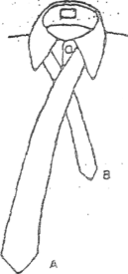
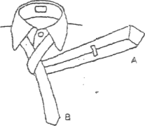
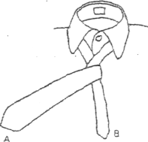

- Take A, which is longer and wider, than 3, and cross it over B.

Bring A around and under B.
- Now bring A back, over B.

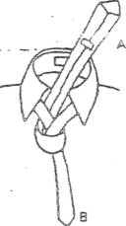
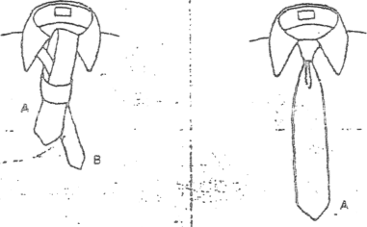
5. Then bring A back down through the loop you have made with A. Tighten the knot, adjusting with both hands, so that the knot comes down into the “V”, forming a dimple.

6. Draw the knot up tightly around your neck, insuring that B is shorter than A and A reaches the tip of your belt buckle.

4. And pull A up and through the loop around your neck

10-7. Purchase of uniforms and insignia
a. Eligible students may wear the uniform prescribed for cadets while attending JROTC
courses of instruction. These students may be issued a uniform at no expense to the
Government.
b. Schools hosting NDCC units will procure and maintain uniforms at no expense to the
Government.
c. The Government purchases JROTC distinctive insignia and accouterments for issue to
cadets.

10-8. Authorized wear of uniform insignia
a. The insignia and accouterments prescribed in this regulation will be worn on the issue-type
uniform.
b. Insignia other than that prescribed for wear with the issue-type uniform may be worn with
the cadet-type uniform at the discretion of the institutional officials. However, the distinctive
JROTC shoulder sleeve insignia is mandatory. TIOH approves distinctive insignia and
accouterments.

10-9. Unauthorized wear of uniforms and insignia
The following are not authorized for wear with JROTC uniforms or by persons associated with the JROTC Program:
a. Designs of medals, badges, ribbons, and shoulder cords that conflict with those authorized
for wear by the Federal or any foreign government.
b. Insignia consisting of the letters 'U.S.'
c. Badges or insignia that resemble badges of other Services, other than the Marksmanship.
d. Oak leaf clusters, palms, stars, or similar items that, that resemble Federal designs.
e. JROTC Cadets are not authorized to wear similar colors of the following Active Duty
units: Special Forces (green); Ranger (tan); Airborne (maroon); and Active duty (black)
berets. The wear of the above berets is reserved exclusively for units of the Active Army.
f. Cadets are not authorized to wear the reverse-sided full color U.S. flag cloth replica.
10-10. Cap insignia
The JROTC cap insignia is a wreath 1 3/16 inches in height containing the letters 'ROTC' on a
panel inside the wreath, with gold color metal (figure 10-1).

10-7. Purchase of uniforms and insignia
a. Eligible students may wear the uniform prescribed for cadets while attending JROTC
courses of instruction. These students may be issued a uniform at no expense to the
Government.
b. Schools hosting NDCC units will procure and maintain uniforms at no expense to the
Government.
c. The Government purchases JROTC distinctive insignia and accouterments for issue to
cadets.

10-8. Authorized wear of uniform insignia
a. The insignia and accouterments prescribed in this regulation will be worn on the issue-type
uniform.
b. Insignia other than that prescribed for wear with the issue-type uniform may be worn with
the cadet-type uniform at the discretion of the institutional officials. However, the distinctive
JROTC shoulder sleeve insignia is mandatory. TIOH approves distinctive insignia and
accouterments.

10-9. Unauthorized wear of uniforms and insignia

The following are not authorized for wear with JROTC uniforms or by persons associated with the JROTC Program:
a. Designs of medals, badges, ribbons, and shoulder cords that conflict with those authorized
for wear by the Federal or any foreign government.
b. Insignia consisting of the letters 'U.S.'
c. Badges or insignia that resemble badges of other Services, other than the Marksmanship.
d. Oak leaf clusters, palms, star, or similar items that, that resemble Federal designs.
e. JROTC Cadets are not authorized to wear similar colors of the following Active Duty
units: Special Forces (green); Ranger (tan); Airborne (maroon); and Active duty (black)
berets. The wear of the above berets is reserved exclusively for units of the Active Army.
f. Cadets are not authorized to wear the reverse-sided full color U.S. flag cloth replica.

10-10. Cap insignia

The JROTC cap insignia is a wreath 1 3/16 inches in height containing the letters 'ROTC' on a
panel inside the wreath, with gold color metal (figure 10-1).

(Figure 10-1. ROTC cap insignia)
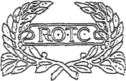
a. How worn.
(1) The cap insignia is worn on the service cap centered over the eyelet (Figure 10-2).

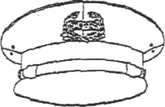

(Figure 10-2. ROTC insignia on cadet-type cap)
(2) The insignia is worn centered on the garrison cap left curtain, 1 inch from the front crease (Figure 10-3).

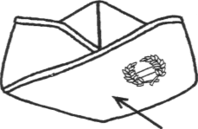
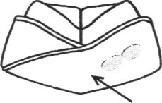
One Inch One Inch
Cadet Officer Enlisted officer
(Figure 10-3. ROTC insignia on garrison cap)
b. School design. Cap insignia of approved TIOH design will be worn as prescribed by the school official for other than issue-type uniforms.
10-11. Corps and collar insignia
The JROTC Corps insignia is the Torch of Knowledge (from the Statue of Liberty), radiant with a raised rim on a disc, 5/8" inch diameter, of gold colored metal (Figure 1(M). The corps insignia will be worn by all participants on Class A and cadet-type uniforms, and by all participants except cadet officers on Class B uniforms


(Figure 10-4. Corps insignia (JROTC))
a. Placement of insignia on Class A uniforms for cadet officers (Figure 10-5).
- Male Cadet Officer. The ROTC insignia (letters) will be worn 5/8 inches above the
notch on both collars with the center line of the insignia bisecting the notch and parallel to the
inside edge of the lapel. The corps insignia should be positioned so that the center line of the
insignia bisects the center line of the ROTC insignia and is parallel to the inside edge of the
lapel.
- Female Cadet Officer. The ROTC insignia will be worn centered on both collars 5/8
inch up from the collar and lapel seam with the centered line of the insignia parallel to the inside
edge of the lapel. The corps insignia will be worn on both lapels 1¹A inches below the ROTC
insignia, with the insignia bisecting the ROTC insignia and parallel to the inside edge of the
lapel.

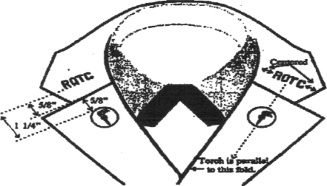
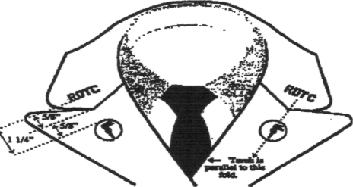

Male Cadet Officer Class A Coast Collar
Female Cadet Officer Class A Coat Collar

(Figure 10-5. Corps and collar insignia (JROTC) on cadet officers coat
b. Placement of insignia on Class A uniforms for enlisted cadets (Figure 10-6). The corps insignia (discs) are worn centered on both lapels of the coat, parallel to the inside edge of each lapel, and placed so the bottom angle is one 1" above the notch on the male and female lapel.
c. How worn on Class B and BDU uniforms.
- By cadet officers, the collar insignia (letters) are worn on the left collar of the outer
garment shirt when insignia of grade is worn on the right collar. Rank and collar insignia are
centered between the inside and outside edge of the collar and one inch above the lower edge of
the collar, with the centerline of the insignia parallel to the lower edge of the collar, bottom of
the insignia to the outside. When insignia of rank (shoulder marks) are worn on shoulder
epaulets, no insignia is worn on the shirt collar.

- By all other cadets, corps insignia (discs) are not worn on Class B or BDU uniforms
when pin-on insignia of rank are worn on shirt collars or shoulder marks are worn on shoulder
epaulets.

10-12. Insignia of grade for cadet officers
a. Description. The insignia for cadet officers consists of silver (white) color on black
background, cloth epaulet sleeve with lozenges and discs. The sleeve is 4 inches in length for
males and 3 inches in length for females. Cadets may wear disc insignia at the discretion of
JROTC instructors.
b. Officer rank. Officer ranks will be limited to those listed in figure 10-7.
- Cadet Colonel. The cadet colonel is identified by three lozenges.
- Cadet Lieutenant Colonel. The lieutenant colonel has two lozenges.
- Cadet Major. The cadet major has one lozenge.
- Cadet Captain. The cadet captain has three discs.
- Cadet First Lieutenant. The cadet first lieutenant has two discs.
- Cadet Second Lieutenant. The cadet second lieutenant has one disc.
c. How worn. These rank insignia are worn on both shoulder epaulets of the AG 344 and the Army Shade 415 gray-green shirt. When wearing rank disc insignia, the disc will be centered between the bottom of the button hole and the top of the shoulder seam of the garment.

10-13. Insignia of grade for cadet noncommissioned officers and enlisted members
a. Description. Insignia is of silver (white) color on black background, cloth shoulder epaulet
sleeve with chevrons, bars, and diamond, star or star within wreath, indicating noncommissioned
officer grades. The shoulder epaulet sleeve is 4 inches in length for males and 3 inches in length
for females. Cadets may wear pin-on insignia of rank at the discretion of JROTC instructors.
b. Grades. Grades will be indicated on the shoulder epaulet sleeve as follows. See Figure 10-

7.
- Cadet Sergeant Major. Three chevrons above three bars with a star within a wreath
between the chevrons and bars.
- Cadet Staff Sergeant Major. Three chevrons above three bars with a star between the
chevrons and bars.
- Cadet First Sergeant. Three chevrons above three bars with a diamond between the
chevrons and bars.
- Cadet Master Sergeant. Three chevrons above three bars.
- Cadet Sergeant First Class. Three chevrons above two bars.
- Cadet Staff Sergeant. Three chevrons above one bar.
- Cadet Sergeant. Three chevrons.
- Cadet Corporal. Two chevrons.
- Cadet Private First Class. One chevron above one bar.

- Cadet Private. One chevron.
- Cadet Basic. No insignia of grade.
c. How worn. The shoulder epaulet sleeve is slipped over shoulder epaulet of uniform so that
the insignia will be centered on the outer half of both shoulder loops of the coat, overcoat, or shirt/blouse.

10-14. JROTC and distinctive shoulder sleeve insignia
a. The JROTC distinctive shoulder sleeve insignia.
(1) Description. The shoulder sleeve insignia is a rectangular device 3 5/8 inches in height and 21/2 inches in width, consisting of a gray center edged with a 1/8 inch scarlet border at the top and bottom. On this device is a yellow olive wreath surmounted in the vertical center by a yellow torch inflamed. Above the center is a white horizontal scroll inscribed 'U.S. Army' and below the center is a white scroll inscribed 'JROTC' all in scarlet letters 5/16 inch in height. The entire device is within a 1/8 inch scarlet border (Figure 10-8).

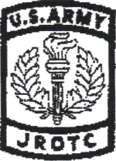

(Figure 10-8. JROTC shoulder sleeve insignia)
- How worn. It is worn on the upper part of the outer half of the left sleeve of the coat and BDU uniform. The top of the insignia will be worn 1/2 inch below the top of the shoulder seam.
- Uniform worn. Issue or cadet-type uniform.
- JROTC subdued distinctive shoulder sleeve insignia. The subdued shoulder sleeve insignia may be worn when wearing the BDU.
b. School shoulder sleeve insignia may be procured at Government expense.
(1) Description. Approved designs that have been submitted to and approved by TIOH,
USA.
- How worn. On right sleeve in the corresponding position to the shoulder sleeve of the coat and BDU uniform. The top of the insignia will be worn 1/2 inch below the top of the shoulder seam.
- Uniform worn. On issue or cadet-type uniform

10-15. Academic achievement insignia
Cadets with at least a B average hi all subjects and an A average in JROTC are authorized to wear the academic achievement insignia. The insignia will be worn on the issue or cadet-type uniform only during the academic term following the term in which the grades were earned.
a. Description. This insignia is a gold colored metal wreath 7/8 inch hi height (Figure 10-9)

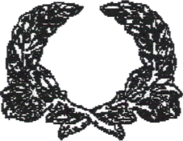

(Figure 10-9. Academic achievement insignia)
b. How worn. It is worn centered immediately above the right breast pocket on the coat or shirt when worn as an outer garment. If the Honor Unit insignia is worn, the wreath will be pinned so that the star will be worn with the wreath (Figure 10-12).



(Figure 10-10. Academic achievement insignia with honor insignia)
c. Subsequent awards. Receipts of subsequent awards are indicated by a felt pad centered background worn beneath the wreath so as not to protrude beyond its edges.
- For second award - a red pad.
- For third award - a silver gray pad.
- For fourth award - a gold pad.

10-16. Honor Unit, Honor Unit with Distinction, and Merit Unit insignia
a. Description.
- Merit Unit insignia; a five-pointed star of white enamel on gold colored metal, 9/16
inches in diameter.
- Honor Unit insignia; a five-pointed star of blue enamel on gold colored metal, 9/16
inches in diameter.
- Honor Unit with Distinction insignia; a five-pointed star of yellow enamel on gold
colored metal, 9/16 inch in diameter).

White Blue Yellow



(Figure 10-11. Honor unit insignia)
b. How worn. These insignia are worn centered 1/4 inch above the right breast pocket on the male uniform and ¼ of an inch above the nameplate on the female uniform, with one point of the star up, on the coat or shirt when worn as an outer garment (Figures 10-12 and 10-13).
10-17. Placement of Nameplate and Unit Crest
Nameplates must conform to the description below and will be worn on issue uniforms.
a. Description. Nameplates will indicate the last name only and will be 1 by 3 inches (may
be longer in case of lengthy names) with white block type lettering 1/4 to 3/8 inch high on a jet-
black background. (It may have a white edge or border not exceeding 1/32 inch in width).
b. How worn on male Class A uniform.
- The pocket area on the Class B uniform is the same as the pocket area on the Class A
uniform. The male name plate will be worn on the flap of the right breast pocket. The name
plate will be vertically centered between the top of the button and the top of the pocket. Center
the name plate horizontally above the button.
- The Honor Unit with Distinction star is worn centered and 1/4 inch above the right
pocket. It can be worn by itself or joined with the Academic Achievement Wreath, hi which
case the star is still positioned 1/4 inch above the seam. The unit crest will be worn centered on
the pocket and centered vertically from the bottom of the pocket flap to the bottom seam of the
pocket.

(3) Ribbons are placed 1/8 inch from the top of the pocket. Medals ot any kind are to be ivorn centered on the pocket flap 1/8 inch from the top of the pocket seam.

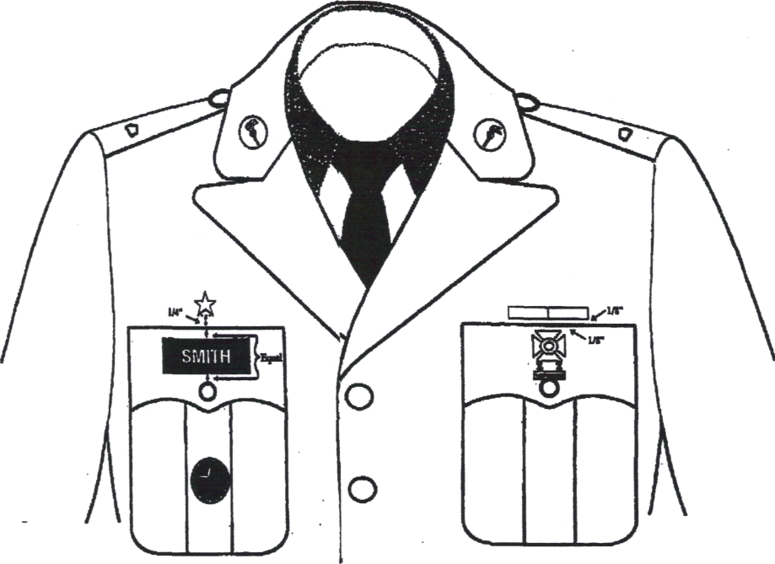

(Figure 10-13. Male Class A uniform)

c. How worn on female Class A uniform.
- The pocket area on the Class B uniform is the same as the pocket area on the Class A
uniform. The bottom edge of the nameplate should rest centered on the imaginary line that runs
to the top of the button.
- The Honor Unit with Distinction Star should be centered on the plate a quarter of an
inch (Vi") above it. It can be worn by itself or joined by the Academic Achievement Wreath, in
which case the star is still positioned 1/4 inch above the nameplate. A ruler or straight edge is a
valuable tool when placing these items on the uniform.
- Ribbons are to be aligned to the top of the first button spaced 1/8 between each row.
Badges and medals are placed 1/8 inch below the ribbons as show in figure 13.

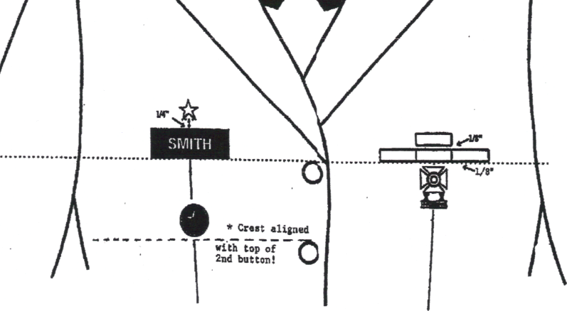

(Figure 10-14. Female Class A uniform)

10-18. Nametape

The JROTC nametape will be —
a. Woven tape of olive green cloth, 1 inch wide, with the inscription 'JROTC' in black block
letters 3/4 inch high.
b. The insignia tape is worn immediately above, and parallel to the top edge of the left breast
pocket of temperate, hot-weather, BDU shirts; BDU field jackets; and on organizational clothing
when required and prescribed by the commander issuing the organizational clothing.
10-19. Optional items
Distinctive Unit Insignia (DUI), shoulder cords, shoulder sleeve insignia, and color trimmings described in this paragraph are optional items.
a. These items may be procured (subject to funding availability) at Government expense for
schools electing to prescribe their wear or by individuals who are voluntary members of
authorized JROTC military organizations. DUI, shoulder cords, shoulder sleeve insignia, and
color trimmings will be worn only after specific design, materials, and quality associated with
their manufacture have been approved by TIOH.
b. School officials may prescribe the wear of approved DUI. Procurement will be as stated in
a above. The DUI will be worn as shown in figures 10-15.
c. Insignia of national or local military honor societies, at the option of the SAI, may—
- Be substituted for school insignia and worn in accordance with b above.
- Approved DUIs will be worn 1/4 of an inch above the right coat pocket on the male
uniform and 1/4 of an inch above the nameplate on the female uniform. All command, region
and school insignias will be worn on the left coat pocket in similar fashion.

(Figure 10-15. Optional Items
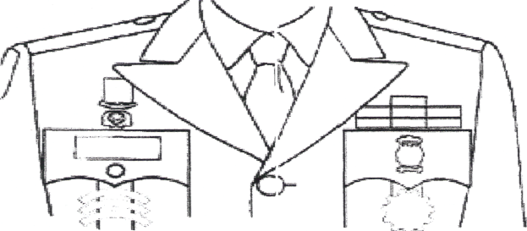

d. School organization DUI will not be worn on insignia of grade shoulder epaulet sleeves. School or organization DUI will not be worn on the BDU uniform.
e. If worn on the class B uniform, the DUI will be worn 1/4" above the right chest pocket or 1/8" above the unit rating insignia or academic wreath above the right chest pocket on the male and worn 1/8" above the nameplate on the female uniform in the same fashion.
f. Shoulder cords. Shoulder cords may be procured at Government expense (subject to funding availability). Solid, single color, or multi-colored shoulder cords may be designed and authorized to designate a host institution, unit, activity or cadet position. Shoulder cords must be approved by USACC. No more than one cord may be worn on each shoulder as shown in figure 10-16.
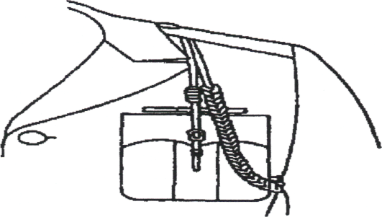
(Figure 10-16 DUI Shoulder Cords)
(1) Shoulder cords will be used to designate participation in extra-curricular activities including but not limited to -
- Color Guard - white (Cable #65005).
- Drill activity - red (Cable #65006).
- Musical activity - blue (Cable #70147).
- Marksmanship activity - tan (Cable #65015).
- Honor organizations, such as national and local honor societies - gold (Cable #70157).
- Orienteering activity - green (Cable #70063).
- Adventure type activity - black (Cable #65018).

