8th Grade Science
Unit 2 Matter Review Test OPEN BOOK DO NOT WRITE ON OR MARK THIS PACKET
Multiple Choice
Directions: Fill in the bubble for the answer you choose on the provided answer grid.
SC.8.P.8.2
1. The terms mass and weight are often used interchangeably. When you purchase produce from the grocery store, you place your items on a spring scale. What physical property of matter is being measured?
A. Mass
B. Weight
C. Mass and Weight
D. The amount of material in an object

SC.8.P.8.2
2. Weight is proportional to but not equal to mass. In which of the following situations would a person show an increase in weight but not an increase in mass?
A. Climbing to the top of a mountain. B. Traveling on the highway in a SUV.
C. Landing on a planet with more gravity. D. Living in a chamber in an underwater
habitat.

SC.8.P.8.2
3. Which statement BEST describes the relationship between mass and weight?
A. As the value for mass increases, the weight decreases.
B. The mass will always be greater than the weight.
C. Weight is always needed to calculate mass.
D. Weight is dependent on mass and gravity.

SC.8.P.8.3
4. Ariel has 2.6 grams of zinc. What volume of the material does she have if zinc has a density of 7.13 g/cm3 Density = Mass /Volume
A. 18.5 cm3 B. 2.7 cm3 C. 4.5 cm3 D. 0.4 cm3

SC.8.P.8.3
5. From the table, which substance has the smallest density? Density = Mass /Volume
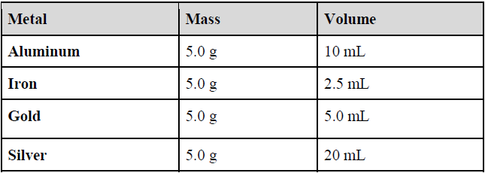
A. Iron B. Gold C. Silver D. Aluminum

SC.8.P.8.3
6. When two liquids are poured into a graduated cylinder, two-layers form. Liquid A has a volume of 16 ml and a mass of 87 g. Liquid B has a volume of 234 ml and a mass of 100 g. Based on this
information which liquid will form the top layer? Density = Mass /Volume
A. Liquid A because it is less dense than liquid B.
B. Liquid B because it is less dense than liquid A.
C. Liquid B because it’s density is greater than liquid A.
D. Liquids A and B have equal densities, so there will be no layers.

SC.8.P.8.3
7. A 5 g sample of pure gold has a density of 19.3 g/ml. Your friend purchased a gold ring that was made of 25 g of pure gold. What is the density of the ring? Density = Mass /Volume
A. 19.3 g/ml B. 96.5 g/ml C. 3.9 g/ml D. 48.3 g/ml

SC.8.P.8.4
8. The state of matter is an example of a physical property. Why is the state of matter considered a physical property, even though a substance may change between a solid, liquid, and gas?
A. The property can be easily observed.
B. The chemical nature of the substance does not change.
C. The state of matter depends on the amount of substance present.
D. Solids, liquids, and gases contain different substances from one another

SC.8.P.8.4
9. Physical properties can be used to classify and compare substances. The illustration below shows a physical property that is being investigated using different materials. What physical property is most likely being investigated in this illustration?
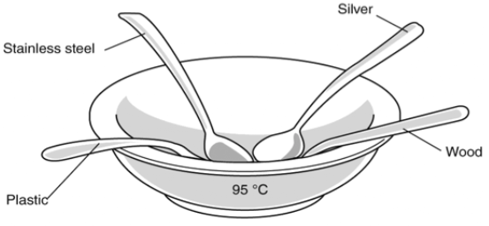
A. Magnetism B. Melting point C. Thermal conductivity D. Electrical conductivity

SC.8.P.8.4
10. Thomas performed an experiment to measure the temperature of water as he heated it on a hotplate.
At the end of his experiment, he plotted the results as shown in the graph below.
Which of the following physical properties of water did Thomas measure during his experiment?
A. melting point and boiling point
B. volume and thermal conductivity
C. solubility and electrical conductivity
D. density and physical states of matter
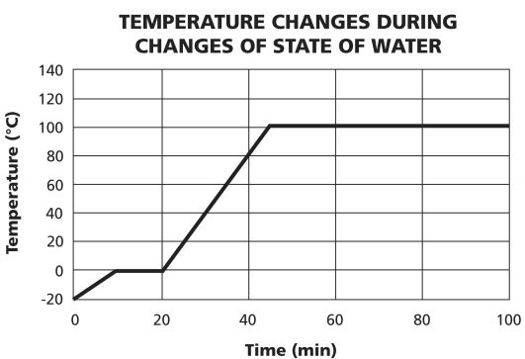

SC.8.P.8.4
11. Amanda is presented with a piece of metal and asked to determine its physical properties.
Which of the following groups best represent the physical properties of metal.
A. thermal conductivity, magnetism, low melting point
B. magnetism, electrical conductivity, high melting point
C. soluble in water, thermal conductivity, low melting point
D. electrical conductivity, high melting point, soluble in water

SC.8.P.8.4
12. Physical properties can be used to compare and classify substances. The process below
demonstrates a physical property of sugar.
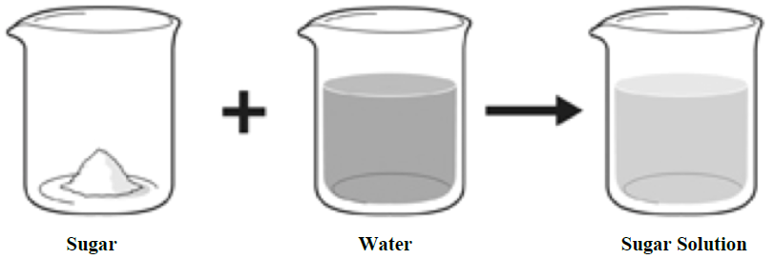
Which of the following physical properties of sugar is demonstrated by the process?
A. thermal conductivity B. melting point C. solubility D. density

SC.8.P.8.4
13. The pictures below show four objects - a paper clip, a pair of scissors, a needle, and a
horseshoe. All objects are made from the same metal.
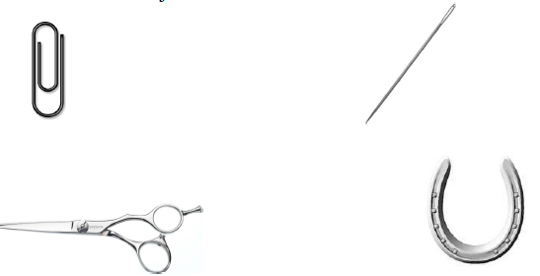
Which of the following physical property is different for all four of these objects?
A. mass B. density C. magnetism D. electrical conductivity

SC.8.P.8.4
14. The two beakers shown below contain pure water.
Which of these properties is the same for the water in both beakers?
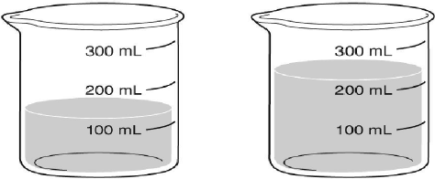
A. mass B. weight C. density D. volume

SC.8.P.8.4
15. A pebble is dropped into a cup of water and sinks to the bottom of the cup. A solid metal
bead of exactly the same size is dropped into the same cup and sinks to the bottom of the
cup. How do the pebble and the metal bead compare?
A. They both have the same mass. B. They are both denser than water.
C. They both have the same density. D. They both contain the same material.

SC.8.P.9.2
16. A student is preparing to bake a cake at home and places several ingredients on the
countertop to use. First he preheats the oven to 175ºC, then mixes all of the ingredients
together. He pours all of the cake batter into 2 pans and bakes for 1 hour. The cake layers
are allowed to cool for 15 minutes. Which of the following indicates that a chemical
change occurred?
A. Preheating the oven to 175ºC. B. Cooling the cake layers.
C. Mixing the ingredients. D. Baking the cake batter.

SC.8.P.9.2
17. There is an acid that smells like sweaty socks. When alcohol is added to it and the
mixture is heated, no change is visible, but a new odor of sweet apples fills the
room. Which of the following is the best explanation for this observation?
A. a chemical change has taken place and no new substance was produced.
B. a physical change has taken place and no new substance was produced.
C. a chemical change has taken place and a new substance was produced.
D. a physical change has taken place and a new substance was produced.

SC.8.P.9.2
18. Jean’s mother lit a candle and placed it on his birthday cake. As they sang happy
birthday, the wick burned, the wax melted, the candle changed shape, and the air
around the candle heated up. Which of the following is NOT an example of a
physical change?

A. The wax melting. B. The wick burning.
C. The candle changing shape. D. The air around the candle heating up.

SC.8.P.9.2
19. When wood burns, a small amount of ashes is produced and gas is given off. How does
this reaction demonstrate the law of conservation of mass?
A. The mass of wood and oxygen that allowed it to burn equals the mass of the ashes and
the gas given off.
B. The mass of the wood and ashes equals the mass of the oxygen and smoke given off
during burning.
C. The mass of just the wood will equal the mass of just the ashes after burning.
D. The mass of the wood does not equal the mass of the ashes.

SC.8.P.9.2
20. In this example of a chemical change, sodium is added to chlorine gas to produce table
salt.
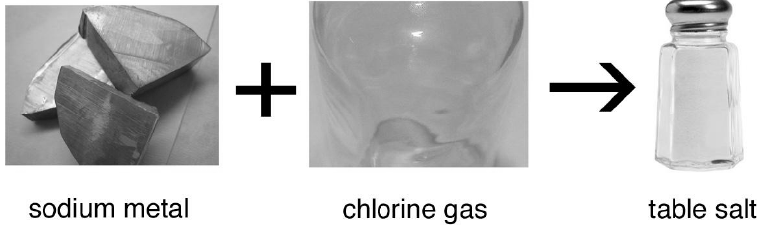
How does the mass of the sodium metal and chlorine gas involved in the reaction,
compare to the mass of the table salt produced?
A. The mass of the sodium metal and chlorine gas combined is equal to the mass
of the table salt that is produced.
B. The mass of the sodium metal and chlorine gas combined is larger than the
mass of the table salt produced.
C. The mass of the sodium metal and chlorine gas combined is less than the mass
of the table salt produced.
D. The mass of the sodium metal is equal to the mass of chlorine gas used and the
table salt produced.

SC.8.P.8.5
21. The chart below shows the different combinations that some elements make when they
react with oxygen.
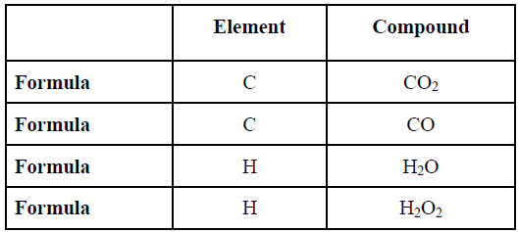
Based on the data in the table above, which is a reasonable conclusion regarding elements and
the compounds they form?
A. When an element reacts to form a compound, its physical properties are not changed.
B. When an element reacts to form a compound, its atoms can only combine in one way.
C. When an element reacts to form a compound, only its chemical properties are changed.
D. When an element reacts to form a compound, its atoms combine in a multitude of ways.

SC.8.P.8.5
22. The drawing below illustrates an interaction between different substances.
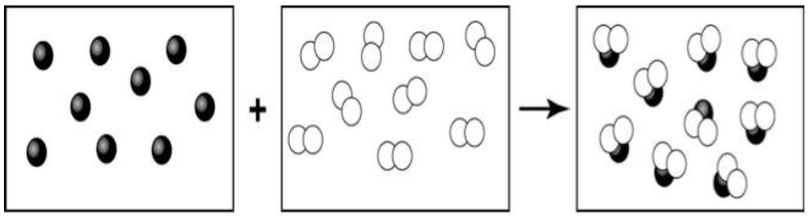
Which statement below best explains what the drawing illustrates?
A. Compounds can combine to form different elements.
B. Atoms of different elements can combine to form compounds.
C. Atoms of different elements can combine to form other elements.
D. Compounds can be broken down to into the various elements from which they are made.

SC.8.P.8.5
23. Alisa needs to make some hot tea for her ill mother. She uses some ice-cold water from
the freezer and heats it up in the kettle. As she hears the teapot whistling, she asks herself,
“How is the motion of the ice water’s particles changing as the hot tea is being made?”
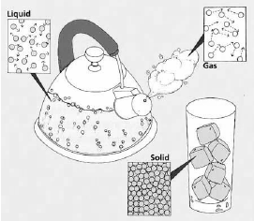What is the best answer to Alisa’s question?
A. The particles in the cold water moved at the same rate until an increase in temperature
caused a decrease in particle motion in the hot tea.
B. The particles in the cold water moved at a slow rate until a decrease in temperature
caused an increase in particle motion in the hot tea.
C. The particles in the cold water moved at a slow rate until an increase in temperature
caused an increase in particle motion in the hot tea.
D. The particles in the cold water moved at a high rate until an increase in temperature
caused a decrease in particle motion in the hot tea.

SC.8.P.8.5
24. Kristin’s teacher gave the students a formative assessment on the movement of particles in
solids, liquids, and gases. She projected the models shown below with the following 3 questions:
1. Which model shows particles of ocean water?
2. Which model shows particles of glaciers?
3. Which model shows particles of hot air?
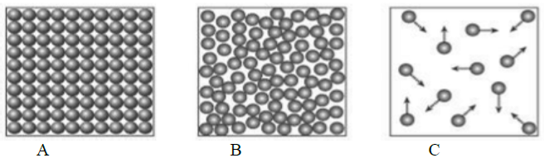
How should Kristin answer the questions?
A. (1) A, (2) B, (3) C B. (1) B, (2) C, (3) A
C. (1) C, (2) A, (3) B D. (1) B, (2) A, (3) C
SC.8.P.8.8
25. Joseph completed an acid-base lab where he identified his unknowns as bases or acids
using his investigative data. He decided to create a table for his data, and used a pH scale
diagram, like the one shown below to identify his unknowns. The table below represents
Joseph’s table.
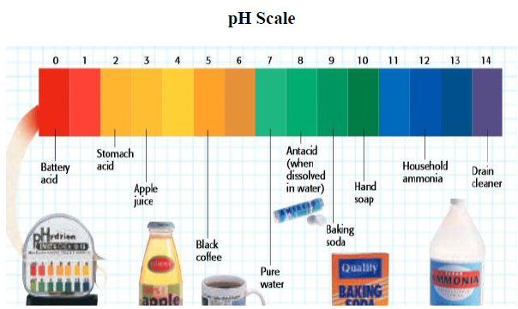
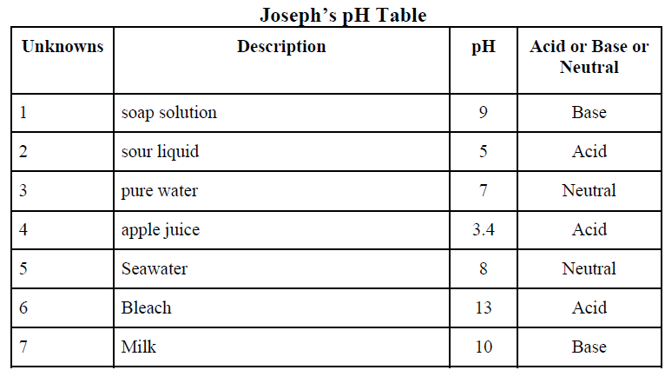Which of the unknown compounds were wrongly identified as acid, base or neutral?
A. Bleach and seawater should be identified as bases.
B. Pure water and seawater should be identified as a neutral.
C. Soap solution and sour liquids should be identified as acids.
D. Sour liquid and apple juice should both be identified as bases.

SC.8.P.8.8
26. The Healthy News magazine reported that more than 38 million people continue to suffer
from allergies, heart problems, digestive issues and weight problems associated with acid
overload. They recommend eating more alkaline foods to shift your body’s pH to a more
ideal pH of 7.5. Below is a list of foods and their pH.
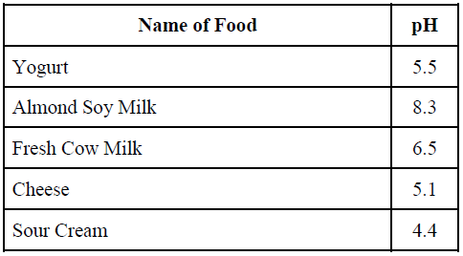
Which of the foods in the table would the magazine editor recommend that you have more of?
A. Yogurt B. Sour Cream C. Fresh Cow Milk D. Almond Soy Milk

SC.8.P.8.8
27. Water is a neutral substance with a pH of 7. Marc was asked to sequence the following
common household substances according to their pH.
When placed in order from highest to lowest pH, which of the following substances is closest
to neutral and is a base?
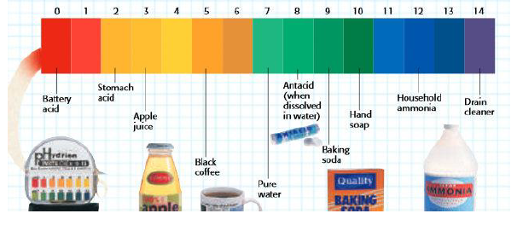
A. Baking Soda B. Black Coffee C. Apple Juice D. Antacid

SC.8.P.8.9
28. Mixtures are two or more substances that are not chemically combined. Which of the
following statements is true about the mixture?
A. Pepsi is a heterogeneous mixture.
B. Milk is a pure substance, not a mixture.
C. Cranberry juice is a homogeneous mixture.
D. Oatmeal with raisins is a homogeneous mixture.

SC.8.P.8.9
29. Two grams of sodium chloride (table salt) were completely dissolved in a glass of water.
How would you classify the resulting material?
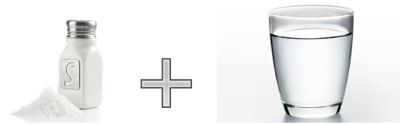
A. As a pure substance. B. As a salt suspension.
C. As a homogeneous mixture. D. As a heterogeneous mixture.

SC.8.P.8.9
30. A water molecule is made up of one oxygen and two hydrogen atoms. Why is water
considered a pure substance?
A. Each water molecule has an identical composition and properties.
B. Water can be combined with other substances by physical means.
C. Water molecules are made up of different types of atoms.
D. Water can not be broken down by physical means.

SC.8.P.8.7
31. The nucleus of most atoms is composed of which of the following sub-atomic particles?
A. tightly packed protons.
B. tightly packed neutrons.
C. tightly packed protons and neutrons.
D. loosely connected protons and electrons.
SC.8.P.8.7
32. The smallest unit of an element is composed of the following “sub-atomic particles”.
A. protium, deuterium, and tritium
B. protons, neutrons, and electrons
C. protons, neutrinos, and ions
D. protons, neutrons, and ions

SC.8.P.8.7
33. The image below shows a model of the atom. Which subatomic particle does the arrow in the image below identify?
A. electron B. neutron
C. orbital D. proton

SC.8.P.8.7
34. According to the scientific theory of atoms, which of the following statements best describes the location of electrons?
A. in the nucleus of the atom
B. both in the nucleus and around it
C. outside the nucleus and often far from it, in the electron cloud
D. outside the nucleus, yet very near it because they are attracted to the protons
SC.8.P.8.6
35. The periodic table was created by grouping elements according to their properties. Oxygen is a gas that has 6 valence electrons and is colorless. Which of the following unknown element would be grouped along with it?
A. Boron B. Selenium C. Aluminum D. Phosphorous
SC.8.P.8.6
36. Which list of elements is arranged in order of increasing atomic number?
A. Sr, Ca, Mg, Be B. Sc, V, Ti, Cr C. B, C, Li, Be D. F, Cl, Br, I

SC.8.P.8.6
37. Which of these elements has physical and chemical properties most similar to Arsenic (As)?
A. germanium (Ge) B. phosphorus (P) C. silicon (Si) D. lead (Pb)

SC.8.P.8.6
38. Strontium (Sr) is a silvery metal element that burns an intense color in air and reacts with water. Which of the following elements will share similar properties?
A. Potassium (K) B. Calcium (Ca) C. Yttrium (Y) D. Tin (Sn)

SC.8.P.8.6
39. The element germanium (Ge) was once use in the manufacture of transistors for radios. What other element has similar properties that might be used for the same purpose?
A. G B. Br C. Sn D. O

The properties of the elements exhibit trends or periodicity. These trends can be predicted using the periodic table. The periodic trend diagram below, shows how properties of elements increase when following the direction of the arrow.
SC.8.P.8.6

40. Using the periodic trend diagram above and the periodic table provided, identify which one of the properties potassium (K) has that is a larger value than the same property for lithium (Li)?
A. atomic radius B. electron affinity
C. ionization energy D. nonmetallic character

