Name: _________________________ Date: ____________ Period: ____ Assign# _______________

Student Exploration: Weight and Mass
Vocabulary: balance, force, gravity, mass, newton, spring scale, weight

Prior Knowledge Questions (Do these BEFORE using the Gizmo.)

- Your weight is the pull of gravity on your body. Suppose you step on a bathroom scale on the Moon. How would your weight on the Moon compare to your weight on Earth?

A. greater on the Moon B. less on the Moon C. same on Earth and the Moon

- Your mass is the amount of matter, or “stuff,” in your body. How would your mass on the Moon compare to your mass on Earth?

A. greater on the Moon B. less on the Moon C. same on Earth and the Moon
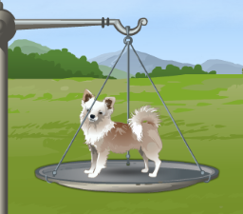
Gizmo Warm-up
On the Weight and Mass Gizmo™, you can use a balance to compare the masses of objects.

- Place the dog on the right pan of the balance. What happens? _____________________________
- Place the 5-kilogram (kg) mass on the other pan. Which has more mass, the dog or the 5-kg mass?

__________________________________________

- The 5-kg mass is heavier than the dog, so take it off the pan and place a 1-kg mass on the pan. Add 1-kg masses to the left pan until it goes down. Then take one of the 1-kg masses off the pan so that the masses are above the dog.

- Use this process of adding and subtracting other masses from the left pan until the two pans are balanced. Add up all the masses on the left pan. This is equal to the mass of the dog.

What is the mass of the dog? _________________________________________________

You can check your answer by clicking the center of the cross beam of the balance.
Activity A:  Weight on different planets | Get the Gizmo ready:  - Click Clear scales to remove all objects from the spring scale and the balance.  - Click the center of the cross beam of the balance to turn off the mass display. | 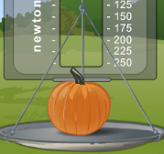

Introduction: A spring scale is used to measure force. Since weight is a type of force, a spring scale can measure weight. The metric unit of force is the newton (N).

Question: Will an object’s weight change on different planets?

- Measure: Place the pumpkin on the spring scale. Click the red line on the scale to see the weight measured to the nearest newton.

What is the weight of the pumpkin? _____________________________________________

- Predict: If you take an object to a different planet, do you think its weight will stay the same or be different? (Circle your answer.)
Same Different

- Collect data: Measure the weights of the following objects on Earth, the Moon, Mars, and Jupiter. Record your measurements in the data table below.
 | Pumpkin | Dog | Watermelon
Weight on Earth
Weight on Moon
Weight on Mars
Weight on Jupiter

- Analyze: Does the weight of an object change when it is moved to a different planet?
_________________________________________________________________________
- Extend your thinking: Which celestial body had the strongest gravity, Earth, the Moon, Mars, or Jupiter? Explain how you know. _____________________________________________________________________________ __________________________________________________________________________________________
Activity B:  Mass on different planets | Get the Gizmo ready:  - Click Clear scales. | 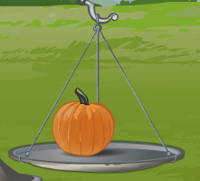

Question: How do weight and mass change on different planets?

- Predict: If you take an object to a different planet, do you think its mass will stay the same or be different? (Circle your answer.)
Same Different

- Collect data: Use the balance to measure the masses of the following objects on Earth, the Moon, Mars, and Jupiter. Record your measurements in the data table below.
 | Pumpkin | Dog | Watermelon
Mass on Earth
Mass on Moon
Mass on Mars
Mass on Jupiter

- Analyze: Does the mass of an object change when it is moved to a different planet?

_________________________________________________________________________
- Draw conclusions: Based on what you have learned about mass and weight, why do you think the mass did not change but the weight did? ____________________________________________________________________ __________________________________________________________________________________________ __________________________________________________________________________________________
- Extend your thinking: First, using the balance, find the mass of a pumpkin on Jupiter. Then place the pumpkin on the spring scale and record its weight. Finally remove the pumpkin and weigh the masses from the balance on the spring scale. How do the weights compare?

_________________________________________________________________________

_________________________________________________________________________
Extension:  Force of gravity | Get the Gizmo ready:  - Click Clear scales. | 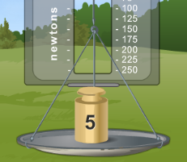

Question: How strong is gravity on Mars, Jupiter, Earth, and the Moon?

- Observe: Using the spring scale, measure the weights of objects on different planets. List the three planets and the Moon from strongest gravity to weakest.

Strongest _____________ _____________ _____________ _____________ Weakest
- Predict: On which planet or moon do you think the 5-kg mass will weigh the most? Least?

_________________________________________________________________________

- Collect data: Find the weight of the 5-kg mass at each location.
 | Earth | Moon | Mars | Jupiter
Weight of 5-kg mass (N)

Was your prediction correct? ____________

- Calculate: Weight depends on mass and the strength of gravity. Estimate the strength of gravity on each location by dividing the weight of the 5-kg mass by 5.

 | Earth | Moon | Mars | Jupiter
Strength of gravity (weight of 5-kg object ÷ 5)

- Calculate: First measure the mass of the flowerpot in the Gizmo. Then predict the weight of the flowerpot on each planet (multiply the mass by that planet’s strength of gravity). Finally check your predictions by actually weighing the flowerpot on each planet, using the Gizmo.

 | Earth | Moon | Mars | Jupiter
Flowerpot mass (kg or g)
Predicted flowerpot weight (N)
Measured flowerpot weight (N)

Vocabulary: Weight and Mass

Vocabulary
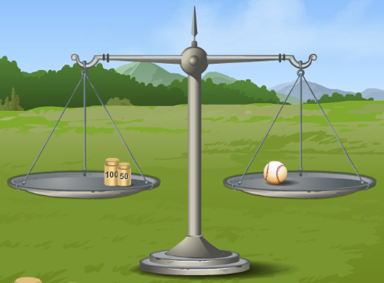
- Balance – an instrument used to compare two masses.
  - Usually an unknown mass on one pan is compared to a known mass on the other pan. The masses are equal when the pans are balanced.
  - A balance cannot measure mass directly. A balance is balanced when the weight on each pan is equal. In a given location, objects with equal weights have equal masses.

- Force – something that can cause a change in motion; a push or a pull.

- Gravity – the force of attraction between objects in the universe due to their mass.
  - Earth’s gravity causes objects to fall to Earth’s surface.
  - Gravity is only significant when one of the objects has a lot of mass, like the Earth. There is very, very little gravitational attraction between you and your couch—but there is some!

- Mass – the amount of matter in an object.
  - In the metric system, units for mass include the kilogram (kg) and the gram (g). There are 1000 grams in a kilogram.

- Newton – the metric unit of force and weight.
  - On Earth’s surface, an object with a mass of one kilogram has a weight of 9.82 newtons (N).

- Spring scale – an instrument used to measure force.
  - The more the spring is stretched, the greater the force.

- Weight – the downward force of gravity on an object.
  - The greater the strength of gravity, the more the object weighs.
  - The greater the mass of the object, the more it weighs.

