Newspaper Project

This document will be updated on a regular basis to help you understand each of the projects that you will be completing within class. I think that it is very important to try and have a better understand of how a business can be organized and learn how the information you learn in class can be applied to a business. You will be working as a contractor for a local newspaper. There will be several assignments that will go along with the course work you will be completing throughout the semester. Each project will be listed under each heading below.

Letter to the Editor – 30 points
You will be writing an article in a few weeks. The topic will be of your choice (as long as it is school appropriate). Use your creativity to make the letter sound very professional…this will only improve your grade. You will need to do the following for this assignment.
- Identify the topic you want to write about. This could be something that you are interested in at home or at school. It could be an activity you are actively involved in. It could be a school issue that you want to address.
- Create a letter using the block style format. (See letter packet if you need help in formatting the letter correctly.)
  - The Inside address is: 1507 W. 8th Street, Meridian ID 83642
  - The person you are writing the letter to is: Mrs. Hanson
  - The letter should be at least two paragraphs. The information within the first paragraph will be asking permission to have your article in the editor’s newspaper as well as the topic you will be writing your article about.
  - The second paragraph will discuss the reason why you want to write the article.
  - Save the document as Letter_Initials.

Letterhead– 10 points
You will be creating letterhead for your newspaper group. This letterhead will be used on your memo and all further communication for this project. The following needs to be included:
- At 1”, insert a line across the page. (Insert/shapes)
- You will need the name of your newspaper as the largest part representing the name of your company.
- You will need to include the names of your group members. This can be done in a text box that you can be creative with the look.
- You need the address: 1507 W. 8th Street, Meridian ID 83642
- You need the phone Number: 208-855-4225

Memo to Your Team Members – 30 points
Once Mrs. Hanson approves your request for your article, she will then tell you who your team members are for the duration of the project. You will then submit a memo to your team members letting them know the following:
- What your topic is for your article
- How long you think your article will be (this is so that the team can identify how much room they will need for your newspaper.)
- Why you chose this topic to go into the newspaper.
- You will save the memo as Memo_ Initials
Use your creativity to make the memo sound very professional…this will only improve your grade.

You will be creating a flyer within Word advertising your newspaper. (30 Points)
Create the name of the newspaper.
Be creative in what you will include within the flyer. Some items to include may be
- How much the newspaper costs
- Where you can purchase the newspaper
- Who will be writing within the newspaper
- What type of articles will be featured within the newspaper
You must use WordArt and ClipArt within the flyer.
Save the document as flyer_ Initials

Remember that creativity will only improve your score.

Newspaper Article – 30 points
You will create the article that you have decided to write about. Please make it very detailed and thought out. Please proof your work, ensuring that grammar and correct spelling has been used. You may research your topic if you need to.

Save the document as article_ Initials

Newspaper – 100 points
Mrs. Hanson will send the articles of each of your team members to you electronically. You will then take those articles and create a newspaper. The following are the requirements for the newspaper. Remember that the more creative and “pleasing to the eye” the better the grade.
- Use WordArt to create the Newspaper Name
- Change the margins so that each margin is .5”.
- The newspaper should have a least 2 columns
- The articles should all be justified (Select the text and click on the justified button within the Paragraph group)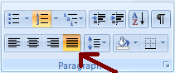

- Each article should have an image within the article.
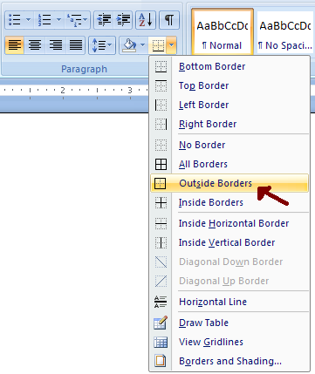
- Any images should have borders around them (Select the image and click on the outside border within the Paragraph group)

- Include a bulleted list within your article (See bullets with the K6 folder on how to make bullets)
- Save the document as Newspaper_ Initials

