Pinellas County Schools

Communities
Reading Listening
Cultures
Speaking Writing

Comparisons
Connections
Listening/Reading
Speaking/Writing

Spanish I
Unit Three: Pasatiempos
Practice Test
ANSWER KEY



Objective 2: I can understand written messages related to leisure time activities.

After reading the letter, list five plans in English for pastimes and activities mentioned by Luisa.

Querido Gustavo,
Voy a estar contigo en cinco días en la playa. ¡Qué bueno! Me gustaría jugar vóleibol en el gimnasio contigo el lunes. El martes, voy a ir al centro comercial. ¿Vas de compras conmigo? Después, el miércoles me gustaría jugar tenis en el parque. ¿Y tú? ¿Quieres ir de pesca el jueves? Me gustaría ir de pesca cerca de la playa. El viernes voy a ir a una fiesta en la casa de Alicia. ¿Quieres ir conmigo? Bueno. Hasta el lunes.
A 5/5
B 4/5
NY
Saludos,
Luisa

Luisa’s plans for pastimes and activities | When?  (¿Cuándo?) | Where?  (¿Dónde?)
1. play volleyball | Monday | The gym
2. go shopping | Tuesday | The mall
3. play tennis | Wednesday | The park
4. go fishing | Thursday | The beach
5. go to a party | Friday | Alicia’s house

Objective 3: I can identify pastimes.

¿Qué quieres hacer?
Identify each of the activities in the space below each picture.
1. Comer 2. Jugar al fútbol 3. Ir de compras
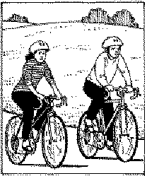

4. Montar en bicicleta 5. Jugar al tenis 6. Jugar al volibol


7. Leer 8. Ir de pesca 9. Jugar a los videojuegos

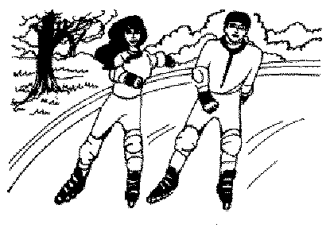

10. Patinar 11. Escuchar música 12. Nadar

A 9/12 correct with no spelling errors.
B 9/12 correct with no more than one spelling error
NY

Objective 4: I can identify places to go.

¿Adónde vas?
Write the name of the place in the space below each picture. Be sure to include an article (el/la)

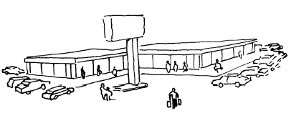
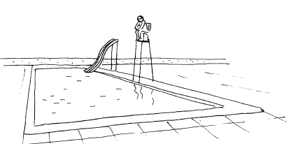

- El centro comercial 2. La piscina

- El cine 4. El parque

5. La playa 6. El gimnasio

A 6/6 correct with spelling.
B 5/6 correct with spelling.
NY

Objective 5: I can describe the seasons and weather. I can express likes and dislikes.
- What verb is used with weather expressions? How is that different from English? HACER and it means to “do” or to “make” in Spanish. In English, we say what the weather is “like,” not what it is “doing” or “making.”

¿Qué tiempo hace?
Match the picture to the season and write a complete sentence for each picture. Name at least one weather expression and one activity that you like to do in that season.

A. 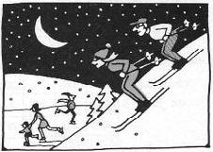 B. 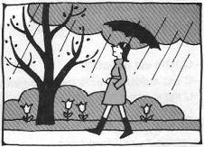
C. 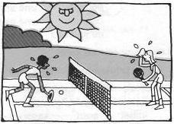 D. 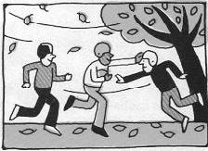

2. C En el verano, hace mucho calor y me gusta jugar al tenis. ______________________________________________________________________
3. D En el otoño, hace viento y me gusta jugar al fútbol americano.
______________________________________________________________________
4. A En el invierno, hace mucho frío y me gusta patinar.
______________________________________________________________________
5. B En la primavera, llueve y me gusta pasear.
______________________________________________________________________

A 9/10 correct with accurate spelling. (Use 4 activities and at least 4 different weather expressions)
B 8/10 correct with no more than 2 minor spelling errors.
NY

Objective 6: I can conjugate the irregular verbs ir and estar.

A. Write the correct form of ir to complete the conversation below.
Margarita: Oye, Pedro, ¿Adónde 1. vas tú mañana?
Pedro: ¿Yo? Bueno, por la mañana 2. voy a la piscina para nadar.
Mario 3. va conmigo. ¿Quieres ir con nosotros?
A 4/4 correct with accurate spelling.
NY
Nosotros 4. vamos a las doce.

B. Write the correct form of estar to complete each sentence.
- Ud. está en el parque.
- María Elena y Pepe están en la piscina.
- Virginia y yo estamos en el centro comercial.
- Yo estoy en el campo.
A 5/5 correct with accurate spelling.
NY
- Tú estás en el gimnasio.

Objective 7 and DP1: I can use regular –ar verbs. I can use ser.

Complete the following paragraph with the correct form of the verb in parentheses.

Mi madre 1. cocina (cocinar) todos los días. A mí no me gusta 2. cocinar (don’t conjugate because another verb [gusta] is right before it!) (cocinar). Yo 3. dibujo (dibujar) en la clase de arte. Esa clase (That class) 4. es (ser) mi favorita. Mi hermano y yo (My brother and I = WE = NOSOTROS) 5. jugamos (jugar) al fútbol con sus amigos. Ellos 6. son (ser) muy atléticos. Mi padre y mi hermana (My father and my sister = THEY = ELLOS) 7. cantan (cantar) en la iglesia. Tú 8. nadas (nadar) en la piscina los fines de semana.

A 8/8 correct with accurate spelling
NY

Objective 8 & DP 2: I can use numbers 0-100

Los números
For each number, write the numeral.

- veintidós 22
- cincuenta y seis 56
- cuatro 4
A 10/10 Correct.
B 8/10 Correct.
NY
- sesenta 60
- treinta y siete 37
- quince 15
- cuarenta y tres 43
- diecinueve 19
- noventa y uno 91
- cien 100

Objective 9 & DP 4: I can answer questions about pastimes and other topics.

Answer the questions in Spanish using complete sentences.

- ¿Qué quieres hacer hoy? Quiero… (plus a couple verbs).
- ¿Qué haces los fines de semana? Yo… (plus a couple verbs – CONJUGATED for the “yo” form!).
- ¿Te gusta salir con amigos? Sí, me gusta salir con amigos (or No, no me gusta salir con amigos).
- ¿Cuántos años tienes? Tengo catorce / quince / dieciséis / diecisiete / dieciocho años.
- ¿Cómo te llamas? Me llamo…

A Well written. Good grammar and wide variety of vocabulary.
B Language used accurately but limited use of vocabulary.
NY

Objective 10: I can talk about other countries and cultures.

For each form of the test you will be required to answer 2 of the following questions based on your knowledge of Spanish culture. Write a short paragraph to answer the question completely.

FOR THESE, LOOK IN THE CHAPTER AND AT YOUR CLASS NOTES! I WENT (OR WILL BE GOING) OVER ALL OF THESE IN CLASS WITH YOU.

- Why has Mexican cuisine had such a big influence on Texan food? How can you tell?
- What does El Cinco de Mayo commemorate? Why is it important in Texas and Mexico?
- What are some elements of conjunto music? What influenced its development and why is it unique to Mexico and Texas?
- If you wanted to play sports in Latin America, how would it be different from how you might play in the U.S.?
- How do the social habits of teenagers in Latin America differ from those of teenagers in the United States? Think about how they relate to their parents and how they go out with their friends.
- What does it mean to go out with someone a la americana? What is the normal custom in Latin America and what does this tell you about Latin American society?
- Why is Spanish so widely spoken in Texas? How does that affect local culture?
- Why did the Spanish build so many missions in Texas? Name a famous mission building.
- How did the rodeo tradition develop in Texas? What types of skills are demonstrated in a rodeo and why were they important in their society?

A Complete answer with 2-3 supporting details.
B Complete answer with 1 supporting detail
NY Incomplete answer/ no supporting details

Objective 11: I can make plans with friends.

El fin de semana
Your friend has invited you to do something this weekend. You cannot do what your friend wants, so you suggest an alternative. Write a paragraph of 5-7 sentences. Be sure to include the following information: 1) state what you cannot do, 2) give an excuse, 3)name 2 activities you like, 4)say what you want to do this weekend, 5)ask your friend if he/she would like to do something with you.

To say, “I cannot…” you say, “No puedo…”
To give an excuse, you would say, “Tengo que…” or “Necesito…” which means “I have to…” or “I need to…”
To say, “I like…” you say, “Me gusta…”
To say, “I want…” you say, “Quiero…”
To ask someone, “Do you want to _____ with me?” you ask,
“¿Quieres _____ conmigo?”

Objective 12: I can describe myself and others.

Speaking

Situation 1

Pretend that you are a new student at your school. Introduce yourself to your new class telling them your name, where you are from, and describe yourself using at least 3 adjectives. Name two things you like and one thing you don’t. Name one thing you want to do this weekend and one thing that you do not want to do.

Situation 2

Students will take turns asking and answering questions. In this dialogue, one student will play the role of a new teacher and the other will be a student in his/her class. Each dialogue must contain questions and answers about name, origin, personal description using at least 3 adjectives, likes and dislikes. Each person will ask what the other person wants to do this weekend and one thing he/she does not want to do.

FOR THESE, REFER TO THE BOOK FOR EACH OF THESE EXPRESSIONS. WE ALSO DID A LOT OF PRACTICE IN CLASS WITH PARTNERS ON THESE TYPES OF EXPRESSIONS, SO YOU CAN ALSO REFER TO YOUR PERSONAL NOTES.

