Pinellas County Schools

Communities
Reading Listening
Cultures
Speaking Writing

Comparisons
Connections
Listening/Reading
Speaking/Writing

Spanish I
Unit Five: La Familia y La Casa
Practice Test


Objective 1: I can understand oral messages about family.

Listen to the following description of María’s family. Check the appropriate boxes for each family member.

 | Carmen | Antonio | José | Susana | Perro
bajo (a)
alto (a)
delgado (a)
feo (a)
guapo (a)
ojos azules
ojos grises

A 12/12 checks recorded accurately
B 10/12 checks recorded accurately
NY

Objective 2: I can understand written messages related to family.

Read the following description of the Rodríguez family members. Answer the questions in English.

Tengo una familia muy grande. Mi padre se llama Roberto. Es alto y muy guapo. Tiene los ojos verdes y el pelo negro. Su mamá, mi abuela Margarita, es alta, y también, muy guapa. Tiene los ojos azules y el pelo rubio. Mis hermanos, Ramón y Ricardo, son gemelos, y tienen quince años. Ramón es bajo, y tiene el pelo rubio. Ricardo es alto, y tiene el pelo negro.
- What is the father’s name? _____________________________________________
- What is the grandmother like?___________________________________________
- How old are the twins? ________________________________________________
- Who has green eyes? _________________________________________________
- What is the father like? ________________________________________________
A 5/5
B 4/5
NY

Objective 3: I can understand written material about rooms and household items.

La casa. Read the following paragraph. Answer the questions in English.

Me llamo José y soy mexicano. Vivo en una casa grande con mis padres, mis hermanos, y mis abuelos. Mi casa tiene una sala, una cocina, un comedor, tres baños, y seis dormitorios. También tenemos un garaje donde mi madre lava la ropa. Nuestra cocina tiene dos refrigeradores. Me encanta mi casa porque es moderna y muy limpia.

- How many rooms does José’s house have? ________________________

- What is his house like? (2 adjectives) _______________________________

- Who lives with José? _______________________________________

- Where does his mom do the laundry? _________________________________

- Where is José from? __________________________________________

A 5/5
B 4/5
NY

Objective 4: I can identify and describe family members.

Mi familia
Write the correct family member.

- La madre de mi padre es mi ______________.
- El hijo de mi tía es mi ______________.
- Yo soy el ______________ de mi abuela.
- El hijo de mi hermano es mi ______________.
- El padre de mi madre es mi ______________.
A 8/8 with accurate spelling.
B 8/8 with one spelling error
or 7/8 with accurate spelling
NY
- El hermano de mi madre es mi ______________.
- La hija de mi padre es mi ______________.
- Yo soy la ______________ de mi abuelo.

Objective 5: I can identify and describe rooms and chores.

La casa. Label the five rooms below. Then, identify at least 1 chore for each room.
1. 2.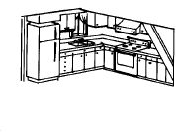

3. 4. 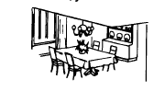
5. 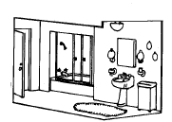
Cuartos Quehaceres

1. _______________ 1. _________________

2. _______________ 2. _________________

3. _______________ 3. _________________

4. _______________ 4. _________________

5. _______________ 5. _________________

I. Room  A 5/5 correct with accurate spelling  NY | II. Chores  A 5/5 with accurate spelling  B 5/5 with minor spelling errors  NY

Objective 6: I can show ownership (using possessive adjectives).

These people are always unprepared. Complete each sentence with the appropriate possessive adjectives.

- Yo no tengo ________ videojuegos y quiero jugar con Alejandro.
- Milena no tiene ________ zapatos.
A 5/5

NY
- Mis primos quieren salir y no tienen las llaves de ________ carro.
- Tú nunca tienes _________ libros para la clase de matemáticas.
- En la casa de nosotros, todos tenemos que hacer _________ quehaceres.

Objective 7: I can use stem-changing verbs.
Complete the following sentences with the correct form of the verb in parentheses.
Siempre cuando 1.____________ (llover), me gusta 2.____________ (dormir). Yo 3.________________ (querer) quedarme en la cama todo el día. Todos los días mis padres 4._______________ (volver) a la casa a las once y media. Ellos y yo 5._________________ (almorzar) juntos. Mis padres siempre 6._________________ (querer) comer sándwiches pero mi hermano y yo 7._________________ (querer) comer arroz con pollo. Yo 8._______________ (volver) a la escuela a la una y media y la clase de ciencias 9.__________________ (empezar) a las dos. ¿Dónde 10.________________ (almorzar) tú? ¿Con quién 11._______________ (merendar) tú?

A 11/11
NY

Objective 8 & DP 1: I can use estar with prepositions of place.

Look at the following picture. Write complete sentences using estar and prepositions of place to describe the relationship between objects.

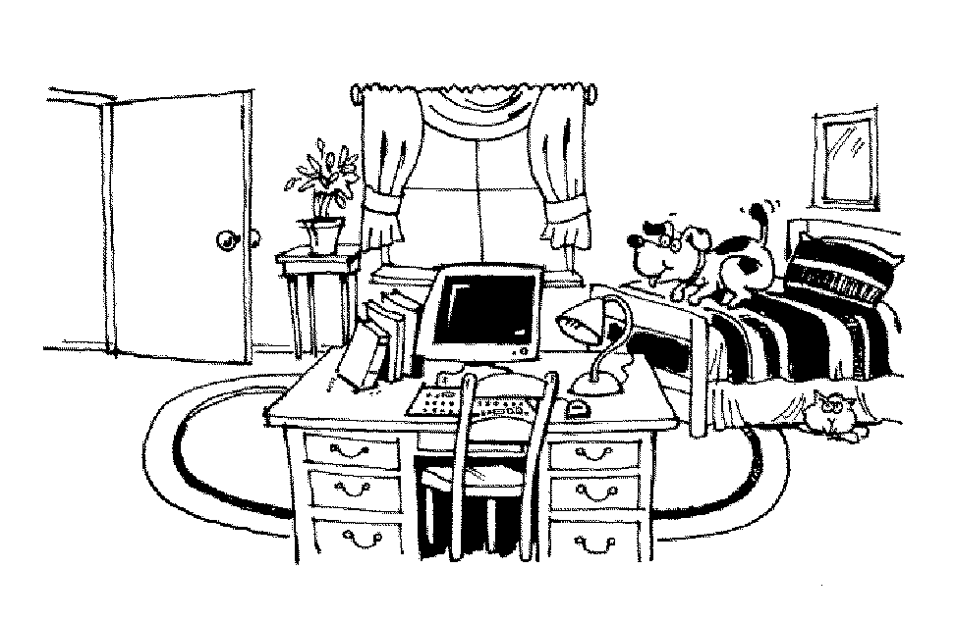

- la cama/ el escritorio
- el perro/ la cama
- la planta/ la ventana
- los libros/ la computadora
- la puerta/ la cama

A 10/10 correct (form of estar and preposition)
B 10/10 with minor errors
NY

Objective 9 and DP2: I can answer questions about my family and friends.

Mi familia.
Write the following questions or statements in complete sentences in Spanish.

1. ¿Cómo se llama tu madre?
_______________________________________________
2. ¿De dónde eres?
________________________________________________
3. ¿Cuántos hermanos tienes?
_______________________________________________
4. ¿Cómo eres?
_______________________________________________
5. ¿Tienes una mascota?
_______________________________________________
6. ¿Cuántos años tiene tu abuela?
_______________________________________________
7. ¿Cómo es tu mejor amiga?
_______________________________________________

A Well written. Good grammar and wide variety of vocabulary.
B Language used accurately but limited use of vocabulary.
NY

Objective 10: I can talk about other countries and cultures.

For each form you will answer 2 of the following questions based on your knowledge of culture and customs. Write a short paragraph to answer the question completely.

- How is the Hispanic custom of surnames different from the system used in the United States?
- What do Hispanic people mean when they talk about la familia? How is that similar to or different from your idea of family?
- How are homes in the southern part of Chile different from homes in the north? Why are they so different? (Name at least 2 reasons).
- Why does Iquique, a city in northern Chile, have examples of Arabic style architecture?
- Copper mining accounts for 40% of the foreign purchases in Chile. What are some positive and negative effects of mining?
- Name 2 significant geographical features of Chile. Why are they important to lifestyle and Chile’s economy?
- 84% of the people in Chile live in cities. How do people outside of the urban areas live? What can we learn about the past from those places?
- Chile has many mountains. Describe 1 positive and 1 negative effect of living in such rocky terrain.
- Why were llamas so important to the Incas? How did the possession of these animals affect the development of their culture?
A Complete answer with 2-3 supporting details
B Complete answer with 1 supporting detail.
NY Incomplete answer/ no supporting details.

Objective 11 & DP 3: I can write a paragraph describing my family members and their activities.

Write 8 or more sentences describing 2 of your family members. Use four sentences for a male relative, and four sentences for a female relative. Be sure to use at least 2 adjectives and at least 1 different chore that each person has to do.

__________________________________________________________________________________________________________________________________________________________________________________________________________________________________________________________________________________________________________________________________________________________________________________________________________________________________________________________________________________________________________

Objective 12: I can talk about myself and my family

Speaking

Situation 1

You have brought your best friend to your family reunion. She/he is having a good time, but would like to know more about your family. Point out 2 of your favorite relatives and give a physical description of at least one male and one female. Name one activity that each person likes to do, one each doesn’t like to do, and a chore that each has to do at home.

Situation 2

It is the beginning of the school year and your teacher is curious about your family. One partner will play the role of student and one will play the teacher and each will take turns asking and answering questions about two different family members (one of each gender). Be sure to talk about personal descriptions, likes, dislikes and one chore that each person has to do at home.

