Pinellas County Schools

Communities
Reading Listening
Cultures
Speaking Writing

Comparisons
Connections
Listening/Reading
Speaking/Writing

Spanish II
Unit Seven: La salud
Practice Test 1


Objective 1: I can understand oral messages about parts of the body and daily routine.

Instructions: You will hear several statements referring to parts of the body and daily activities. Select the body part mentioned by choosing the letter of the corresponding picture. State the activity in English for each.

A. | B. | C. | D.
E . | F. | G. | H.
I. | J. | K. | L.

Letter | Activity

1.

2.

3.

4.

5.

6.

7.

8.

9.

A 8/9 correct
B 7/9 correct

NY

Objective 2: I can understand written material about parts of the body, health and how people feel.

Instructions: Read Juan’s journal entry. Answer the questions in complete sentences in English based on the passage.

lunes

Me siento mal. Acabo de comer un pastel de chocolate y muchos dulces. Me duele el estómago y estoy muy cansado. No quiero hacer nada. Necesito comer mejor porque quiero bajar de peso pero es muy difícil. Me encantan las papas fritas y el tocino. Debo hacer ejercicio y seguir una dieta sana. Pienso buscar un pasatiempo. Me gustaría patinar en el parque o nadar en la piscina. Mi hermano es muy atlético y delgado. Debo practicar deportes con él en la escuela.

1. What did Juan just eat?

________________________________________________________________

2. What should he do?

________________________________________________________________

3. What would he like to do?

________________________________________________________________

4. Who plays sports and where?

________________________________________________________________

5. What day is it?

A 5/5 correct
B 4/5 correct
NY

Objective 3: I can identify parts of the body and personal care items.

Label the items below. Be sure to use the correct article (el/la or un/una)

1. _____________ 2. _______________ 3. ______________

4. _______________ 5. _________________ 6. _________________

7. ___________________ 8. __________________ 9. _________________

10. __________________ 11. _________________ 12.__________________

A 10/12 No spelling errors
B 10/12 With 2 minor spelling errors
NY

Objective 4 & DP1: I can write about how someone feels using idiomatic expressions with estar and tener.

Instructions: Identify the correct expression with estar or tener in the space below each picture. Use a different expression for each picture. Be sure to check for noun/adjective agreement.
 | 101°
Mamá y Papá | Ella
1. __________________________ | 2. ______________________________
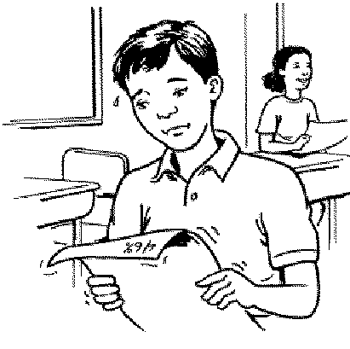

Tú | Yo
3._______________________________ | 4._____________________________
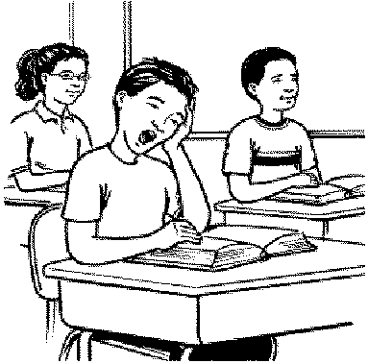
Ustedes | El Sr. Martín
5. _____________________________ | 6. ____________________________
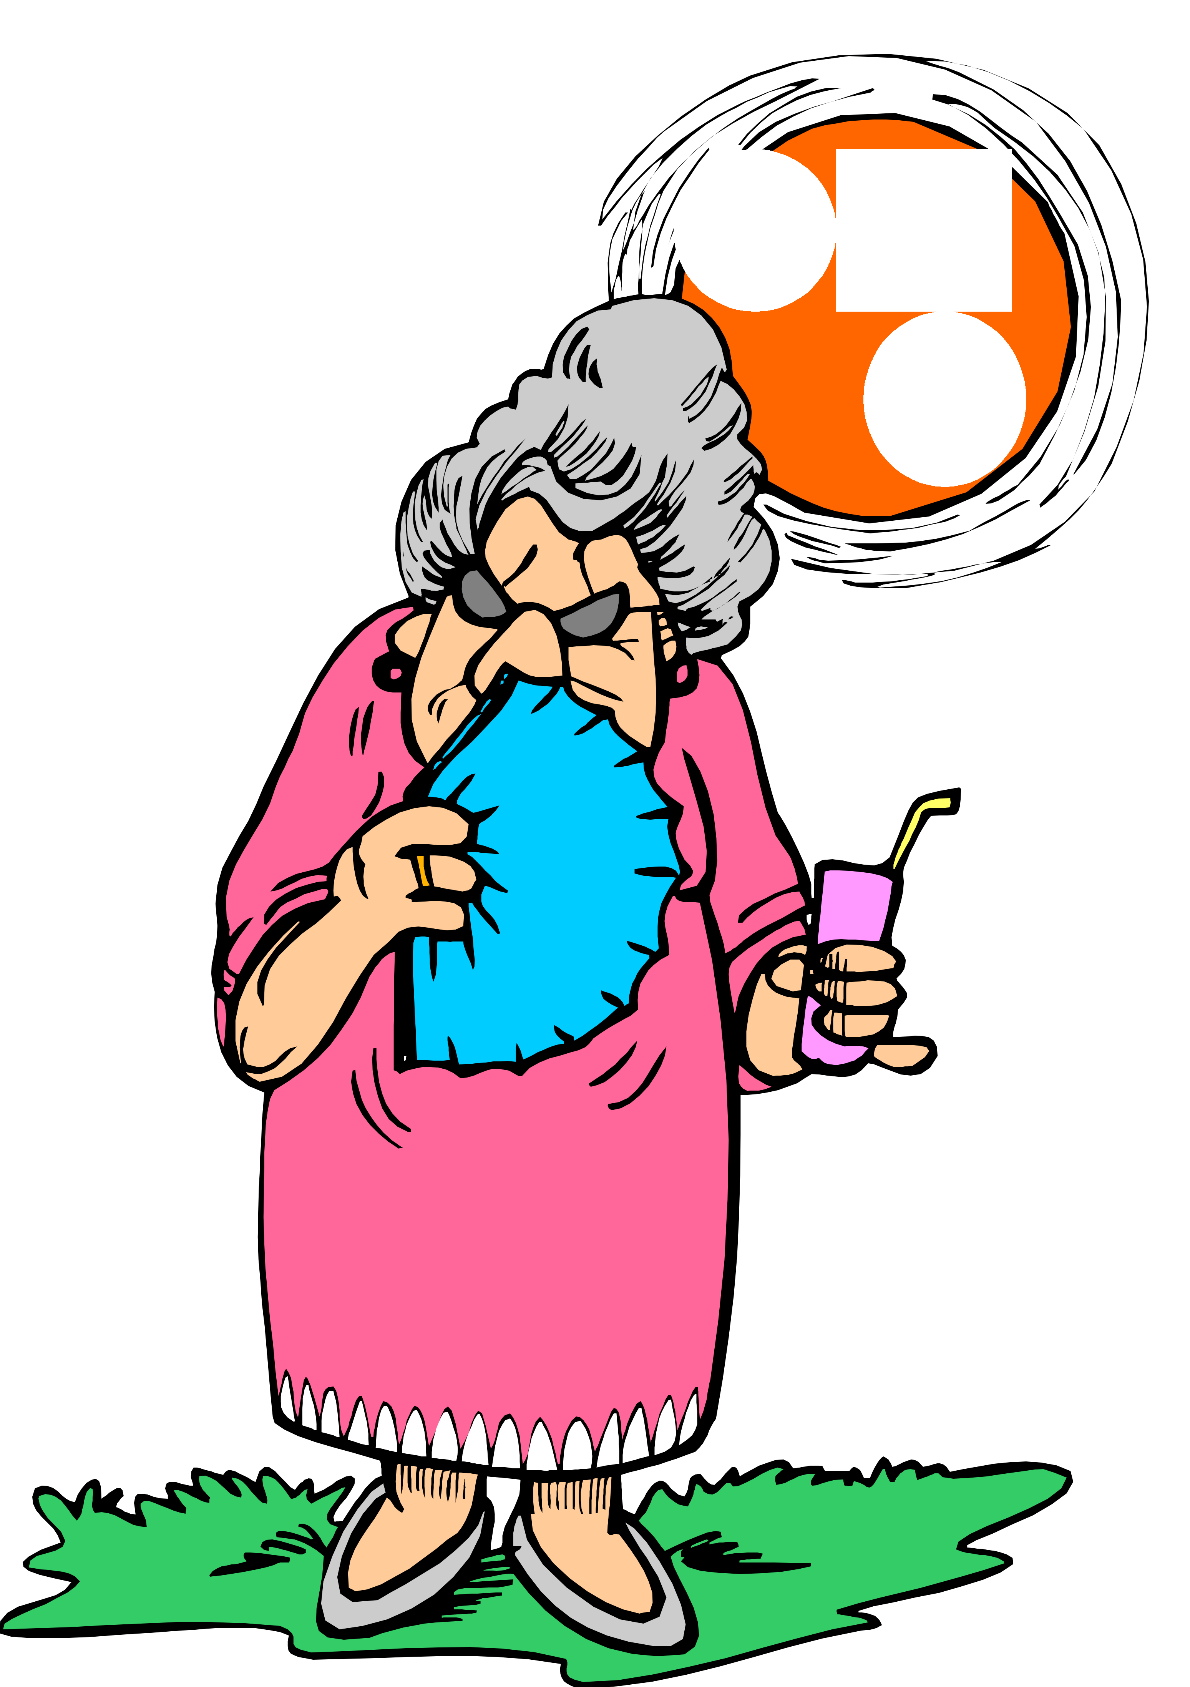

Tú y yo | Nosotros
7. _______________________ | 8. ____________________________

A 8/8 No spelling errors on vocabulary and no conjugation errors
B 7/8 With correct verb conjugation and 2 minor spelling errors
NY

Objective 5 & DP2: I can use reflexive pronouns. I can use stem-changing reflexive verbs.

Instructions: Conjugate the verb. Be sure to use the correct reflexive pronoun.

Siempre hay mucho que hacer antes de salir de la casa. Mi mamá 1.__________________ (despertarse) primero. Mis padres 2._______________ (bañarse) y después mi mamá prepara el desayuno. Yo 3.____________ (peinarse) pero mi hermana tiene que 4. ________________ (secarse) el pelo. Mi hermana y yo queremos vernos bien y nosotras siempre 5._________________ (maquillarse). ¿Y tú,? ¿Cómo 6._______________ (vestirse) para ir a la escuela?

A 6/6
NY

Objective DP3: I can use stem-changing verbs.

Instructions: María’s life is very routine. Conjugate the verb in parentheses to correctly complete the paragraph describing a typical day.

Querido Paco,

Mi vida es muy aburrida. Todos los días son iguales y yo 1.___________ (querer) algo más. Salgo de mi casa a las seis de la mañana y las clases 2.________________ (empezar) a las siete. En la clase de educación física nosotros siempre 3.____________ (jugar) tenis. Me gustaría 4.____________(jugar) béisbol. Yo 5._______________ (almorzar) a las once pero mi mejor amigo 6.____________ (almorzar) a las doce. ¿A qué hora 7.____________ (almorzar) tú?
Por la tarde voy al restaurante con mis padres. Ellos siempre 8._____________ (pedir) el pescado. Mi hermano 9.____________ (pedir) dos burritos de pollo. ¿Qué 10._____________ (poder) hacer nosotros para escapar de la rutina? ¿Cuándo 11.____________ (tener) tú tiempo para visitarme?

Un abrazo,

María

A 11/11
NY

Objective 6 and DP4: I can answer questions about my health and personal routine.

Answer the questions in complete Spanish sentences.

- ¿A qué hora te despiertas? ________________________________________________________
- ¿Cómo estás hoy?
________________________________________________________
- ¿Qué tienes que hacer para prepararte por la mañana? (2 cosas) ________________________________________________________
- ¿Cómo eres?
________________________________________________________
- ¿A qué hora se acuestan tus padres por la noche? ________________________________________________________
- ¿Qué hacen tú y tus amigos para mantenerse en forma? ________________________________________________________
- ¿Te duele algo hoy? ________________________________________________________
- ¿Te gusta hacer ejercicio?
________________________________________________________

A Well written. Good grammar and wide variety of vocabulary.
B Language used accurately but limited use of vocabulary.
NY

Objective 7 I can describe my daily routine.

Mi rutina diaria. Write 8 to 10 sentences describing what you do to get ready for school on a typical morning. Be sure to use at least 5 reflexive verbs and name at least 3 body parts. Also name something that you should do to improve your health.

Objective 8: I can talk about my personal health.

Instructions: You and a partner will take turns asking and answering questions in a particular situation. Choose the situation and follow the directions.

Situation #1
One of the partners is out of shape and frequently late to school. The other partner is in good shape and gets to school on time. Take turns asking and answering questions to improve the late student’s health and to help him/her be on time more often.

Situation #2
Look at the picture and describe your daily routine using each of the items.

Situation #3
You are not feeling well today. You run into a friend on the street that asks you what is wrong.
- Respond by saying you are not feeling well today. (Make up a illness)
- Respond to your friend’s question.
- Reject your friend’s advice.
- Suggest a different remedy.

Situation #4
You are talking to your friend on the phone.
- Tell your friend that you are very tired today.
- Mention a reason for being tired.
- React to your friend’s suggestion.
- Offer advice to a friend.

Objective 9: I can describe countries and cultures.

For each form of the test you will be required to answer 2 of the following questions based on your knowledge of Spanish culture. Write a short paragraph to answer the question completely.

- What are three things that are important about Tierra del Fuego?

- Why is there European style architecture in Argentina?

- What are picadas, and why do you think they are socially significant?

- How are young people’s leisure activities in Argentina similar to and different from those in the United States?

- Why is the ski season in July and August in Argentina?

- Why are the “pampas” important to the economy of Argentina?

- Why is the “festival del tango” held in Buenos Aires?

- Describe the tradition of drinking “el maté” in Argentina. Why do you think it is so important in their culture?

10. What is a “parrillada”, and why is it important to Argentine culture?

A Complete answer with 2-3 supporting details
B Complete answer with 1 supporting detail
NY Incomplete answer/ no supporting details

