Pinellas County Schools

Communities
Reading Listening
Cultures
Speaking Writing

Comparisons
Connections
Listening/Reading
Speaking/Writing

Spanish II
Unit Nine: Celebraciones
Practice Test


Objective 1: I can understand oral messages about activities during different holidays.

Los días de fiesta: Identify the holiday and when and what people did in English.

a. b. c.

d. e.

Picture Activity

1. ______ _________________________________________
2. ______ _________________________________________
3. ______ _________________________________________
4. ______ _________________________________________
5. ______ _________________________________________

A 5/5 correct
B 4/5 correct
NY

Objective 2: I can understand written messages about parties and foods.

Read the following paragraph and answer the questions that follow in English.

El primero de enero es el Día de Año Nuevo, pero la celebración empieza con La Nochevieja, el treinta y uno de diciembre. La Nochevieja es una celebración divertida en todas las ciudades. Las familias preparan una cena de comida muy deliciosa. En algunos países, a las doce todos comen doce uvas, una uva para cada mes para tener suerte todo el año. En España, los muchachos cenan con sus familias a las diez de la noche y hablan hasta las doce. Después de celebrar el Año Nuevo con la familia, los jóvenes españoles salen a la calle a la una de la mañana para reunirse con los amigos. ¡Bailan hasta las cuatro o cinco de la mañana!

- Why do some people eat 12 grapes? _____________________________________________
- When does the New Year celebration start? _____________________________________________
- What do young people in Spain do after midnight? _____________________________________________
- At what time do Spaniards get home? _____________________________________________
- What is the New Year’s Eve celebration like? ____________________________________________

A 5/5 correct
B 4/5 correct
NY

Objective 3 and DP1: I can conjugate –er and –ir verbs in the preterite I can conjugate –ar verbs in the preterite.

Conjugate the verbs to correctly complete the paragraph.

A mí me encanta mi cumpleaños. El año pasado yo lo 1. _______________ (pasar) muy bien. Mis amigos 2. ______________ (colgar) decoraciones en la casa. Yo 3. ______________ (recibir) muchos regalos. Mis hermanos también 4._______________ (recibir) muchos regalos. Mi abuela 5. ________________ (preparar) arroz con pollo y nosotros 6. ___________________ (comer) mucho. Mi hermana y yo 7. _______________ (comprar) flan y un pastel y mi padre los 8.________________ (comer). ¿Qué 9.________________ (preparar) tú? ¿Qué 10. ______________ (recibir) tú?

A 10/10 correct
B 9/10 correct
NY

Objective 4 and DP2: I can answer questions using direct object pronouns.
Answer the following questions in Spanish replacing the direct object with the direct object pronoun.

- ¿Cuándo recibiste los regalos? ________________________________
- ¿Decoraron Uds. el gimnasio? ____________________________
- ¿Quién te invitó a la fiesta? _______________________________
- ¿Llamaste a las profesoras? _________________________________
- ¿Bebieron ellos la limonada? ___________________________________
A 5/5 correct with one minor spelling error.
B 5/5 correct with three minor errors.
NY

Objective 5: I can use verbs in the present progressive.

Use the present progressive to tell what each person is doing.

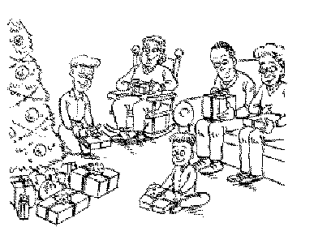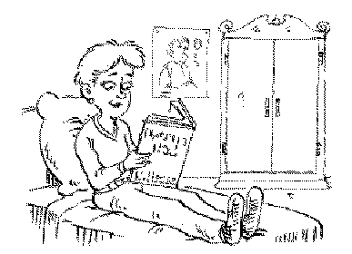

1. Nosotros ____________________. 2. Tú ____________________.

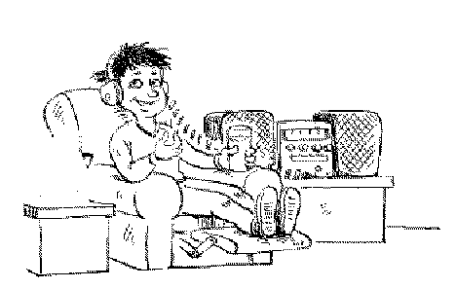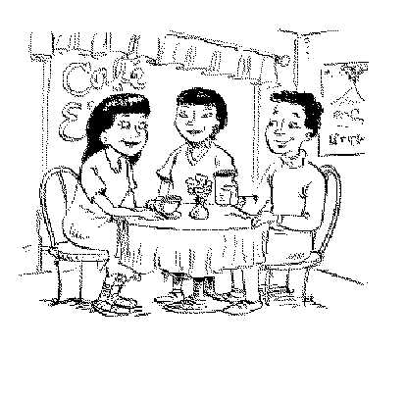

3.Yo ____________________. 4. Los jóvenes ____________________.

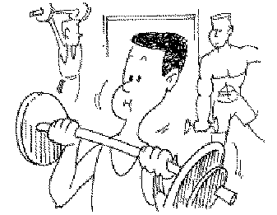

5. Javier____________________.

A 5/5 correct
NY

Objective 6 and DP3: I can answer questions about holidays and family.

Answer the questions in complete Spanish sentences.

¿Con quíen celebraste la Nochevieja? ___________________________________________________
- ¿Qué hiciste en el Día de la Independencia?
___________________________________________________
- ¿Cuándo es tu cumpleaños?
___________________________________________________
- ¿Qué recibiste en tu cumpleaños?
___________________________________________________
- ¿A qué hora te levantas para ir a la escuela?
___________________________________________________
- ¿Qué planes tienes para el Año Nuevo?
___________________________________________________
- ¿Qué comiste en la fiesta?
___________________________________________________
- ¿Cómo se llama tu profesor de matemáticas?
___________________________________________________

A Well written. Good grammar and wide variety of vocabulary.
B Language used accurately but limited use of vocabulary.
NY

Objective 7: I can write a paragraph describing a party.

Look at the picture and describe the party. Say what you think the celebration is and describe in the preterite any preparations that were made for the party. Use the present progressive to name three activities that the guests are doing now.

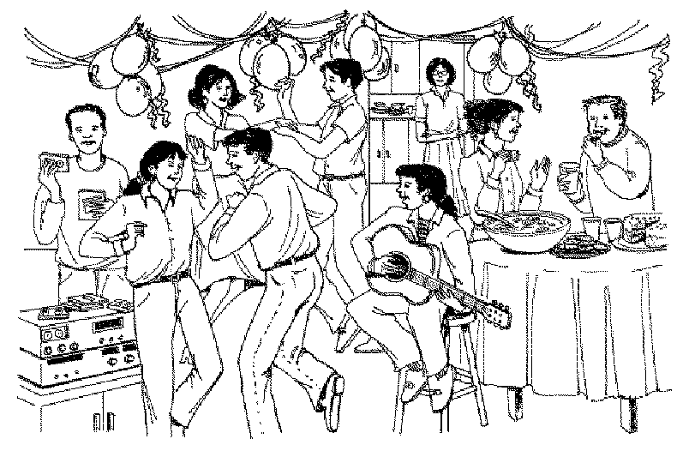

________________________________________________________________________________________________________________________________________________________________________________________________________________________________________________________________________________________________________________________________________________________________________________________________________________________________________________________________
Checklist:
______I have at least 3 sentences in the preterite.
______I have at least 3 sentences in the present progressive.
______I have at least 8 sentences.
______I have checked for noun/adjective and subject/verb agreement.

See writing rubric

Objective 8: I can talk about parties and holidays.

Choose from the following prompts. You may work with a partner (partners) or alone.

1. Describe your favorite holiday celebration. Say what you usually do and with whom. Then, describe how you celebrated last year. Say what you did, what you ate and drank, and mention something special that happened.

2. In groups of three act out a humorous scene in which two students are discussing the preparations for a surprise party. As they are asking each other what has already been done, the third student overhears them and asks what they are doing. The other two students must try to cover up what they are doing, because the party is for the third student. They create humorous excuses about what they are doing.

Objective 9: I can talk describe countries and cultures.

For each form of the test you will be required to answer 2 of the following questions based on your knowledge of Spanish culture. Write a short paragraph to answer the question completely.

- Why are houses in the Domincan Republic made from wood and zinc? Name an advantage and a disadvantage of using these materials.
______________________________________________________
- Why do hurricanes cause so much damage when they hit the Dominican Republic?
_________________________________________________________
- Beef is rarely eaten in the Dominican Republic. What are some reasons for this? (Think about what is required to raise cattle.)
_______________________________________________________
- What does New Year’s Eve in Spanish speaking countries have in common with New Year’s Eve in the United States? How is the celebration different?
__________________________________________________________
- How is a quinceañera similar to and different from a “Sweet Sixteen”?
__________________________________________________________
- Three Kings Day is a very popular celebration in the Hispanic world. Why is it so important and how is it celebrated?
.__________________________________________________________
- Name 2 unique things about Lago Enriquillo and how they affect wildlife.
__________________________________________________________
- Santo Domingo, the capital of the Dominican Republic, is located on the coast. Name an advantage and a disadvantage of this location. __________________________________________________________
- How does the Dominican celebration of Carnaval compare to the Independence Day celebration in the United States? __________________________________________________________

A Complete answer with 2-3 supporting details
B Complete answer with 1 supporting detail
NY Incomplete answer/ no supporting details

