https://www.google.ca/maps/place/Batoche,+SK+S0K/@52.6618925,-106.1709367,9z/data=!4m2!3m1!1s0x5303f18ecd21ea15:0xbba4f0bebd56d88f
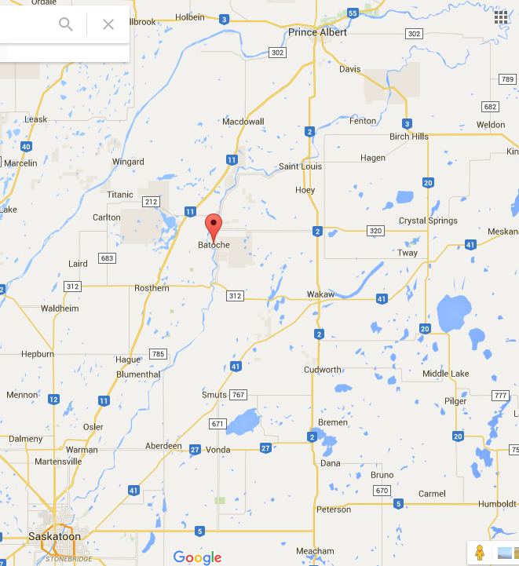
Use the arrows pointing to key rivers and locations to help you identify the correct location for Batoche.

