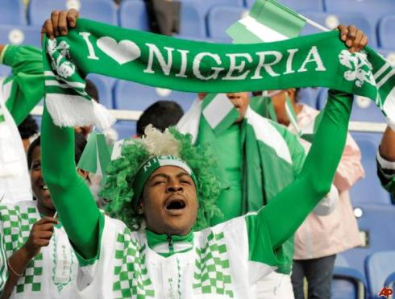
Lagos Nigeria Group
MEGACITY #1
Why Did People Migrate to This City? | What Challenges Do They Face?

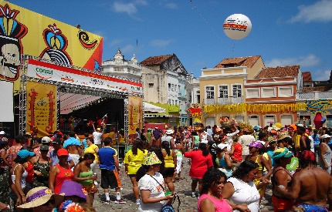
Rio Janerio, Brazil
MEGACITY #2
This Photo by Unknown Author is licensed under CC BY-SA
Why Did People Migrate to This City? | What Challenges Do They Face?

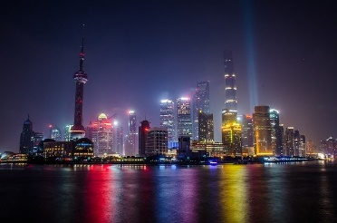
Shanghai, China
MEGACITY #3
Why Did People Migrate to This City? | What Challenges Do They Face?

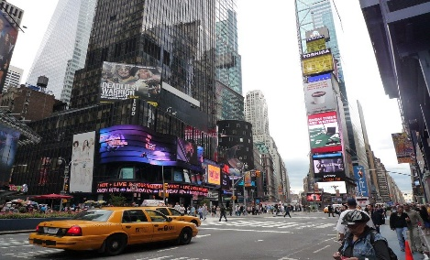
New York, USA
MEGACITY #4
Why Did People Migrate to This City? | What Challenges Do They Face?

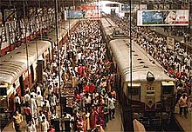
Mumbia, India
MEGACITY #5
Why Did People Migrate to This City? | What Challenges Do They Face?

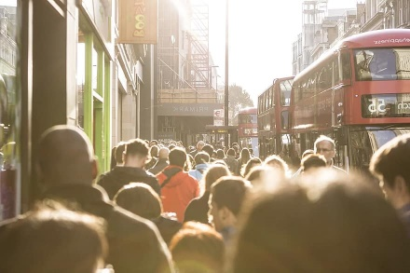
London, England
MEGACITY #6
Why Did People Migrate to This City? | What Challenges Do They Face?

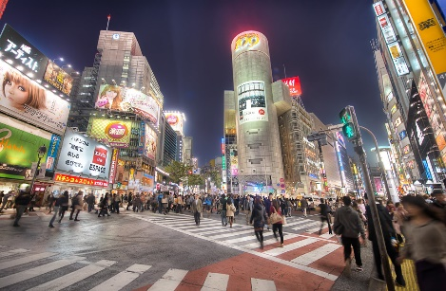
Tokyo, Japan
MEGACITY #7
Why Did People Migrate to This City? | What Challenges Do They Face?

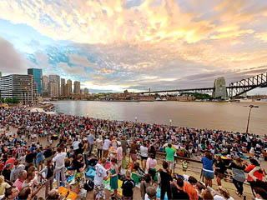
Sydney, Australia
MEGACITY #8
Why Did People Migrate to This City? | What Challenges Do They Face?

