**Determining Minimal NaCl concentration for Plasmolysis.**

**Background and Introduction:**

When plant cells are placed in a hypertonic solution, they undergo **plasmolysis,** in which much of the

water exits the cell and the plasma membrane pulls inward—the cell wall, however, retains its shape. When a plant cell has sufficient water in its cytoplasm, the cell maintains is shape by exerting **turgor pressure** onto the cell wall. As water flows in and the solutes cannot flow out, the increased numbers of molecules inside the cell push on the external wall. Initially you will make a slide of an Elodea leaf under normal (isotonic) conditions. Then you will make a leaf slide under hypertonic and hypotonic conditions, you should be able to predict what will happen to plant cells when osmotic pressure changes—becoming hypotonic or hypertonic. Plant cells have both a cell wall (which is rather inflexible) as well as a semi-permeable membrane.

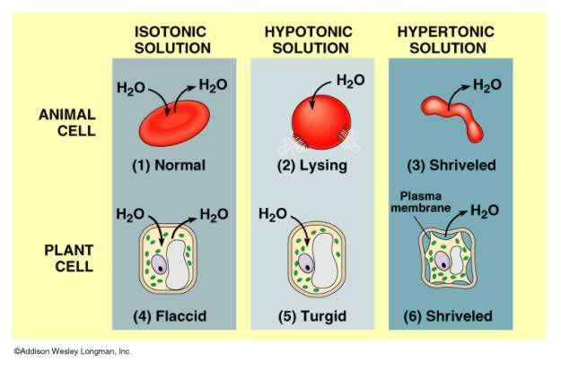

For Elodea, an aquatic plant, you will be making a slide on an intact leaf. On low power, you will be able to see the cell wall and chloroplasts and possibly the nucleus (though it is clear and often difficult to see)

**Instruction: GENERAL:**

• Make sure to write your protocol, concentrations, etc in your lab notebook. If you needed to perform this a week later, include all the information you would need.

• Draw what you see in the microscope; this is part of recording your results.

DETAILED

1. Prepare a **200mL** of a **1.0M NaCl** solution, ensuring the NaCl is completely dissolved.

2. Set up the microscope.

3. Make a wet mount of an Elodea leaf.

**Task #1: Making a Wet mount and determining base-line or control measurements.**

a. Remove a small leaf from the Elodea plant

b. Place the leaf in the center of a glass microscope slide

c. Take a transfer pipette and remove some of the water from the Elodea container and place one drop on top of the leaf

d. Carefully place a plastic cover-slip on top of the leaf, making sure to remove all air bubbles

- Hold cover-slip over slide at 45° angle, touching bottom of cover-slip onto slide.

- Drop cover-slip over Elodea leaf with water

- If bubbles, press edges of cover-slip with finger VERY gently

e. View the leaf under your microscope using all three magnifications, to observe their usual appearance under normal osmotic condition and sketch on **high** **power** in your notebook

**Is this a Hypertonic, Hypotonic, Isotonic solution? Draw and Describe appearance in notebook**

**Label cell wall and chloroplasts.**

f. Place a small piece of paper towel on the slide next to the cover-slip (it is best to use the

corner or edge of the paper towel. The paper towel will absorb water from beneath the cover slip and the water solution will be drawn under the cover slip and across the slide.

g. Add three drops of 1.0 NaCl solution to the slide by placing 2-3 drops at the edge of the cover-slip and letting it “wick” under the cover-slip.

h. Wait 5 minutes

i. Observe the slide again. Note any changes in appearance

**Is this a Hypertonic, Hypotonic, or Isotonic solution? Draw and Describe appearance in notebook**

**Label cell wall and chloroplasts.**

j. Repeat using distilled water

**Is this a Hypertonic, Hypotonic, or Isotonic solution? Draw and Describe appearance in notebook**

**Label cell wall and chloroplasts. Label and complete the figures below.**

Elodea 1: ________________ Elodea 2: ________________ Elodea 3: _________________

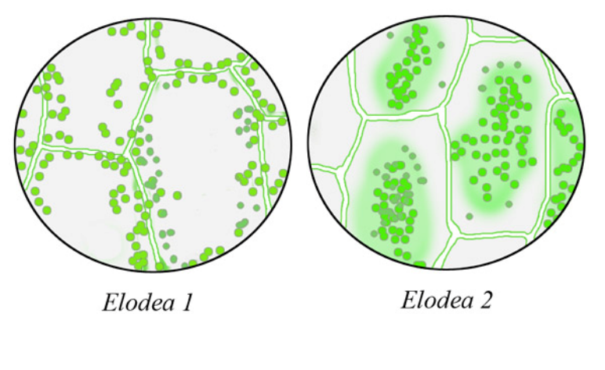

**Question: Think of what you have learned about experimental design from previous science classes. What is the purpose of the baseline measurement?**

**Inquiry-based exercise:** Determining **threshold** for plasmolysis in Elodea

**“It wouldn’t be called research if we knew what we were doing—Albert Enstein”**

In scientific experiments, the answers are not known ahead of time. In addition, scientists have

to devise appropriate protocols or methods to test their hypothesis. Even if most or all of the procedures involved are standard techniques, scientists still have to determine what groups they are testing (control vs. treatment), what sorts of data they need to collect, and how various data will be interpreted. Before an experiment is executed, a scientist must first design the experiment

**Task #2: Your Mission: Your task is to determine the minimum concentration of NaCl necessary to cause plasmolysis in Elodea leaves.**

**Carefully consider the following. Address each of the following in your strategy.**

• What is your question?

• How will you determine when a cell has experienced plasmolysis? What will it look like?

• How long will you allow the cells to sit in the salt solution before making your observation?

How are you going to measure the time?

• From the 1M NaCl solution, what concentrations and dilutions of NaCl will you make from the

1M solution to test plasmolysis? Perform these calculations before you begin.

• How many readings at one concentration will you take? One, two, or three?

• How will you record the data?

• How will you present your results graphically and in figure form?

• What problems could you encounter and how will you solve them?

**Getting ready for the experiment**

• Discuss your strategy with your lab group mates

• Write out a protocol and strategy in your lab notebooks **before** you begin

**STOP:** Before you begin your experiment, show your protocol to the lab instructor in order for it to be validated.

**Once your experimental plan is validated by the instructor, you may proceed with your experiment. Be sure to clean up when you have collected all your data and are done.**

**Address the questions below BEFORE the next lab period.**

1. What is the salt concentration inside the cell under normal conditions?

2. What is the salt concentration outside the cell under normal conditions?

3. How does your **threshold of plasmolysis** compare to the above conditions?

4. Research plasmolysis in plant cells and tonicity. Why is this feature of cells important to cell function and life?

5. Make a table of your results, including the average and standard deviation.