

The 7-Eleven eBook is a mini-guide designed for claim handlers who are new to Sedgwick and who are handling 7-Eleven claims, or veteran Sedgwick colleagues who have transitioned to the 7-Eleven account.

This Electronic Book (eBook) contains various resources that will be able to assist Sedgwick colleagues as they start handling this client and beyond, to show the variations between Sedgwick Service Expectations (SEs) and 7-Eleven’s Client Service Instructions (CSIs).

Table of Contents

Investigation & Coverage | Page 2
Fast Track Protocols | Page 5
Documentation & Coding | Page 6
Action Plans & SIR Overview | Page 8
Reserves | Page 11
Video Requests | Page 13
Franchised Stores New Agreement | Page 14
Subrogation | Page 21
Index | Page 23

Investigation & Coverage
3 Point Contacts:

- Claimant
- Store
- Witness

What to ask:
- Ask until you can visualize a clear image/movie
- Any/all prior & current health issues
- Who, what, where, why, when, & how
- Anyone else involved in the incident?
- Witnesses?
- Claimant first & last name, DOB, gender, & SSN = Need to confirm the 5 MMSEA items

Deep Thinking Required:
- Does everything correlate & make sense?
- Information match incident reports/police reports, statements, & medical records?
- Always be on the lookout for other parties who may be responsible for all or a portion of the loss

If there are differences in versions – clarify
with each party. If you have major
differences you should discuss with your
Team Leader as to what your next steps
should be.


Notable Timeframes
1

Business day to complete initial verbal attempts for 3-point contacts

4
2 additional contact attempts in the next 4 business days – and send a letter

14
Complete liability determination within 14 calendar days from date of report for Auto claims and Property claims

Complete liability determination within 30 calendar days from date of report for General Liability claims
30



JURIS Tips
- Use the Investigation Screen for initial statements – make sure all required note types are addressed
- Avoid using N/A when documenting in JURIS – provide value; spell out your work
- Use the correct note types to clarify appropriate parties’ statements & info received
- If a witness statement is not needed, the examiner must update the file notes (WT note type) to include rationale why a witness was identified, but not contacted.

Review JURIS Note Types for Investigation

CM = Claimant Contact
CN = Client/Store Contact
WT = Witnesses
EV = Evaluation (Liability Determination)

Claim Status:

Once the investigation has been completed, will you compromise or deny the claim?


Available Notes Space for Week 1:

An EV note should be established with a detailed rationale that includes your investigation process, liability determination, which should outline all parties’ negligence.
Update EV notes as your investigation develops

Coverage
Your coverage note should be clear and reflect a sound coverage analysis. Outline any potential coverage issues. The timeframe to have a coverage note in the file is within 5 business days from the report date. Must complete the Coverage Tab in Investigation screen.

Available Note Space for Investigation & Coverage:

Return to Table of Contents

Fast Track Protocols
Claim Sub-Status Code: Fast Track
No recorded statement requirement
No releases needed
Also, no release needed for undisputed PD claims under $2.5K

First Call Settlements: Contact store first, contact claimant second, nominal amount
15
Liability decision to be made within 15 calendar days of the “TO US” date

30
Claim to be closed within 30 calendar days of the “TO US” date
30
Supervisors will review all open claims at 30 calendar days. Need escalation?

Available Notes Space for Fast Track Protocols:

Return to Table of Contents

Documentation & Coding


All documentation is potentially discoverable


File documentation and coding must be updated throughout the life of every claim, every time

Keep every claim…
- Professional
- Avoid abbreviations (outside of industry standards)
- Complete thoughts, spell check, and proofread before saving the note

Ensure claim and description coding are accurate, complete, and appropriately located within the system.

Main coding areas in JURIS and important to 7-Eleven:
- Source Code – located under the Claimant name
- Cause Code – choose the best option
- Nature/Result – Update as the claim evolves
- Part/Target – The most injured site if multiple body parts involved
- Loss Description – Update to include all damages/injuries
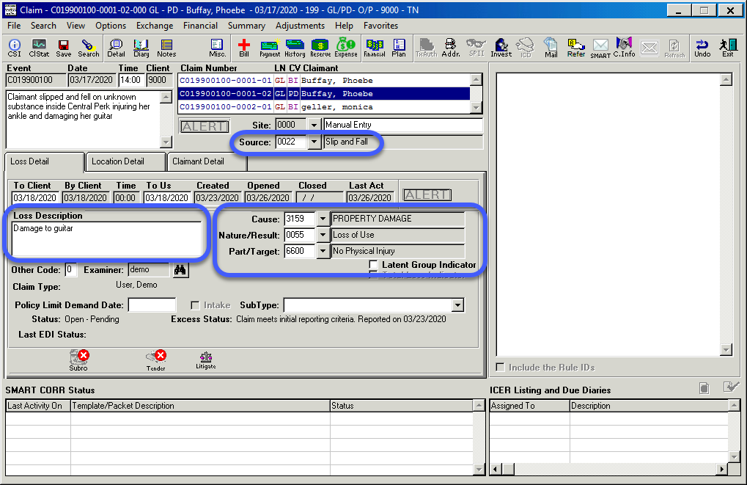

Event Notes: Create an Event Note when applicable to the investigation of an entire loss, accident scene, investigation, liability determination, police reports, etc.

If additional exposures are discovered on a current event, the new exposure needs to be added within one business day.

Index matches should be…
- Documented; pursued appropriately
- Include in the Action Plan and set diaries accordingly
- If Index results indicate no impact on current claim, then document rationale

Documentation & Coding Tips
- Every time you open a claim, review the Main Claim Screen coding for accuracy
- Always address Index results received, whether results may impact current claim or not – and document under appropriate note type

JURIS Note Types for Documenting Index Matches

IS = Documentation or rationale of Index results

Available Notes Space for Documentation & Coding:

Return to Table of Contents

Action Plans & SIR

Action Plans should reflect our work product for anyone who reviews a claim
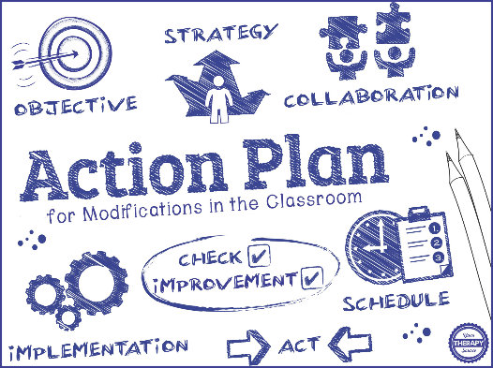
Action Plan content should include:
- Identify & document issues requiring resolution
- Include a detailed plan
- Identify goals
- Outline meaningful activities to achieve goals
- Provide timeline for completion

Templates for Action Plans are highly recommended to help capture all required fields necessary for a complete Action Plan, which can be in 2 areas:
- Notes Screen
- Investigation Screen

There are various sections to an Action Plan template:
- Current Status – Summary of where the claim is at the time of the Action Plan
- Goal – Goal for this claim during the next 90 days
- Strategy – Numbered-point, specific activities to be undertaken to achieve the goal
- Target Date – Timeframe in which the goal will be completed

SIR = Stored Informational Retrieval

SIR is paperless documentation system for scanning, storage, & retrieval of document images

SIR can be used for the following:
- Review correspondences related to claims
- Document the information into JURIS notes
- Ensure all info is accurate, updated

Access SIR from either…
- One JURIS Main Menu – Home tab (Green Mail Icon button) – Main SIR page
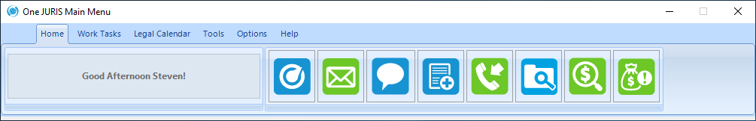

- Main Claim Screen – Top toolbar (Mail button, upper-right hand side) – Case View
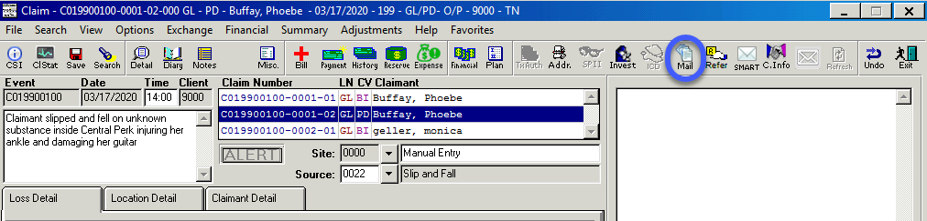

Every correspondence received in SIR will be assigned a unique DCN
DCN = Document Control Number

Drop File = Placing documents into SIR via email
There are a variety of options in sending documents from email directly into SIR

Drop File SIR Emails | Mail Status | Doc Type | Color
dropfile@acssedgwickcms.com | Read | Email | No
unreaddropfile@acssedgwickcms.com | Unread | Email | No
unreadcolordropfile@acssedgwickcms.com | Unread | Email | Yes
colordropfile@acssedgwickcms.com | Read | Email | Yes
dropfileclaimcorrespondence@acssedgwickcms.com | Read | Claim Corresp | No
dropfileinvestigation@acssedgwickcms.com | Read | Investigation | No
dropfilelegal@acssedgwickcms.com | Read | Legal | No

Subject Line – The description on the email can be sent within the forwarded email. The subject line should still include only the claim number, but the note subject can be added.

Type in the claim number and 2 tilde signs (~~) in the subject line with no spaces between them. Type in the note subject following the tilde signs and send the email to SIR.
NOTE: The tilde sign (~) is located above the TAB key on a keyboard
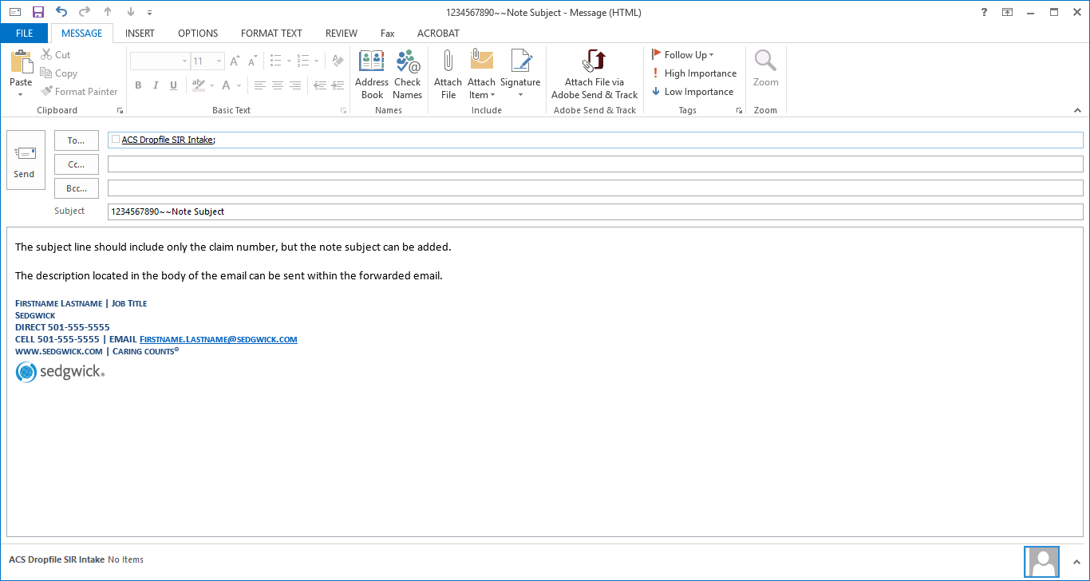
Example of a Drop File SIR email


Notable Timeframes
14
Calendar days to provide initial Action Plan from claim open date on new or converted claims
5

Business days from reopened date to add Action Plan, or to update if material change
5

Business days to document new non-legal correspondences that come into SIR
1

Business day to document new legal correspondences that come into SIR

JURIS Tips
- Use the Action Plan templates available in JURIS to address all required components
- Provide clearer steps in establishing Action Plan goals – don’t just say “close claim”
- Document SIR correspondences in SIR; use the ability to copy SIR note into JURIS

JURIS Note Types for Action Plans

AP = Action Plans, used to provide direction in the “Current Status” & handling of the claim

Available Notes Space for Action Plans:

Return to Table of Contents

Reserves

Sedgwick’s Reserve Philosophy:
- Ensure the ultimate probable exposure of claims is established appropriately, timely and regularly evaluated for accuracy.
- Consider all information gathered since the initial investigation that impacts the claim reserve
- Reflect the most probable outcome
- Do this throughout the life of the claim based on the facts available

Key factors to consider when handling Bodily Injury (BI):
- Past & Future Medical
- Cost Containment Programs (Collateral Source Rules for the state of loss)
- Essential Services (Travel expenses, homecare)
- Occupation
- General Damages (Pain & Suffering and Scarring)
- The “X” Factors (Venue, etc.)

Key factors to consider when handling Property Damage (PD):
- Auto Property Damage
- Personal Property Damage
- Real Property (Interruption of business, etc.)

Key factors to consider for Expenses:

Reserving Blunders:
- Under-reserving
- Over-reserving
- Stair-stepping

Notable Timeframes
2
Business days from open/reopen date for initial reserve.
Business days from a material change that impacts the reserves
30

Calendar days from open date to review and adjust, as necessary
90

Review every 90 calendar days, thereafter, for the life of the claim (at a minimum)


Tips
- Reserve notes should be detailed with your thought process behind the amounts
  - Use the comment field on the Reserve screen
- Don’t forget to address Loss and Expense reserves
- Utilize reserve worksheet & full report (required) for 7-Eleven concurrence for any reserve increases for claims valued more than authority
- Reserves and Evaluations can never be over-explained
- Liability reserve authority up to $25,000 total incurred
- Supervisor approval and 7-Eleven concurrence required on all newly established reserve and/or reserve increase above authority

Review JURIS Note Types

RS = Document your reserve rationale

Available Notes Space for Reserves:

Return to Table of Contents

Video Requests

Note Types for Video Requests

Available Note Space for Video Requests:

Return to Table of Contents

Franchised Stores on New Agreement

FZ – Franchised Store

The LOCATION DIRECTORY is the first step in verifying if a Franchised Store is on the new 2019 agreement.

Claims TO report to Franchisee broker/carrier:
- Falls outside the store with an alleged defect that 7-Eleven is responsible for (parking lot)
- Drive-Thru

*If reported to a carrier, Sedgwick Examiner will need to secure video to protect 7-Eleven

Claims NOT TO report to Franchisee broker/carrier:
- Carwash
- Bad Gas/Contaminated Fuel
- Alleged defect of gas pump/hose causing fuel spill

Available Note Space for Franchised Stores:

Return to Table of Contents

Subrogation

Subrogation = Transferring a risk from one party to another who is legally obligated to pay

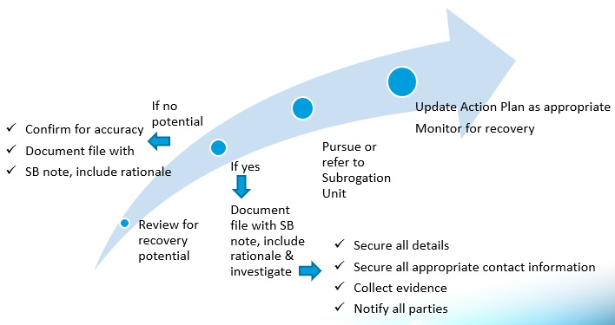

Subro Tips
- Always document under
- Complete diaries & schedule new ones to continue to remain active in claim handling
- Click the Refresh button at least twice per day, to know if any new claims or diaries have been assigned since the JURIS application was originally opened

Review JURIS Note Types for Subro
SB = Document initial investigation, information related to recoup related claim cost, and rationale for pursuit and or the abandonment of the recovery. Activate the subrogation button once you have notified the other party of the intent to subrogate.

Available Notes Space for Subro:

Return to Table of Contents

Compliance Audit Overview

Overall compliance audit goal = 90% or better

Compass.net is used for auditing purposes:
- Auditors will evaluate colleagues’ pending; randomly pull 3 claims to review
- Examiners and Team Leads are given an opportunity to review audits
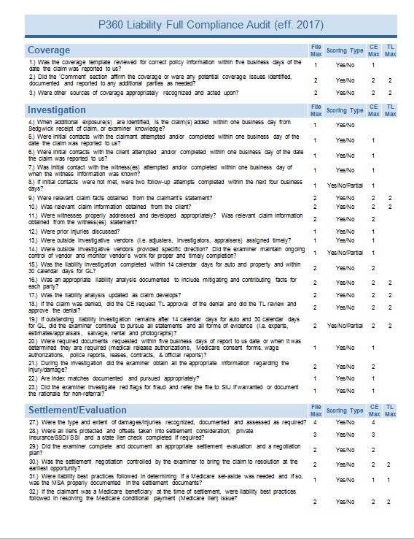
- Allows for rebuttal process

Audit compose of 3 separate scores:
- File Score – The entire claim’s score
- CE Score – The currently assigned
claim handler’s score
- Supervisor (TL) Score

Audits are also composed into 3 Tiers:
- Tier I
- Tier II
- Tier III
Claims are categorized into Tiers depending on
how long they have been opened

The Investigation is especially important for
Audit purposes because it’s the first category
And has the most questions on the P360 compliance audit compared to any other category

P360 auditors will look to confirm when a claim is reviewed for denial (full or partial) – to confirm TL/Supervisor approved the denial

2 Components to Action Plans, Reserves, Coverage, & Liability decisions that are reviewed in a P360 compliance audit:
- Timeliness – Ensuring actions are taken in an appropriate rate
- Content – The value of the information documented

Supervisors are accountable for providing timely reviews to assist claim handlers with meaningful guidance – Claim handlers are expected to comply with all supervisor directives

Notable Timeframes
21
Pay invoices within 21 calendar days of receipt
Respond to demand packages within 21 days of receipt
- Must acknowledge within 5 business days of receipt
1

Thoroughly review new litigation within 1 business day
7
Business days from when claim handler receives notification of a new audit to review
the audited claim & provide rebuttals, if needed

Audit JURIS Tips
- Avoid using “N/A” when completing the initial investigation required note types
- Provide value to documentation in JURIS & SIR
- If any questions or audit results appear unclear, then consult with your Team Lead or auditor to provide clarification

Review JURIS Note Types for Audits

SR = Supervisor notes; may contain additional directives for claim handler to complete

Available Notes Space for Compliance Audit:

Return to Table of Contents

Index
Guides
JURIS Guide | 2020 JURIS Guide - LB
SIR Guide | 2020 SIR Guide

Sedgwick On Demand Series
SMART Correspondences | On Demand Training - SMART Correspondence
Reserves | ODG - Official Disability Guidelines
Settlement Negotiation | Settlement Negotiation - LB - Recorded Training
JURIS | JURIS Tips - LB - Recorded Training
WebEx | Let's Break to Educate - WebEx Basics - Recorded Training

Additional Resources (Sedgwick & External)
Internal & External Resources | Sedgwick Service Expectations
 | The Current Homepage
 | Casualty Training Page
 | All States - Cubicle Reference Chart 2019
 | Venue Map
 | Collateral Source Rules
 | Liability Practice Group

Return to Table of Contents

