Me llamo ________________________Clase_____Fecha______/______/______
Spanish III – Preterite Tense Review – Guided Notes
The preterite tense is used to talk about actions __________________________________.
Preterite Regular Verb Endings
-er /-ir verbs
-ar verbs

¡Practicar!
1. I climbed ___________________
2. you informal singular climbed ___________________
3. you formal singular climbed ___________________
4. we ran ___________________
5. you informal plural ran ___________________
6. you formal plural ran ___________________
Irregular Preterites

There are many irregular preterites… (sorry)
….but __________________________________________

Pattern #1 – Regular Endings, but No Accents
The verbs ________ (___________) and _______ (____________) have regular endings, just _______________________.
I gave =
she gave =
he saw =
I saw =
Pattern #2 - -car, gar, and –zar Spelling Changes
Verbs that end with the letters ________, _______, or _______ have a spelling change in the _________ form to ____________________________________________________.
examples: __________, __________, __________,
I practiced =
I played =

I organized =

Pattern #3 - -ir Verbs with a Stem-Change in the Present Tense
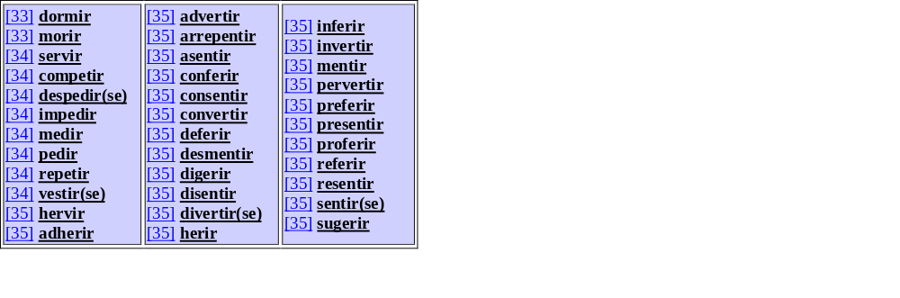
-ir verbs that have an ____________ or ___________ stem-change in the present tense have a spelling change in the 3rd person forms of the preterite.
examples: __________, __________, __________
he slept =
she followed =

they preferred =

Pattern #4 – The Verbs ir and ser
The verbs _______ (________) and _______ (__________) have the same irregular conjugations in the preterite.

Pattern #5 – Verbs with Irregular Stems in the Preterite
Some verbs __________________ in the preterite. This group of verbs has their own set _________________________.
decir =
andar =
haber =
hacer =
traer =
estar =
poder =
querer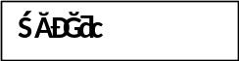 =
conducir =
tener =
poner =
venir =
*
saber =

These verbs all use the same set of endings:

Pattern #6: Verbs That End with Double Vowels
Verbs like ____________ and _____________ have _________________________ in the 3rd person forms, and have an ___________________ to __________________________.

The “to know” Verbs
The “to know” verbs have __________________________ when used in the preterite.
verb
present
preterite

saber
conocer

