Me llamo _______________Clase______Fecha______/______/_____
Spanish III – Guided Translation – text page 95

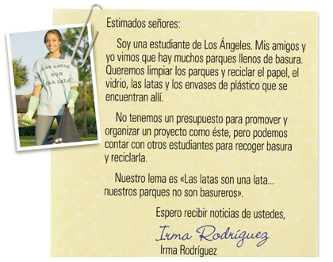
Un canal de televisión local organizó un concurso para crear un anuncio de publicidad en español para un proyecto de acción social. El gran premio es la oportunidad de filmar el anuncio en cooperación con el canal.

Dear Sirs;
______________ from Los Angeles. My friends
and I ________ that there are ______________
full of ___________. We __________________
the parks and __________________, the glass,
______________ and the _________________

that are found there. We do not ____________________ to promote and ___________ a
____________ like this, but we _____________________other students in order to
______________ and _____________. Our ____________ is “The cans ____________...our
____________ are not ____________.”
I ________ to __________ news _____________. Ima Rodriguez
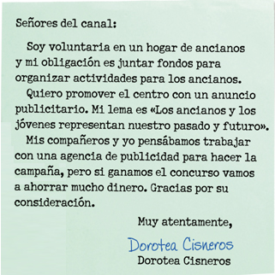
Gentlemen from the TV channel;

I __________________ in a ______________
and my obligation is ______________ in order to
___________________ for ______________.
I ________________ the center with ________
_______________. My _________ is “The ________
and the __________ represent ________________.”
My friends and I __________________ with a
______________________ in order to _________ a
______________, but if ____________ the contest
we are going to ____________________. Thank you
for your consideration. Sincerely, Dorotea Cisneros

