Me llamo _____________________Clase______Fecha______/______/______
Spanish III – Guided Translation – text pages 272-273
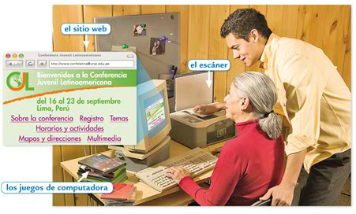
Raúl is Raúl is _____________ for
information _______________
about a _________________,
in _______, in which he is
_______________________.
He ______ that his _________
wants to __________ how to
_________________, and he
offers to _________________.

“Well, ___________, I ________ that ___________________ with ________________ to
__________________________, and I ____________ that I __________________. That’s
why I am __________________ you ______________.
___________ connecting, you should __________ your ____________ and ____________
If you ___________, use my ________________, in order that you can ________________
from _____________ places _______________________.”

“To __________ how to ____________ to the ___________ is very __________________.
You will be able to _________________ about your _______________, _______________
photos and participate in __________________ that ___________________. Remember
that you should never ________________________! You will _______________________
how to go from one _______________ to _____________; you only have to ____________
the _______________ that __________ on them. And other very ___________________,
you will ____________________ how to ___________________ in case you want to
____________________________ while I am ______________________________.”
Raúl ___________________ that his ______________ for the ___________________ is
not ___________________. He does not _____________________ in his ____________.
