Me llamo _____________________Clase______Fecha______/______/______
Spanish III – Guided Translation – text page 298
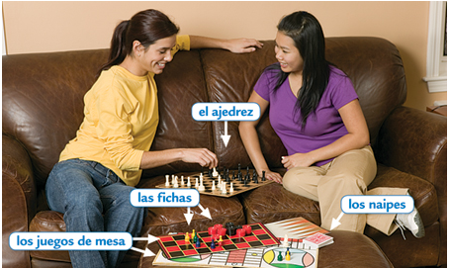
Gladys _____________
___________________
___________________.

The student club is
___________________
and _______________.
Here, I __________ do
_______________ like
_____________ or ___________________, ______________________ of the acting club,
or ___________________ my friends with our leisure time in order to __________,
_________________ on the news, ______________________, or play _____________
and other _________________. What I like the most is _______________________ of
the ____________ and that I ______________________ far from the noise __________
street. In addition, in the reception room, there is ____________ where I can ___________
about _______________________ or make plans for ___________________. I like
___________________!

Also ___________________ to do __________ neighborhood, __________ the club.
