Me llamo _____________________Clase______Fecha______/______/______
Spanish III – Presentación de Vocabulario – text page 299
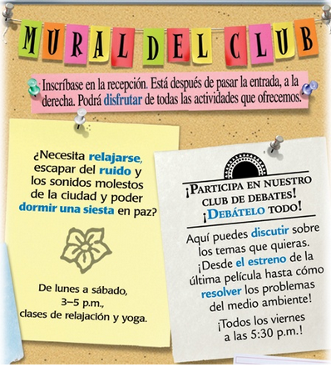
Here is a bulletin board
with information about
student clubs.
Answer the following
questions about the
information posted.

1. When you walk in
to the reception room,
what are you supposed
to do? _____________

2. After completing the above activity, which
direction do you turn?
_____________

3. In the last sentence,
you are told you should
__________________
__________________

4. The first club (on the
left) asks you if you need to do four things. What are these four things? ______________________________
________________________________________________________________________
If you want to do these things, which club should you join? ________________________
When do they meet? _______________________________

The second club posted (on the right_ is asking you to participate in what kind of club? ______________ The post tells you that you can _______________________________.
It suggest topics from the premiere of the ________________ to the problems of the
_______________________.
When do they meet? ________________________________

Explain in Spanish which club you would join, and why. _____________________________
_________________________________________________________________________

