Nombre: ______________________________ La fecha:_____________

Nuevas clases, nuevos amigos

Actividad 1: Ms. Sosa is a new advisor at school and she’s helping students choose two electives for next semester. Based on each student’s interests, write two classes that he or she might enjoy.
las matemáticas el arte la geografía las ciencias
la educación física la computación el francés las ciencias sociales

1. Mauricio enjoys sculpting, painting, and learning foreign languages.
___________________ y __________________
2. Malinda likes computers and working with numbers.
___________________ y __________________
3. Becky enjoys playing softball and wants to be a veterinarian.
___________________ y __________________
4. Teodoro likes drawing and finding out about different countries.
___________________ y __________________
5. Laura likes learning about society and would like to be an accountant.
___________________ y __________________
Actividad 2: Agnes has chicken pox, so her friend Julie is picking up this week’s assignments for her. Julie forgot to write the subjects for each of the assignments. Help Agnes figure out which class each assignment is for.
1. Pintar un autorretrato (self-portrait). ________________
2. Dibujar un mapa de España. ______________________
3. Leer el poema.___________________
4. Memorizar las tablas de multiplicar (multiplication). _______________
5. Estudiar el sistema de respiración. ______________
Instrucciones: Match the most logical picture with the correct class. Write the letter on the line.

1. _____ A. La clase de ciencias sociales

2. _____ B. La clase de arte

3._____ C. La clase de matemáticas
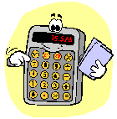
4. _____ D. La clase de ciencias

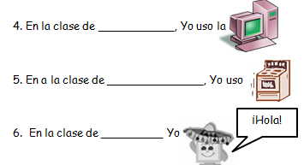

Instrucciones: Read the following clues and write a class (or part of your day) on the line that matches the description.
1. En la clase de ____________, yo

2. Durante el ______________, Yo

3. En la clase de __________, Yo

Instrucciones: Write any classes that you can think of that start with or have any of the following letters in the word.
Ex. La educación física
__________l_____________
__________e_____________
__________m_____________
__________a_____________
__________n_____________

