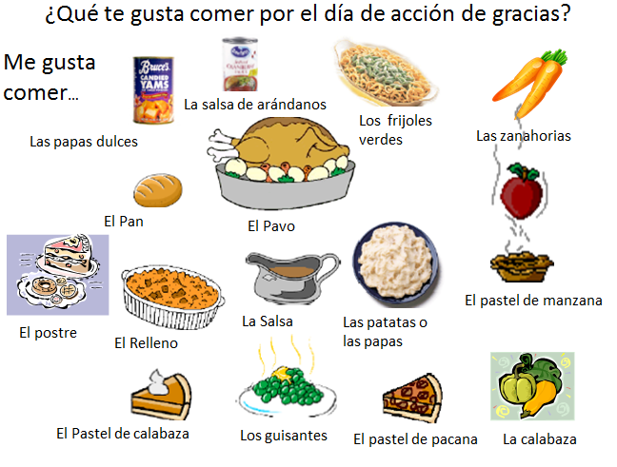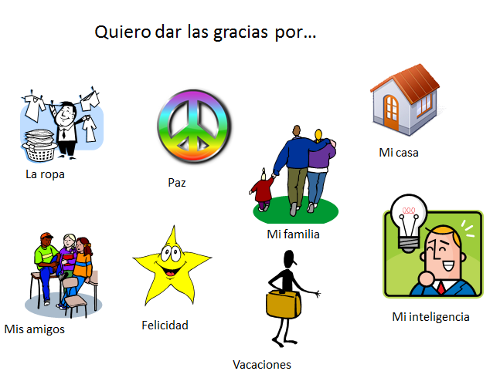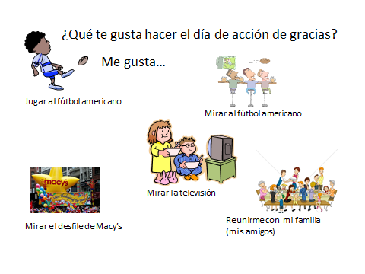
Palabras se asocian con día de acción de gracias –
Write a short paragraph, en español, about your Thanksgiving celebration. You may wish to include what you like to eat, what you like to do and what you are thankful for. Write your final draft in the belly of the turkey and COLOR it!

