Nombre: ___________________________ La fecha: ________
¡Dime!- Los Adjetivos
Actividad 1: You are friends with a pair of twins named Patricio and Patricia. People are always commenting on how alike they are. Make sure to put the correct adjectives in the right column!
Patricio | Patricia  Interesante  Delgado
 | Estudiosa
Simpática
Extrovertido
Atlético
Delgada
Extrovertida
Popular
Atlética
Simpático
Inteligente
Elegante

Actividad 2: Which words from the word bank can describe Roberto? Which would describe Yolanda? Which could they share? Complte the Venn diagram accordingly.
artístico atrevida atlético estudiosa graciosa impaciente simpático
inteligente ordenada paciente perezosa reservado serio sociable
talentosa trabajador
Yolanda
Roberto

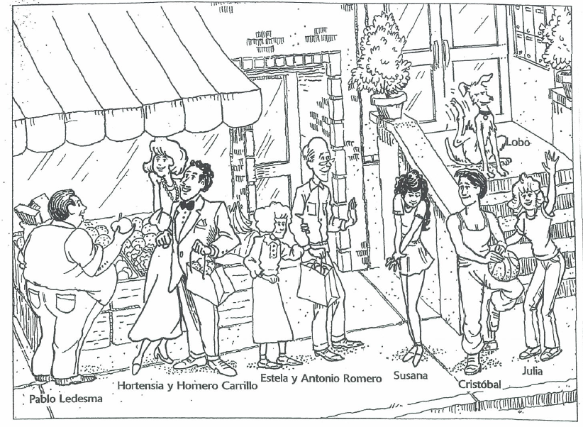
Actividad 3: You have just moved to the neighborhood in the drawing. You want to remember who everyone is, so you take notes about each one. Mention at least one physical trait and one personality trait.

1. Pablo Ledesma es _______________________________________________________________
2. Hortensia Carrillo es ____________________________________________________________
3. Homero Carrillo es ______________________________________________________________
4. Estela Romero es_______________________________________________________________
5. Antonio Romero es ______________________________________________________________
6. Susana es ____________________________________________________________________
7. Cristóbal es ___________________________________________________________________
8. Julia es ______________________________________________________________________
9. Lobo es ______________________________________________________________________

