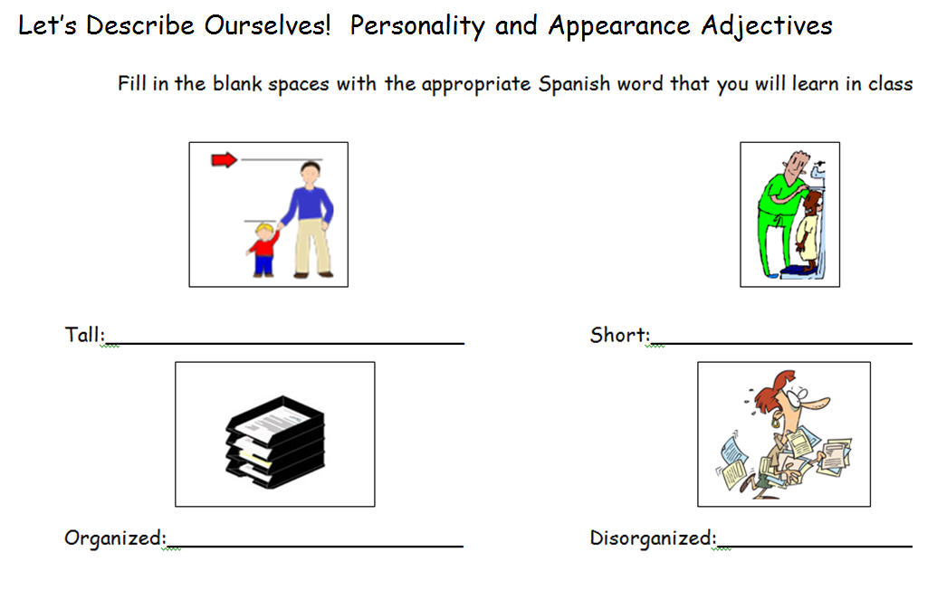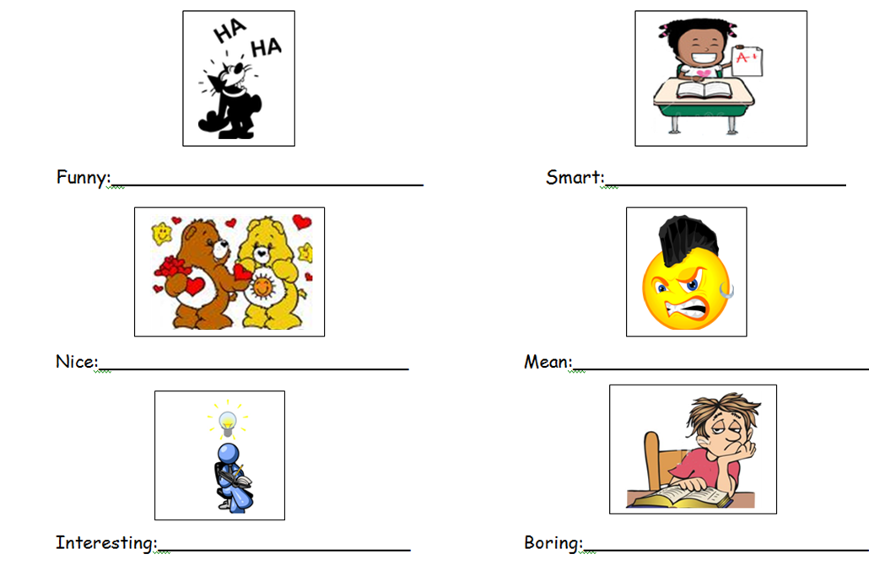
¿Cómo eres?
_____________
Soy....
______________

Fill in the blank spaces with the appropriate Spanish word that you will learn in class.
Pregunta Importante
Me llamo _________________ La fecha es ________________
Boring: __________
Interesting::__________
Mean: __________
Nice: ___________
Smart: ___________
Funny::___________
Disorganized: ____________
Organized: ___________
Short:______________
Tall: ______________
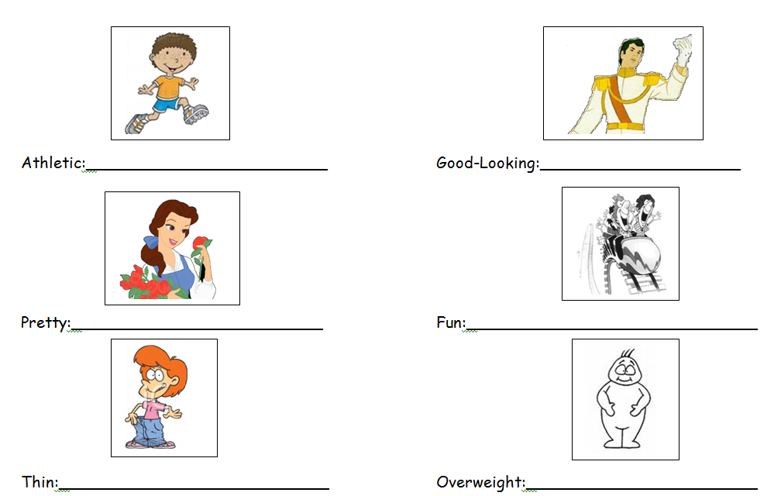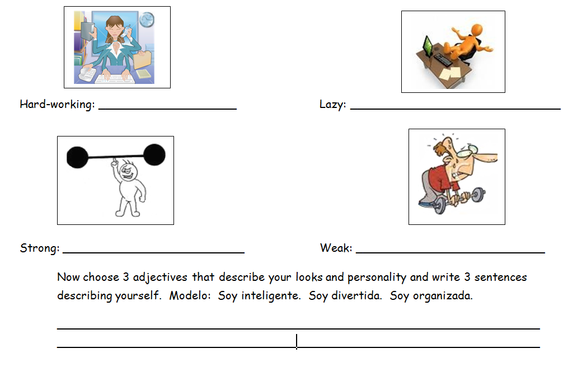
Good-Looking: ________
Hard-working: ___
Now choose 3 adjectives that describe your looks and personality and write 3 sentences describing yourself.
Modelo: Soy inteligente. Soy divertida. Soy organizada. ______________________________________________________________________________________________
Athletic: ______________
Strong:
Weak:
Lazy:
Overweight:

Thin:
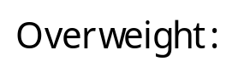
Pretty:
Fun: ______________

