NAME: __________________________________________________ DATE: _____________________ PERIOD: _______
DRAFTING I
AUTO CAD REFERENCE TUTORIAL LINKS FROM AUTODESK WEBSITEhttps://academy.autodesk.com/software/autocad

Basic AutoCad
Review each subject Beginner 1-9 and Intermediate 1-16 . You will need to watch the videos for an understanding of how the software works. You have to copy and paste the URL into the browser.
https://academy.autodesk.com/software/autocad

BEGINNER
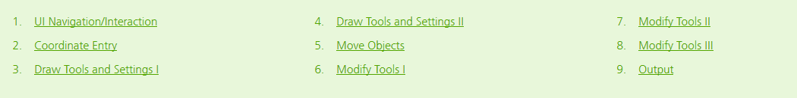

INTERMEDIATE
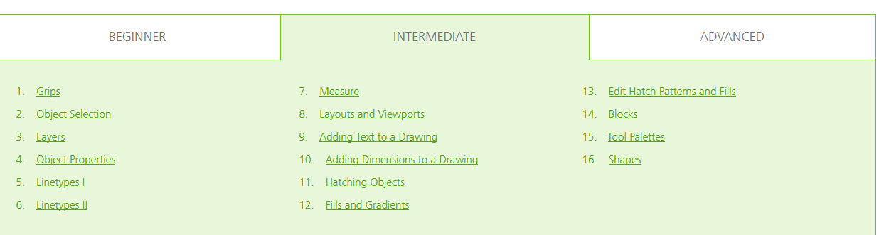

ADVANCED
