Concepts and Trends
UNIT I: Concepts and Trends Essential Standard: 1.00
Understand Fundamental Concepts and Trends of Drafting
Indicator: 1.01 Understand BIM, and Rapid Prototyping.
Indicator: 1.02 Understand Industrial Design, Sustainable Design, and LEED.
Indicator: 1.03 Understand Career Options.

Introduction: The purpose of this unit is to provide students with a basic understanding of the Concepts and Trends associated with Drafting and Design. Today, drafting tasks have evolved into more automated and accelerated systems through the use of Computer Aided Design (CAD). CAD allows for the use of digital drawings, filing, and the use of virtual modeling, which cuts down on time required to create, edit, modify, produce, and present drawings and models to perspective businesses and clients.

Concepts and Trends - Explain the following:
A. The purpose of Building Information modeling (BIM) is to provide insight for creating and managing building and infrastructure projects faster, more economically, and with less environmental impact.
B. The purpose of Rapid Prototyping is to quickly provide a scale model of a physical part or assembly by using data from a three dimensional (3D) CAD design to fabricate the part. There are a variety of methods to fabricate the part, to include 3D printing.
C. Industrial Design can be identified as a designer’s ability to apply both art and scientific techniques to help create, and solve problems related to a product’s form, use, ergonomics, development, marketability, and profitability. Industrial Design is significantly related to engineering design.
D. Sustainable Design, and is also known as Environmental Design. This concept is closely related to sustainability and green design.
E. Leadership in Energy & Environmental Design, or LEED, was developed by the U.S. Green Building Council to help with environmental responsibility. LEED has evolved to be the representative and leader in green building technologies.

LEED.
The process of Building Information Modeling, or BIM, is closely tied to the advantages of CAD software use. Building Information Modeling can be defined as the process of managing building data through the creation of a Building Information Model that covers not just geometry and spatial relationships but also geographic information and properties of building components. The use of the BIM process helps to create models of the building's actual parts, and include data pertaining to that part, such as size and model number. The concept is that, when a building model is shared between the design team, the construction company, and the owner/operator, the data loss associated with the building model, is minimized. The BIM process actually allows for data to be continually added to the model. Other examples of advancements in CAD also include Rapid Prototyping, and Digital Prototyping. Rapid Prototyping (RP) allows for the quick and efficient fabrication of physical models using three-dimensional CAD data. Rapid Prototyping is used in an ever increasing number of industries. This allows those companies to turn innovative ideas into successful end products more rapidly and efficiently. Another concept associated with the advancement in CAD, is Digital Prototyping. This is a revolutionary approach to product development that allows one to design, visualize, and simulate products rapidly and cost-effectively through the use of the Cad software.

UNIT I: Concepts and Trends: Essential Standard: 1.00
Understand Fundamental Concepts and Trends of Drafting
Indicator: 1.01 Understand BIM, and Rapid Prototyping.
A. Explain the following: 1. Building Information Modeling (BIM). 2. Rapid Prototyping.
Requirements: Students are required to be able to define and understand current trends associated with the drafting industry, more specifically, BIM and Rapid Prototyping.

UNIT I: Concepts and Trends: Essential Standard: 1.00
Understand Fundamental Concepts and Trends of Drafting
Indicator: 1.02 Understand Industrial Design, Sustainable Design, and LEED.
A. Explain the following: 1. Industrial Design. 2. Sustainable Design. 3. LEED.
Requirements: Each student is required to define and understand current trends associated with the drafting industry, more specifically, understand Industrial Design, Sustainable Design, and LEED.
1. Assign students or groups of students a short research project whereby the outcome is to gain a better understanding of the concepts.
2. Have students, or groups present their research findings to their classmates.
3. The research project should be completed as prescribed by the teacher.
4. Set due date.
6. Every effort should be made to encourage students to provide accurate and detailed information from their research findings.
7. Research should also reflect the students’ understanding of the subject.

UNIT I: Concepts and Trends: Essential Standard: 1.00
Understand Fundamental Concepts and Trends of Drafting
Indicator: 1.03 Understand Career Options.
A. Explain the following career options:

1. Engineer
2. Manufacturing
3. Electrical
4. Transportation
5. Fabrication
6. Construction
7. Architecture
8. Public Utilities
9. State & Local Government
10. Armed Services
11. College & Universities

B. Basic Drafting Jobs:
1. Drafter Trainee: Assists with drawing preparation and performs support tasks and typically requires high school diploma including drafting classes and/or apprenticeships during high school.
2. Junior Drafter: Prepares drawings under direction of drafting technician or senior detailer and typically requires at least one year of high school drafting and an associate degree in drafting technology.
3. Drafting Technician (Drafter): Prepares drawings with less supervision than a Junior Drafter and typically requires an associate degree in drafting technology and one year of drafting experience.
4. Design Drafting Technician: Combines design and drafting skills, interpretation of designer’s sketches and engineer’s details and typically requires an associate degree in drafting technology and one year of drafting experience.
5. Designer: Works with engineers and drafters to turn conceptual design into usable production drawings and specifications, typically requires an associate degree and at least five years industrial experience, knowledge of design process and drawing requirements.
6. Checker: Experienced drafter who checks drawings created by drafting technicians for accuracy and completeness and typically requires an associate degree and at least five years industrial experience, detailed knowledge of design process and drawing requirements.
7. Senior Detailer: Especially skilled in understanding details of how things work and go together, capable of detailing complex parts and making details understandable and typically requires an associate degree and at least five years industrial experience, knowledge of drawing requirements.
8. Engineer: Has at least a four-year degree in an engineering specialty, must be licensed by the state(s) in which they operate and has many specialized branches. Uses technical drawings to communicate ideas and products for manufacturing or construction and most major corporations employ a complete engineering design team.
1. Research and development personnel
2. Development engineer 3. Project engineer 4. Design engineer 5. Technical illustrator
C. Branches of Engineering
1. Aerospace: Designs aircraft for NASA, public transportation and military applications and/or may work with sub-systems, such as electrical, mechanical, structural, etc.
2. Architecture: Interest in building and construction, typically, Architects and Architectural Designers have a four or five-year degree and must be licensed by the states in which they operate. Must create original designs that are pleasing to the eye as well as functional and meet client and code requirements. Drawings include floor plans, foundation plans, site plans, elevations, and specialty plans for electrical, plumbing, heating & air, etc. Additional courses of study for specializing in various fields such as Landscape architects, City planners, Interior designers.
3. Civil: a. Designs structures, environmental systems, and various construction projects. Arguably the oldest engineering profession.
c. May do analysis and design for materials and structural systems for buildings, aircraft, etc. 4. Electrical/Electronic
a. Designs electric power devices, controls, mechanisms, and
electrical systems. b. Works with power transmission, analog and digital circuits,
and communications. 5. Mechanical: a. Similar to engineering with more emphasis on creative abilities of the drafter: creativity, ingenuity and technical knowledge
b. Work from sketches or just a memo describing a new product idea
c. Determine how or if ideas might work and provide accurate drawings and specifications for proposed products
Requirements: Each student is required to select and research a specific career
field. Have the students research occupational data for both North Carolina and the
Nation, as the data pertains to related Darting careers.
1. Assign students or groups of students a short research project whereby the
outcome is to gain a better understanding of the careers associated with
Drafting. 2. Have students, or groups present their research findings to their classmates. 3. The research project should be completed as prescribed by the teacher. 4. Set due date. 6. Every effort should be made to encourage students to provide accurate and detailed information from their research findings.
7. Research should also reflect the students’ understanding of the subject.

Ideation: (Supplemental) UNIT III: Ideation
Essential Standard: 2.00: Understand the Ideation process
Indicator: 2.01 Understand the Ideation process.
Introduction: Introduction: The purpose of this unit is to provide students with a
basic understanding of the Design Thinking process whereby the students learn
how to use their own creativity to see things in a different perspective. Through this
process, students are introduced to various aspects understanding the creative
process required to Understand, Explore, Define, Ideate, Prototype, Refine, and
eventually Solve potential design challenges real world design professionals might
face.
Defined: Ideation is the creative process of generating, developing, and communicating new ideas, where an idea is understood as a basic element of thought that can be visual, concrete, or abstract. Ideation encompasses each stage of a thought cycle, from innovation, to development, to actualization.
Ideation is an essential part of the design process.
Sketching: UNIT III: Sketching Essential Standard: 3.00
Apply sketching skills and techniques (Architectural & Engineering)
Indicator: 3.01 Apply Rough sketching (lettering for clarity, uppercase caps).
Indicator: 3.02 Apply 2D sketching – Single and Multi-view.
Indicator: 3.03: Apply 3D sketching – Pictorials (isometric, oblique).
Introduction: As instrument drawing becomes less prevalent in industry, the ability
to create accurate technical sketches becomes more important. The curriculum
team feels that it is critical for students to be able to communicate technical
information through different types of sketches. This unit will cover the purpose of
sketching, materials needed for sketching, techniques for sketching, importance of
proportions, the types of sketches, and differences between isometric, oblique and
perspective sketches.
Sketching - Explain the following: A. The purpose of a sketch is to quickly and easily get an idea on paper. Sketches can take the form of the following:
1. Design sketches - Design sketches are rough sketches that are used to
quickly capture an idea. They tend to have less detail, structure and
restrictions than freehand or technical illustrations.
2. Freehand technical sketches - Freehand technical sketches can be
multiview or pictorial sketches. This type of sketch usually includes
more detail and structure than design sketches. They also typically
include dimensions.
3. Technical illustrations - Technical illustrations include more detail,
structure, and restrictions than other types of sketches. The objective
here is to create a sketch that looks as close to the final object as
possible. B. Only pencil and paper (plain or grid) are needed to make a sketch.
C. Techniques for sketching: 1. straight lines 2. Angles 3. circles
D. Sketches must be proportional. Use aids when sketching (pencil as measuring
device to divide lines equally or proportionally).
E. Types of sketches 1. Single-view 2. Multiview 3. Pictorials

UNIT III: Sketching: Essential Standard: 3.00 Demonstrate basic sketching skills and techniques. Indicator: 3.01 Apply Rough Sketching (Lettering to Clarify, Uppercase, Caps). A. Explain the following:
1. Freehand Lettering (both Mechanical and Architectural).
2. A multiview sketch shows different views of an object as seen from
different positions and arranged in a standard order. 3. Pictorial sketches show height, width and depth of an object in one view. 4. The three basic types of pictorials are isometric, oblique, and perspective.
B. Explain the following terms, concepts and procedures for lettering:
1. Identify and select appropriate lettering styles appropriate for use in
drawings.
2. The uniformity in height, proportion, line, and spacing of letters, words,
and numbers, is essential.
3. Write letters, numbers, fractions and decimals in ANSI style, gothic,
modern and italics styles.
4. Space words correctly using correct strokes in ANSI style lettering.
5. Annotating drawings with notes.
Requirements: Each student is required to practice freehand lettering using the
teacher-demonstrated lettering techniques.
1. Using only pencil, eraser, and the paper provided (or worksheet) by the
teacher, produce freehand lettering. 2. Use accepted drafting standards for lines and freehand lettering. 3. The lettering should be done at a scale provided to the students by the teacher. 4. Letter the alphabet, and numbers. Also provide words and sentences for the students to letter.
6. Every effort should be made to encourage students to recreate accurate
sketches of the letters, numbers, words, and sentences being reproduced on
the paper/worksheet provided.
7. Sketches should reflect an understanding of the letter’s/number’s shape and
features as determined from the original. Areas of evaluation will include the
accuracy, and the quality the lettering.
Drafting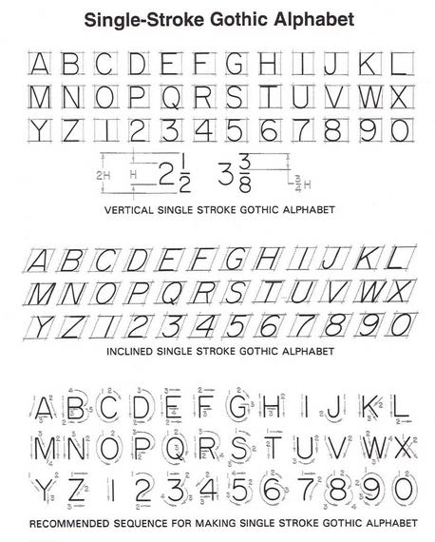UNIT III: Sketching Essential Standard: 3.00 Demonstrate basic sketching skills and techniques. Indicator: 3.02
Apply 2D Sketching – Single and Multi-view. Requirements: Each student is required to create a simple single view and Multiview sketch.
1. Using only pencil, eraser, and the paper provided by your instructor, sketch a
SINGLEVIEW (front view), and MULTIVIEW sketch of the object whose
pictorial is given below. 2. The sketch should be done at a scale of 1:1 (full size) using the measurements provided.
3. Use accepted drafting standards for lines and freehand lettering.
4. Letter your name, problem number (3.02.001), scale, and date in the title
block. 6. An effort should be made to create a balanced appearance of the sketch on
the paper provided. 7. Your sketches should reflect an understanding of the object’s shape and features as determined from the pictorial. Other areas of evaluation will
include the accuracy of your measurements, and the quality of your line work
and lettering.

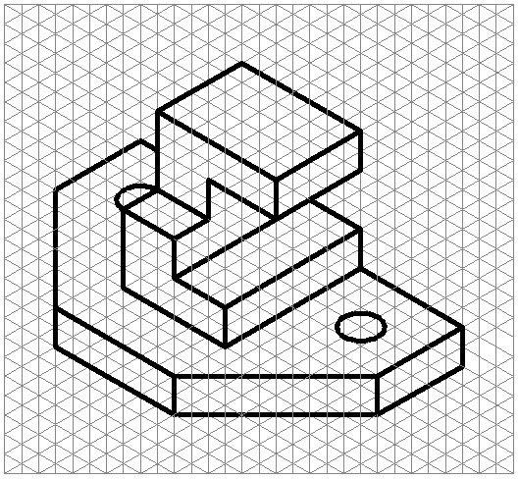
UNIT III: Sketching Essential Standard: 3.00 Demonstrate basic sketching skills and techniques. Indicator: 3.03 Apply 3D Sketching – Pictorials (Isometric, Oblique).
Requirements: Each student is required to create a simple isometric pictorial
sketch. 1. Using only pencil, eraser, and isometric grid paper, to sketch an ISOMETRIC pictorial of the object whose views are given on the next page.
2. The sketch should be done at a scale of 1:1. One square grid equals one
isometric grid. 3. Use accepted drafting standards for lines and freehand lettering.
4. Letter your name, problem number (3.03.001), scale, and date in the title
block. 5. Do NOT include any hidden lines on your isometric sketch.
7. An effort should be made to create a balanced appearance of the sketch on
the paper provided.
8. Your sketch should reflect an understanding of the object’s shape and
features as determined from the orthographic views. Other areas of
evaluation will include the accuracy of your measurements, and the quality of
your line work/lettering
.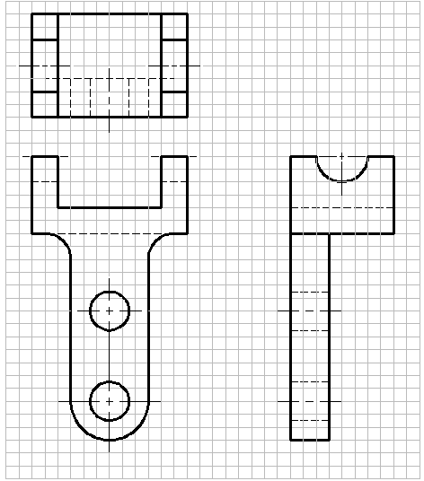
UNIT III: Sketching Competency: 3.00 Demonstrate basic sketching skills and techniques. Indicator: 3.03 Apply 3D Sketching – Pictorials (Isometric, Oblique).
Requirements: Each student is required to create a simple oblique pictorial sketch.
1. Using only pencil, eraser, and the paper provided by your instructor, sketch a
CAVALIER OBLIQUE pictorial (using a receding axis angle specified by your
instructor) of the object whose orthographic views are given below.
2. The drawing should be done at a scale of 1:1. One square grid equals one
oblique grid. 3. Use accepted drafting standards for lines and freehand lettering.
4. Letter your name, problem number (3.03.002), scale, and date in the title
block.
5. Do NOT include any hidden lines on your oblique sketch.
7. An effort should be made to create a balanced appearance of the sketch on
the paper provided.
8. Your sketch should reflect an understanding of the object’s shape and
features as determined from the orthographic views. Other areas of
evaluation will include the accuracy of your measurements, and the quality of
your line work and lettering.
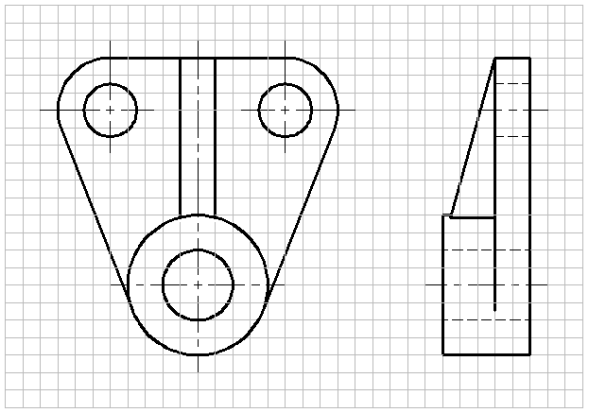
CAD Skills: UNIT III: CAD Skills Essential Standard: 4.00 Apply CAD User Skills (with the use of CAD Software)
Indicator: 4.01 Apply procedures for working with the User interface
(navigation tools).
Indicator: 4.02 Apply procedures for creating drawings (coordinates and draw
tools). Review Geometric Shapes.
Indicator: 4.03 Apply procedures for manipulating objects (grips, object
selection, drawing aids).
Indicator: 4.04 Apply procedures for working with the drawing organization
and inquiry commands (layers).
Indicator: 4.05 Apply procedures for altering objects (modifying).
Indicator: 4.06 Apply procedures for working with layouts (templates,
viewports).
Indicator: 4.07 Apply procedures for annotating the drawing (adding Text).
Indicator: 4.08 Apply procedures for dimensioning.
Indicator: 4.09 Apply procedures for hatching objects (Drawing
enhancements).
Indicator: 4.10 Apply procedures for working with reusable content (blocks).
Indicator: 4.11 Apply procedures for creating Additional drawing objects
(polylines splines ellipse).
Indicator: 4.12 Apply procedures for plotting the drawing.
Introduction: The purpose of this unit is to introduce students to the
fundamentals of 2D and 3D CAD concepts and commands. CAD technology
continues to evolve from simple 2D drawings to the functionality to create
sophisticated, rendered, 3D solid models. The curriculum team felt strongly that
Drafting I should be heavily concentrated with the use of CAD concepts and
skills, and that 3D CAD should be introduced to students. This gives the
students a good foundation for the upper level courses. This unit will cover
terms related to CAD, reasons for using CAD, set-up, draw, and modify
commands, point-entry methods, and basic 3D modeling terms and commands.
The 2D CAD material can be sufficiently covered with AutoCAD LT, AutoCAD,
Inventor, DraftSight, SolidWorks, CADKEY, DATACAD, or the equivalent.
Proceed:
Essential Standard: 4.00 Apply CAD User Skills (with the use of CAD Software) Indicator: 4.01
Apply procedures for working with the User interface (navigation tools).
Drafting
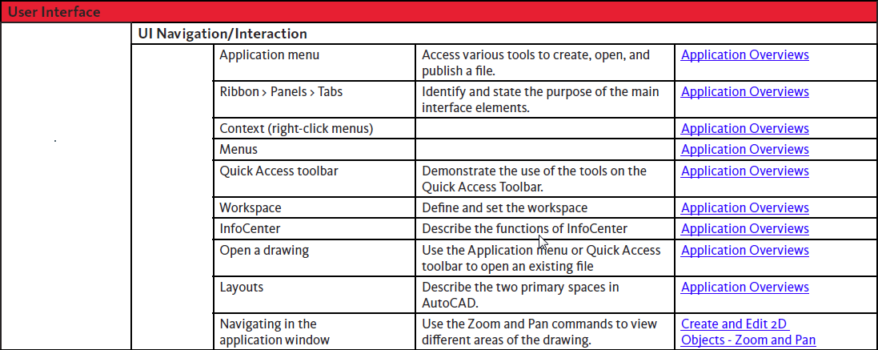
Requirement: Each student is required to apply the procedures above to show
an understanding and possible mastery of the concepts, as applied to teacher
directed classroom assignments.
Essential Standard: 4.00
Apply CAD User Skills (with the use of CAD Software)
Indicator: 4.02
Apply procedures for creating drawings (coordinates and draw tools). Review
Geometric Shapes.
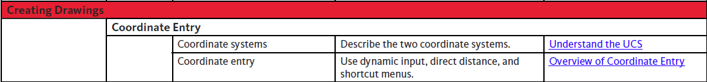
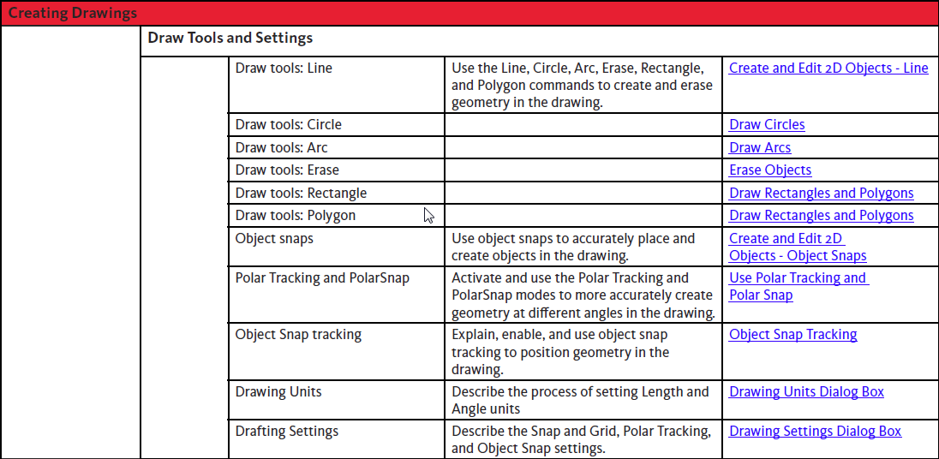
Requirement: Each student is required to apply the procedures above to show
an understanding and possible mastery of the concepts, as applied to teacher
directed classroom assignments
Essential Standard: 4.00 Apply CAD User Skills (with the use of CAD Software) Indicator: 4.03 Apply procedures for manipulating objects (grips, object selection, drawing aids).
Requirement:

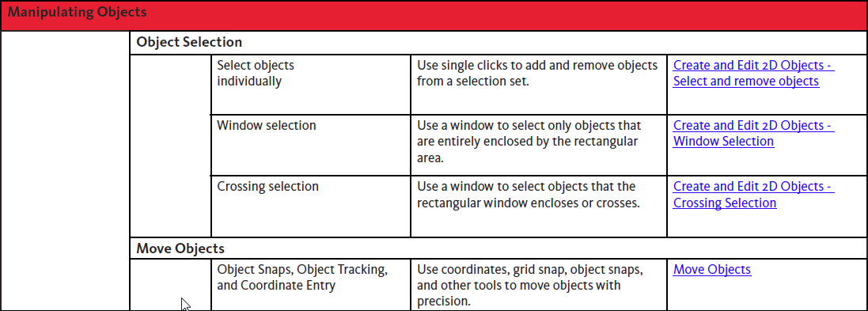

Requirement: Each student is required to apply the procedures above to show
an understanding and possible mastery of the concepts, as applied to teacher
directed classroom assignments.
Essential Standard: 4.00 Apply CAD User Skills (with the use of CAD Software) Indicator: 4.04 Apply procedures for working with the drawing organization and inquiry commands (layers).
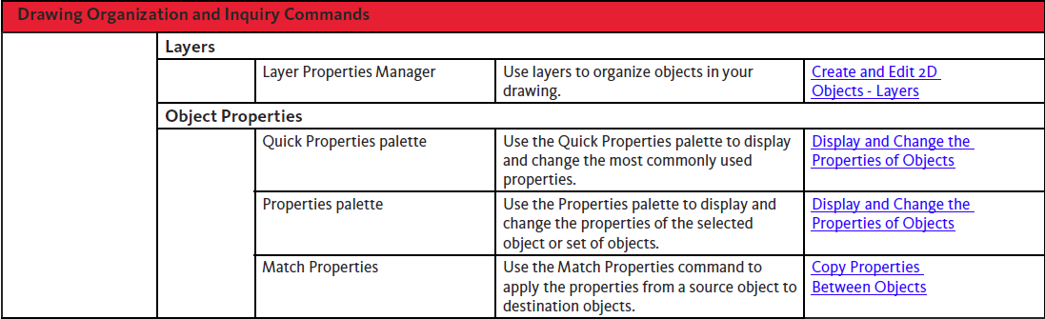
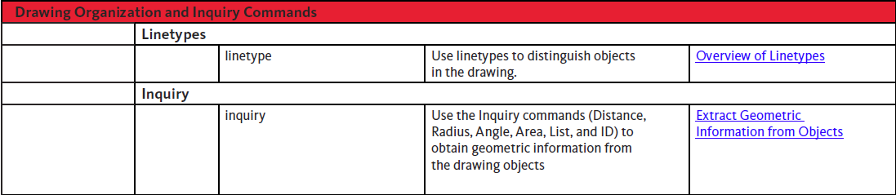
Requirement: Each student is required to apply the procedures above to show
an understanding and possible mastery of the concepts, as applied to teacher
directed classroom assignments.
Essential Standard: 4.00 Apply CAD User Skills (with the use of CAD Software) Indicator: 4.05 Apply procedures for altering objects (modifying). 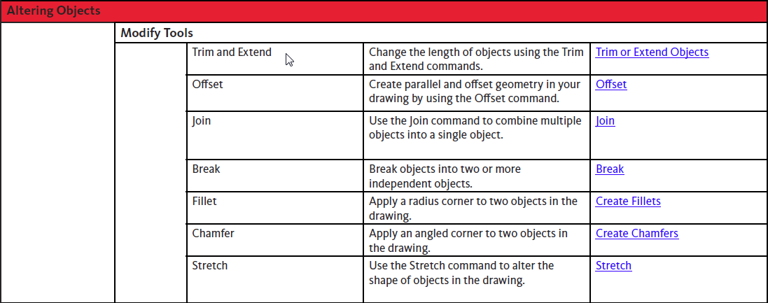

Requirement: Each student is required to apply the procedures above to show
an understanding and possible mastery of the concepts, as applied to teacher
directed classroom assignments.
Essential Standard: 4.00
Apply CAD User Skills (with the use of CAD Software)
Indicator: 4.06
Apply procedures for working with layouts (templates, viewports).

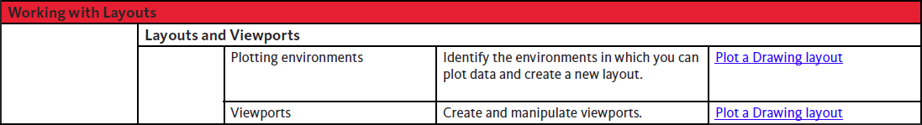

Requirement: Each student is required to apply the procedures above to show
an understanding and possible mastery of the concepts, as applied to teacher
directed classroom assignments.
Drafting Page 27 of 41
Essential Standard: 4.00
Apply CAD User Skills (with the use of CAD Software)
Indicator: 4.07
Apply procedures for annotating the drawing (adding Text).
Requirement:
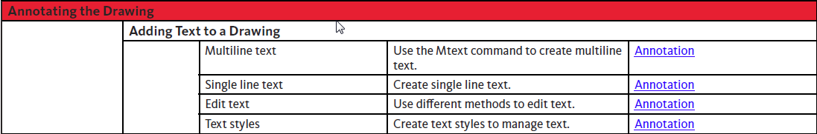
Requirement: Each student is required to apply the procedures above to show
an understanding and possible mastery of the concepts, as applied to teacher
directed classroom assignments.
Essential Standard: 4.00
Apply CAD User Skills (with the use of CAD Software)
Indicator: 4.08
Apply procedures for dimensioning.

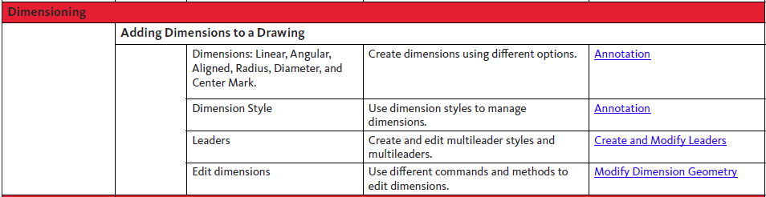
Requirement: Each student is required to apply the procedures above to show
an understanding and possible mastery of the concepts, as applied to teacher
directed classroom assignments.
Drafting Page 28 of 41
Essential Standard: 4.00
Apply CAD User Skills (with the use of CAD Software)
Indicator: 4.09
Apply procedures for hatching objects (Drawing enhancements).
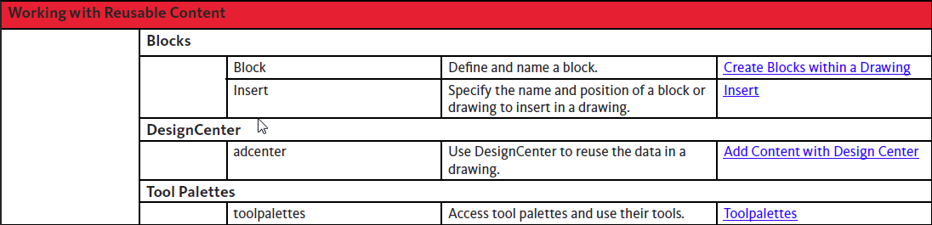
Requirement: Each student is required to apply the procedures above to show
an understanding and possible mastery of the concepts, as applied to teacher
directed classroom assignments.

Essential Standard: 4.00 Apply CAD User Skills (with the use of CAD Software) Indicator: 4.11 Apply procedures for creating Additional drawing objects (polylines, splines, ellipses).
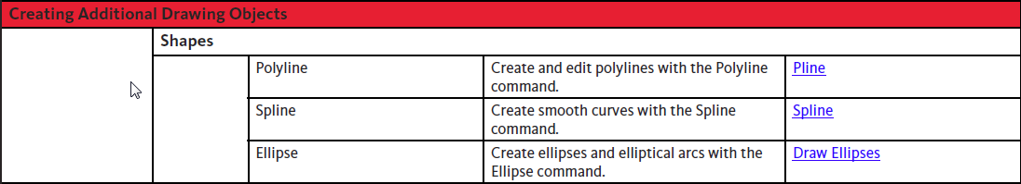
Requirement: Each student is required to apply the procedures above to show
an understanding and possible mastery of the concepts, as applied to teacher
directed classroom assignments.
Essential Standard: 4.00
Apply CAD User Skills (with the use of CAD Software)
Indicator:
4.12 Apply procedures for plotting the drawing.
Requirement: Each student is required to apply the procedures above to show
an understanding and possible mastery of the concepts, as applied to teacher
directed classroom assignments.

